Lesson 2.8 Guided Notes

Session 1 · Finding the Mean
I can find the mean of a data set by sharing the total equally among the values. · 6.SP.B.5c
Word / Spanish | Meaning — complete the blank | Example
mean / media | The fair share: add all values, then ________ by how many there are. | (3 + 5 + 6 + 10) ÷ 4 = 6
average / promedio | Another ______ for the mean. | the average score
measure of center / medida de centro | One number that tells a _________ value of the data. | mean, median
data set / conjunto de datos | All the ________ you collected. | 8, 15, 11, 6

Key idea
Mean = _____ of the values ÷ ________ of values.
Count every value, even a ______.
The mean lands between the _______ and greatest values.

Worked example
Four friends have 3, 5, 6 and 10 stickers. Find the mean.
Add: 3 + 5 + 6 + 10 = _____
Count the values: there are _____.
Divide: 24 ÷ 4 = _____. Check: 6 is between 3 and 10.
Answer: The mean is _____ stickers.

You try
1. Find the mean of each data set.
a. 4, 8, 6, 10, 7 ______
b. 3, 5, 7 ______
________________________________________________________________
2. Five families paid $18, $24, $15, $21 and $22 for tickets. Find the mean amount.
________________________________________________________________
Sum it up: The mean is a fair share because ___.
________________________________________________________________

Session 2 · Reaching a Target Mean
I can find the value a data set still needs in order to reach a target mean. · 6.SP.B.5c
Word / Spanish | Meaning — complete the blank | Example
target mean / media objetivo | The mean you ______ to reach. | a goal mean of 29
target total / total objetivo | Target mean × number of ________. | 8 × 4 = 32
missing value / valor faltante | Target total − the sum you _________ have. | 32 − 22 = 10

Key idea
Work __________: target total = target mean × number of values.
Then __________ the sum so far to find the missing value.

Worked example
Quiz scores are 6, 7 and 9. What fourth score gives a mean of 8?
Count all the scores, including the missing one: _____.
Target total: 8 × 4 = _____. Sum so far: 6 + 7 + 9 = 22.
Subtract: 32 − 22 = _____.
Answer: The fourth score is _____. Check: 32 ÷ 4 = 8

You try
1. Fill in each blank.
a. Mean 25, 4 values. Total = ______
b. Need 72, have 57. Missing = ______
________________________________________________________________
2. Maria scored 85, 90 and 88 on three quizzes. What score on quiz 4 gives a mean of 90?
________________________________________________________________
Sum it up: To find a missing value, I first find the ___ because ___.
________________________________________________________________

Session 1 · Model, reason, and explain
Finding the Mean · 6.SP.B.5c
Success: represent the quantities, justify the relationship, and check the result with the correct units.
Four groups collected 0, 2, 4, and 10 cans. Use a fair-share model to find the mean. Explain why the group with zero cans is still included in the divisor.
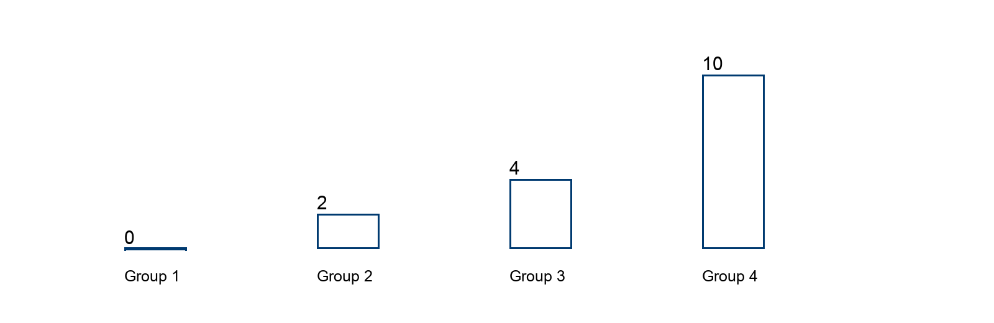
________________________________________________________________
________________________________________________________________
________________________________________________________________

Extend your reasoning
Must a group actually have the mean number? Construct a two-group counterexample.
________________________________________________________________
________________________________________________________________
Self-check: Did my model, calculation, explanation, and units agree?

Session 2 · Model, reason, and explain
Reaching a Target Mean · 6.SP.B.5c
Success: represent the quantities, justify the relationship, and check the result with the correct units.
Three quiz scores are 6, 8, and 9. What fourth score gives a mean of 8? Each quiz has a maximum of 10. Could a fourth score produce a mean of 9? Explain.
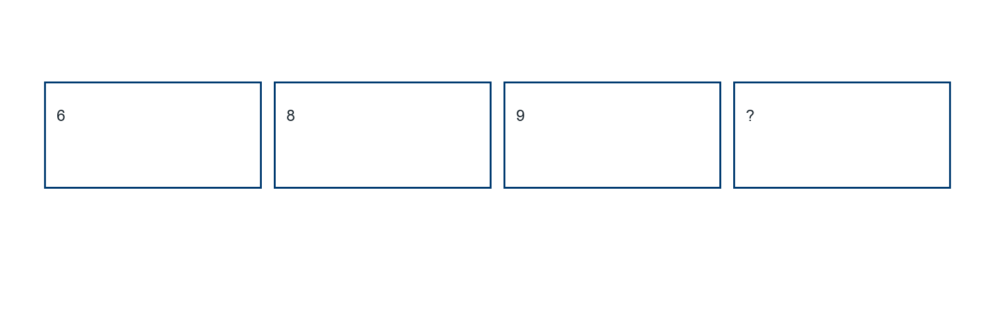
________________________________________________________________
________________________________________________________________
________________________________________________________________

Extend your reasoning
Find the greatest possible final mean and explain why it is a maximum.
________________________________________________________________
________________________________________________________________
Self-check: Did my model, calculation, explanation, and units agree?

