Name Date Period
Lesson 2-9 · Session 1 · Guided Steps · Form A
Finding Mean Absolute Deviation (MAD)
Learning target — I can find the mean absolute deviation of a data set and explain what it measures. · 6.SP.B.5c
REMEMBER
• MAD (mean absolute deviation) = the mean of the distances from the mean.
• Steps: find the mean, find each value’s distance from it (never negative), then average the distances.
• If all values match, the MAD is 0. A small MAD means values sit close to the mean.
GUIDED PRACTICE fill in each blank — problems 1–4
1. Science Quiz. The mean of 13, 15, 19, 23 and 25 is 19. Complete the table. Then find the MAD:
Value | 13 | 15 | 19 | 23 | 25
Distance from 19

Step 1 Add the five distances:
Step 2 Divide by 5: ÷ =

2. Gym Visits. The dot plot shows the visitors to a gym on four evenings.
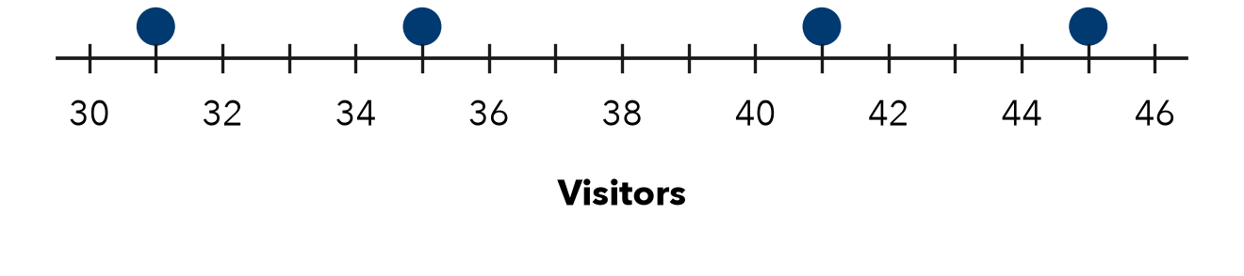
a. Mean:
Step 1 Read the four values: , , ,
Step 2 Add them, then ÷ 4: ÷ 4 = visitors
b. MAD:
Step 3 Distances from the mean: , , ,
Step 4 Add them, then ÷ 4: ÷ 4 = visitors

3. Afternoon Temps. Four afternoon temperatures were 53, 57, 59 and 63°F. Find the MAD.
Step 1 53 + 57 + 59 + 63 =
Step 2 Mean: ÷ 4 =
Step 3 Distances: , , ,
Step 4 MAD: ÷ 4 = °F

4. All the Same. Four values are 25, 25, 25, 25. Elise says the MAD cannot be found. Is she right?
Step 1 Mean of the four values:
Step 2 Each distance from the mean:
Step 3 MAD = ÷ 4 =
Step 4 Is Elise right?

ON YOUR OWN use the open space · show your work · label units
5. Reading a MAD. Six delivery times have a mean of 45 minutes and a MAD of 3 minutes. What does the MAD tell a customer?  Show your work. | 6. Homework Pages. Five students turned in 12, 18, 20, 22 and 28 pages. Find the mean and the MAD.  Show your work.  Mean, MAD ,

7. Missing Distance. Four values have mean 50 and MAD 5. Three distances from the mean are 6, 2 and 4. Find the fourth distance.  Show your work.  Distance | 8. Two Groups. Free throws made — Group 1: 6, 8, 10, 12. Group 2: 4, 9, 10, 13. Both means are 9.  a. MAD of Group 1:  b. MAD of Group 2:  Show your work.  c. What does the MAD tell you that the mean does not?

FIND THE ERROR explain the mistake, then fix it
9. Damaris’s Work. For 17, 19, 25, 27 (mean 22), Damaris added −5, −3, +3, +5 and reported a MAD of 0. Explain her mistake and find the MAD.
Show your work.

TEST PRACTICE choose the best answer
10. MAD stands for —
A middle and difference B mean added data C median absolute distance D mean absolute deviation

11. Distances from the mean are never —
A zero B negative C whole numbers D decimals

CHECK YOURSELF
□ I can do this on my own □ I need a little help □ I have a question about #

