Name Date Period
Lesson 2-9 · Session 1 · Guided Steps · Form B
Finding Mean Absolute Deviation (MAD)
Learning target — I can find the mean absolute deviation of a data set and explain what it measures. · 6.SP.B.5c
REMEMBER
• MAD (mean absolute deviation) = the mean of the distances from the mean.
• Steps: find the mean, find each value’s distance from it (never negative), then average the distances.
• If all values match, the MAD is 0. A small MAD means values sit close to the mean.
GUIDED PRACTICE fill in each blank — problems 1–4
1. Spelling Quiz. The mean of 11, 14, 18, 22 and 25 is 18. Complete the table. Then find the MAD:
Value | 11 | 14 | 18 | 22 | 25
Distance from 18

Step 1 Add the five distances:
Step 2 Divide by 5: ÷ =

2. Gym Visits. The dot plot shows the visitors to a gym on four evenings.
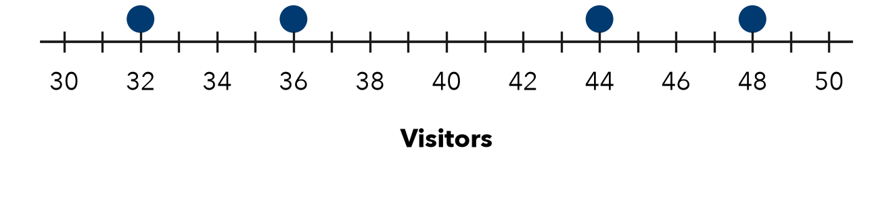
a. Mean:
Step 1 Read the four values: , , ,
Step 2 Add them, then ÷ 4: ÷ 4 = visitors
b. MAD:
Step 3 Distances from the mean: , , ,
Step 4 Add them, then ÷ 4: ÷ 4 = visitors

3. Afternoon Temps. Four afternoon temperatures were 61, 64, 68 and 71°F. Find the MAD.
Step 1 61 + 64 + 68 + 71 =
Step 2 Mean: ÷ 4 =
Step 3 Distances: , , ,
Step 4 MAD: ÷ 4 = °F

4. All the Same. Four values are 40, 40, 40, 40. Kenji says the MAD cannot be found. Is he right?
Step 1 Mean of the four values:
Step 2 Each distance from the mean:
Step 3 MAD = ÷ 4 =
Step 4 Is Kenji right?

ON YOUR OWN use the open space · show your work · label units
5. Reading a MAD. Six bus rides have a mean of 30 minutes and a MAD of 2 minutes. What does the MAD tell a rider?  Show your work. | 6. Homework Pages. Five students turned in 10, 16, 22, 24 and 28 pages. Find the mean and the MAD.  Show your work.  Mean, MAD ,

7. Missing Distance. Four values have mean 60 and MAD 6. Three distances from the mean are 3, 7 and 5. Find the fourth distance.  Show your work.  Distance | 8. Two Groups. Free throws made — Group 1: 5, 7, 9, 11. Group 2: 2, 8, 9, 13. Both means are 8.  a. MAD of Group 1:  b. MAD of Group 2:  Show your work.  c. What does the MAD tell you that the mean does not?

FIND THE ERROR explain the mistake, then fix it
9. Tobias’s Work. For 26, 28, 34, 36 (mean 31), Tobias added −5, −3, +3, +5 and reported a MAD of 0. Explain his mistake and find the MAD.
Show your work.

TEST PRACTICE choose the best answer
10. A deviation is the distance between a value and the —
A mean B median C greatest value D range

11. A smaller MAD means the data is —
A more spread out B larger C closer to the mean D negative

CHECK YOURSELF
□ I can do this on my own □ I need a little help □ I have a question about #

