Lesson 2.9 Guided Notes

Session 1 · Finding Mean Absolute Deviation (MAD)
I can find the mean absolute deviation of a data set and explain what it measures. · 6.SP.B.5c
Word / Spanish | Meaning — complete the blank | Example
mean absolute deviation (MAD) / desviación media absoluta | The ______ of the distances from the mean. | distances 4, 0, 1, 3: MAD 2
deviation / desviación | How _____ one value is from the mean. | mean 19, value 23: 4
absolute value / valor absoluto | A number’s distance from 0; it is never __________. | |−5| = 5
spread / dispersión | How far _______ the values are. | small MAD = tight set

Key idea
Find the mean, then each value’s __________ from the mean.
The MAD is the ______ of those distances.
A small MAD means the values are _______ to the mean.

Worked example
Four plants grew 3, 7, 8 and 10 cm. Find the MAD.
Mean: 28 ÷ 4 = _____
Distances from 7: 4, _____, 1, 3
Add the distances: _____. Divide by 4.
Answer: MAD = _____ cm

You try
1. The mean is given. Find the MAD.
a. 2, 4, 6, 8 (mean 5) ______
b. 8, 14, 16, 22 (mean 15) ______
________________________________________________________________
2. The mean of 4, 6, 8, 10, 12 is 8. Find the MAD.
________________________________________________________________
Sum it up: The MAD tells me ___ because ___.
________________________________________________________________

Session 2 · Comparing Data Sets Using MAD
I can compare two data sets that share a mean by comparing their mean absolute deviations. · 6.SP.B.5c
Word / Spanish | Meaning — complete the blank | Example
variation / variación | How ___________ the values are from each other. | larger MAD = more variation
consistent / consistente | Values stay _______ together; the spread is small. | small MAD = consistent
MAD / desviación media absoluta | The mean __________ of the values from the mean. | MAD 1.5 versus MAD 4

Key idea
Two sets can have the same mean and ___________ MADs.
The set with the _________ MAD is steadier (more consistent).

Worked example
Baker A made 8, 9, 11, 12 cookies per tray. Baker B made 4, 8, 12, 16. Both means are 10. Who is steadier?
A’s distances: 2, 1, 1, 2. MAD = 6 ÷ 4 = _____
B’s distances: 6, 2, 2, 6. MAD = 16 ÷ 4 = _____
Answer: Baker _____ is steadier: 1.5 < 4.

You try
1. Both sets have a mean of 30. Find each MAD.
a. Set 1: 26, 28, 32, 34 ______
b. Set 2: 20, 24, 36, 40 ______
________________________________________________________________
2. Machine A fills bottles with mean 500 mL and MAD 2 mL. Machine B: mean 500 mL, MAD 14 mL. Which is more consistent?
________________________________________________________________
Sum it up: When two sets have the same mean, I compare ___ because ___.
________________________________________________________________

Session 1 · Model, reason, and explain
Finding Mean Absolute Deviation (MAD) · 6.SP.B.5c
Success: represent the quantities, justify the relationship, and check the result with the correct units.
Plant growth measurements are 2, 4, 6, and 8 centimeters. Find the mean, each distance from the mean, and the MAD. Explain why the distances do not cancel.
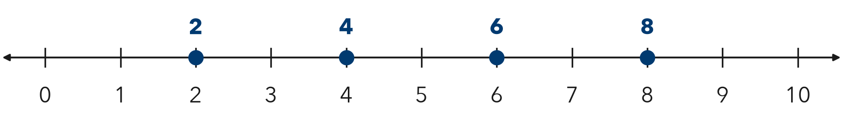
________________________________________________________________
________________________________________________________________
________________________________________________________________

Extend your reasoning
Explain the difference between the mean of 5 cm and MAD of 2 cm in one connected sentence.
________________________________________________________________
________________________________________________________________
Self-check: Did my model, calculation, explanation, and units agree?

Session 2 · Model, reason, and explain
Comparing Data Sets Using MAD · 6.SP.B.5c
Success: represent the quantities, justify the relationship, and check the result with the correct units.
A: 4, 5, 5, 6 and B: 1, 3, 7, 9 have the same mean. Compute their MADs and explain which set is more consistent around its mean.
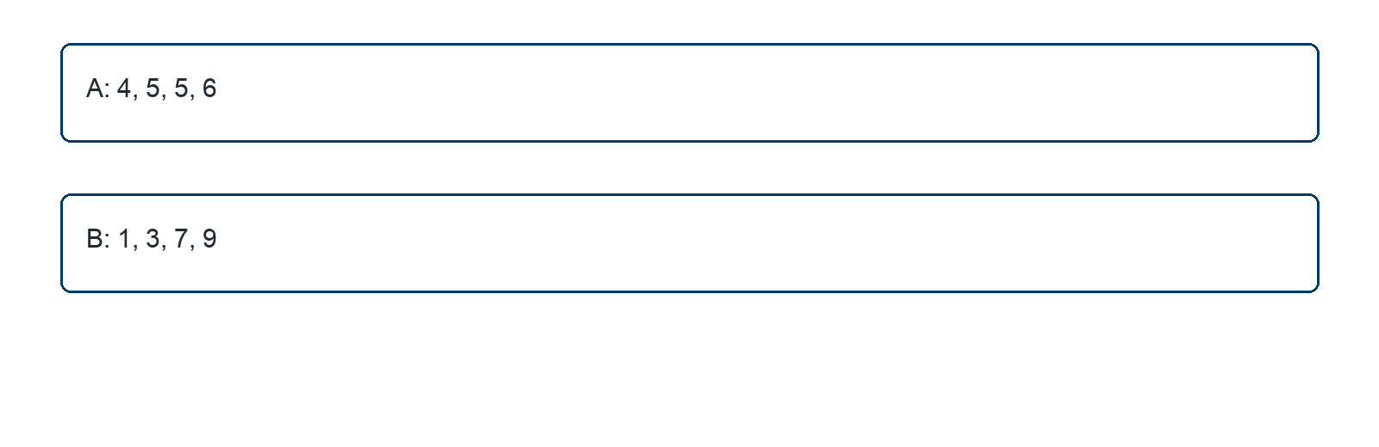
________________________________________________________________
________________________________________________________________
________________________________________________________________

Extend your reasoning
Create four observations with mean 5 and MAD 0. Explain your set.
________________________________________________________________
________________________________________________________________
Self-check: Did my model, calculation, explanation, and units agree?

