Name Date Period
Lesson 3-1 · Session 2 · Guided Steps · Form A
Ratios and Tape Diagrams
Learning target — I can use a tape diagram to share a total according to a given ratio. · 6.RP.A.1
REMEMBER
• A tape diagram uses equal boxes. The ratio tells how many boxes each group gets.
• One box = total ÷ total parts. Multiply one box by each term.
• If you know one group, divide it by its boxes to find one box.
GUIDED PRACTICE fill in each blank — problems 1–4
1. Trail Mix. A recipe uses 2 cups of granola for every 3 cups of cranberries. A chef makes a 25-cup batch.
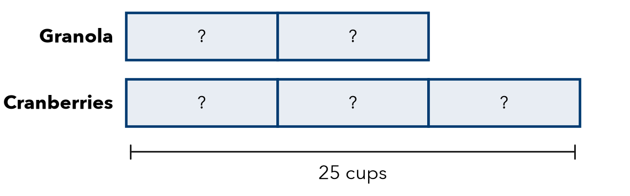
Step 1 a. Total parts: + =
Step 2 b. One box: ÷ = cups
Step 3 Granola: × = cups
Step 4 Cranberries: × = cups
Step 5 c. Check: + = cups

2. Smoothie. A smoothie uses 3 strawberries for every 2 bananas. A pitcher uses 20 fruits. How many bananas?  Step 1 Total parts: + =  Step 2 One box: ÷ =  Step 3 Bananas: × =  Answer bananas | 3. Mural Paint. Art club mixes 4 cups blue with 1 cup white. They need 35 cups in all. How much blue?  Step 1 Total parts: + =  Step 2 One box: ÷ =  Step 3 Blue: × =  Answer cups

4. Fish Tank. A tank has goldfish and guppies in the ratio 5 to 3. There are 32 fish in all. How many goldfish?
Step 1 Total parts: + =
Step 2 One box: ÷ =
Step 3 Goldfish: × =
Answer goldfish

ON YOUR OWN use the open space · show your work · label units
5. Camp Counselors. A camp has 1 counselor for every 6 campers. There are 42 campers. How many counselors are needed?  Show your work.  Answer counselors | 6. Splitting Money. Two cousins share $45 in the ratio 4 : 5.  a. Cousin 1: $  b. Cousin 2: $  Show your work.

7. Find the Total. A trail mix uses 2 parts raisins to 5 parts nuts. The recipe uses 15 ounces of nuts.  a. How many ounces is one part? oz  b. How many ounces does the recipe make in all? oz  Show your work. | 8. Garden Beds. A gardener plants beans and corn in the ratio 5 : 3 with 96 seeds in all.  a. Bean seeds and corn seeds:  b. How many more bean seeds than corn seeds?  c. Next year she wants equal amounts. What ratio?  Show your work.

FIND THE ERROR explain the mistake, then fix it
9. Sofia’s Work. A mix uses 2 cups sugar and 5 cups flour, 28 cups in all. Sofia divided 28 by 2 and got 14 cups of sugar. Explain her mistake and find the sugar.
Show your work.

TEST PRACTICE choose the best answer
10. A ratio of 2 : 3 shares a total of 30. One box is worth —
A 5 B 6 C 10 D 15

11. A ratio of 1 : 4 shares 25 cookies. The larger share is —
A 4 B 5 C 20 D 24

CHECK YOURSELF
□ I can do this on my own □ I need a little help □ I have a question about #

