Lesson 3.1 Guided Notes

Session 1 · Understanding Ratios
I can describe a relationship between two quantities using ratio language. · 6.RP.A.1
Word / Spanish | Meaning — complete the blank | Example
ratio / razón | A comparison of two _________. | 3 to 5, 3 : 5, 3/5
term / término | One of the two _________ in a ratio. | In 3 : 5, the terms are 3 and 5.
part-to-part / parte a parte | Compares one group with _________ group. | apples : oranges
part-to-whole / parte al todo | Compares one group with the _______. | apples : all the fruit

Key idea
Write a ratio in the _______ the question asks.
For part-to-whole, _____ the groups to find the whole.
To simplify, divide both terms by the same ________.

Worked example
A shelf has 6 math books and 9 reading books. Write math to all books in simplest form.
All books: 6 + 9 = _____.
Math first: 6 : _____.
Divide both terms by _____: 2 : 5.
Answer: Math to all books = _____ : 5

You try
1. A pack has 10 pens and 15 pencils. Write each ratio in simplest form.
a. pens to pencils ______
b. pencils to all ______
________________________________________________________________
2. A team has 7 forwards and 4 defenders. Write the ratio of defenders to forwards.
________________________________________________________________
Sum it up: In a ratio, order matters because ___.
________________________________________________________________

Session 2 · Ratios and Tape Diagrams
I can use a tape diagram to share a total according to a given ratio. · 6.RP.A.1
Word / Spanish | Meaning — complete the blank | Example
tape diagram / diagrama de cinta | A drawing with _______ boxes that shows a ratio. | 2 boxes : 3 boxes
unit (one box) / unidad | The amount inside _____ box. | 24 ÷ 4 boxes = 6 in each box
total parts / partes totales | All the boxes _______ together. | 3 + 1 = 4 parts

Key idea
Add the ratio terms to find the _______ parts.
One box = total ÷ _____________.
Multiply one box by each ______ to find each share.

Worked example
Ana and Ben share 28 stickers in the ratio 3 : 4. Find each share.
Total parts: 3 + 4 = _____.
One box: 28 ÷ 7 = _____ stickers.
Ana: 3 × 4 = _____. Ben: 4 × 4 = 16.
Answer: Ana gets _____ and Ben gets _____. Check: 12 + 16 = 28

You try
1. Add the terms to find the total parts.
a. 3 : 5 ______
b. 7 : 2 ______
c. 4 : 6 ______
________________________________________________________________
2. Share $56 in the ratio 3 : 4. Find both shares.
________________________________________________________________
Sum it up: To share a total in a ratio, I first ___ because ___.
________________________________________________________________

Session 1 · Model, reason, and explain
Understanding Ratios · 6.RP.A.1
Success: represent the quantities, justify the relationship, and check the result with the correct units.
A tray holds 4 blue counters and 6 yellow counters. Write blue:yellow, yellow:blue, and blue:all in simplest form. Explain what each number counts.
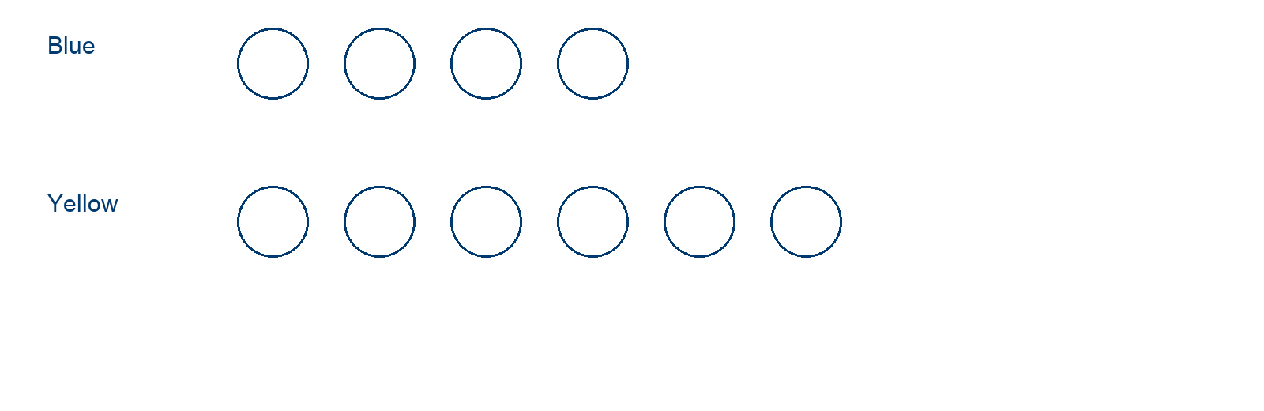
________________________________________________________________
________________________________________________________________
________________________________________________________________

Extend your reasoning
Add equal numbers of blue and yellow counters. Must the ratio stay the same? Give a counterexample.
________________________________________________________________
________________________________________________________________
Self-check: Did my model, calculation, explanation, and units agree?

Session 2 · Model, reason, and explain
Ratios and Tape Diagrams · 6.RP.A.1
Success: represent the quantities, justify the relationship, and check the result with the correct units.
Split 35 stickers between two groups in the ratio 2:3. Label the equal tape units, find both shares, and check their sum.
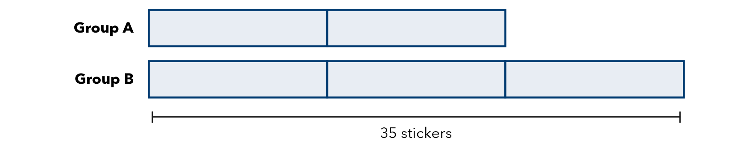
________________________________________________________________
________________________________________________________________
________________________________________________________________

Extend your reasoning
Create a different total that can be shared in ratio 2:3 using whole stickers.
________________________________________________________________
________________________________________________________________
Self-check: Did my model, calculation, explanation, and units agree?

