Lesson 3.2 Guided Notes

Session 1 · Understanding Unit Rates
I can find a unit rate and use rate language such as “per hour” or “each.” · 6.RP.A.2
Word / Spanish | Meaning — complete the blank | Example
rate / tasa | A comparison of two amounts with ___________ units. | 96 pages in 3 hours
unit rate / tasa unitaria | The amount for exactly _____ unit. | 32 pages per 1 hour
per / por | Means “for ______” one. | miles per hour
constant rate / tasa constante | The amount stays the ______ every time. | 15 pages every minute

Key idea
To find a unit rate, ________ the first amount by the second.
Multiply the unit rate by any number of units to _________.
Always label the _______: miles per hour, dollars per pound.

Worked example
A printer prints 90 pages in 6 minutes at a steady rate. How many pages in 7 minutes?
Divide to find 1 minute: 90 ÷ 6 = _____ pages per minute.
Multiply for 7 minutes: 15 × 7 = _____.
Check: 15 × 6 = _____.
Answer: _____ pages in 7 minutes

You try
1. Find each unit rate.
a. 84 words in 7 minutes ______ per min
b. $56 for 8 hours ______ per hour
________________________________________________________________
2. A car travels 150 miles in 3 hours at a steady speed. How far does it go in 5 hours?
________________________________________________________________
Sum it up: A unit rate tells the amount for ___ because ___.
________________________________________________________________

Session 2 · Comparing Unit Prices (Best Buy)
I can compare unit prices to decide which package is the better buy. · 6.RP.A.2
Word / Spanish | Meaning — complete the blank | Example
unit price / precio unitario | The cost of exactly _____ item or unit. | $1.75 per pound
better buy / mejor compra | The choice with the _______ unit price. | $1.60 < $1.75
total price / precio total | What the _______ package costs. | $9.60 for the bag

Key idea
Unit price = total cost ÷ number of _______.
Find the unit price of ______ package, then compare.
The _______ unit price is the better buy.

Worked example
Store A sells 5 notebooks for $7.50. Store B sells 8 for $10.40. Which is the better buy?
A: $7.50 ÷ 5 = $______ per notebook.
B: $10.40 ÷ 8 = $______ per notebook.
$1.30 < $1.50, so Store _____ is cheaper.
Answer: Store B saves $______ per notebook.

You try
1. Find each unit price.
a. 6 apples for $4.50 ______ each
b. 10 pencils for $2.50 ______ each
________________________________________________________________
2. A 12-oz bottle costs $2.40. A 20-oz bottle costs $3.60. Which is the better buy?
________________________________________________________________
Sum it up: To pick the better buy, I compare ___ because ___.
________________________________________________________________

Session 1 · Model, reason, and explain
Understanding Unit Rates · 6.RP.A.2
Success: represent the quantities, justify the relationship, and check the result with the correct units.
A printer makes 84 pages in 6 minutes at a steady rate. Find pages per minute and minutes per page. Which rate directly answers how many pages it makes in 5 minutes?
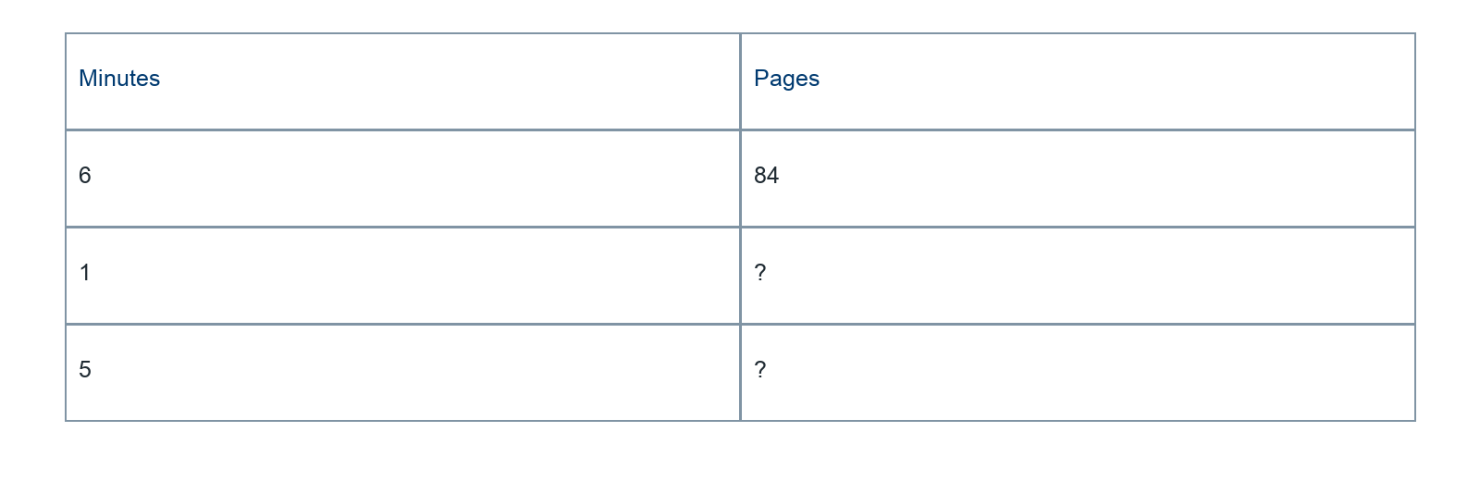
________________________________________________________________
________________________________________________________________
________________________________________________________________

Extend your reasoning
When would minutes per page be useful?
________________________________________________________________
________________________________________________________________
Self-check: Did my model, calculation, explanation, and units agree?

Session 2 · Model, reason, and explain
Comparing Unit Prices (Best Buy) · 6.RP.A.2
Success: represent the quantities, justify the relationship, and check the result with the correct units.
Pack A contains 6 notebooks for $9.30. Pack B contains 8 for $12. Compare cost per notebook without rounding until the comparison is made. Which has the lower unit price?
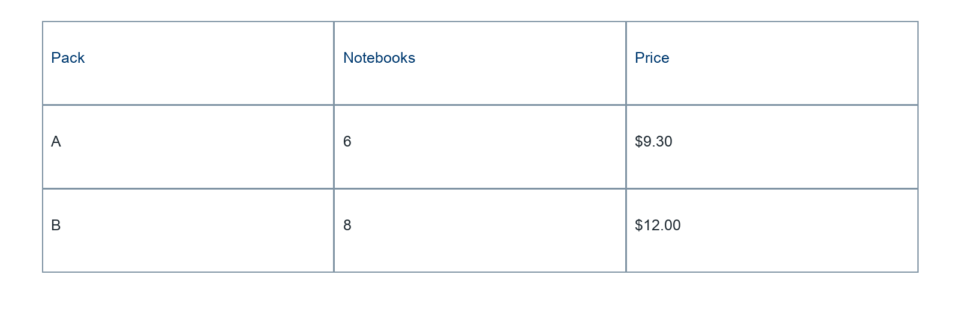
________________________________________________________________
________________________________________________________________
________________________________________________________________

Extend your reasoning
If you need exactly 6 notebooks and can buy only whole packs, does the lower unit price guarantee a lower checkout cost?
________________________________________________________________
________________________________________________________________
Self-check: Did my model, calculation, explanation, and units agree?

