Lesson 3.3 Guided Notes

Session 1 · Equivalent Ratios and Tables
I can build a ratio table by scaling both rows by the same factor. · 6.RP.A.3a
Word / Spanish | Meaning — complete the blank | Example
equivalent ratios / razones equivalentes | Ratios that make the same ____________. | 2 : 3 and 4 : 6
ratio table / tabla de razones | A table of ____________ ratios. Each column is one pair. | 3 : 2, 6 : 4, 9 : 6
scale factor / factor de escala | The number you __________ or divide both terms by. | 2 : 3 × 4 = 8 : 12

Key idea
To find an equivalent ratio, multiply or divide ______ terms by the ______ number.
Adding the same number to both terms does _____ keep the ratio.

Worked example
A drink mix uses 5 scoops of powder for every 2 cups of water. How much water goes with 15 scoops?
Find the scale factor: 15 ÷ 5 = _____.
Multiply the water by the same factor: 2 × 3 = _____.
Check: 15 : 6 divided by 3 gives _______ again.
Answer: 15 scoops of powder go with _____ cups of water.

You try
1. Juice uses 1 cup of concentrate for every 4 cups of water. Complete the table.
________________________________________________________________
2. Fill in the missing number.
a. 5 : 2 = 20 : ______
b. 6 : 9 = 2 : ______
________________________________________________________________
Sum it up: To build a ratio table, I ___ both rows by the same number so that ___.
________________________________________________________________

Session 2 · The Bridge Strategy (Scaling Ratios)
I can use the bridge strategy to scale a ratio when I cannot multiply by a whole number. · 6.RP.A.3a
Word / Spanish | Meaning — complete the blank | Example
bridge ratio / razón puente | A _________ equivalent ratio you build first, then scale up. | 8 : 20 = 2 : 5
simplify / simplificar | Divide both terms by the ______ number. | 8 : 20 ÷ 4 = 2 : 5
greatest common factor / máximo común divisor | The _________ number that divides both terms. | GCF of 8 and 20 is 4

Key idea
When no whole number takes you to the target, ________ both terms down to a bridge ratio.
Then __________ both terms of the bridge up to the target.

Worked example
A trail mix uses 6 cups of nuts for every 8 cups of raisins. How many cups of raisins go with 15 cups of nuts?
6 × a whole number never equals _____.
Divide both terms by 2: 6 : 8 becomes _______.
Multiply both terms by 5: 3 : 4 becomes 15 : _____.
Answer: 15 cups of nuts go with _____ cups of raisins.

You try
1. A glaze uses 8 spoons of honey for every 20 spoons of water. How much water goes with 14 spoons of honey?
________________________________________________________________
2. Use a bridge to find the missing number.
a. 6 : 9 = 10 : ______
b. 12 : 16 = 9 : ______
________________________________________________________________
Sum it up: I use a bridge ratio when ___, and I check my answer by ___.
________________________________________________________________

Session 1 · Model, reason, and explain
Equivalent Ratios and Tables · 6.RP.A.3a
Success: represent the quantities, justify the relationship, and check the result with the correct units.
A recipe uses 3 cups of oats for 2 cups of seeds. Complete the table for 6, 9, and 12 cups of oats. Explain why adding 3 to both entries of 3:2 does not preserve the recipe.
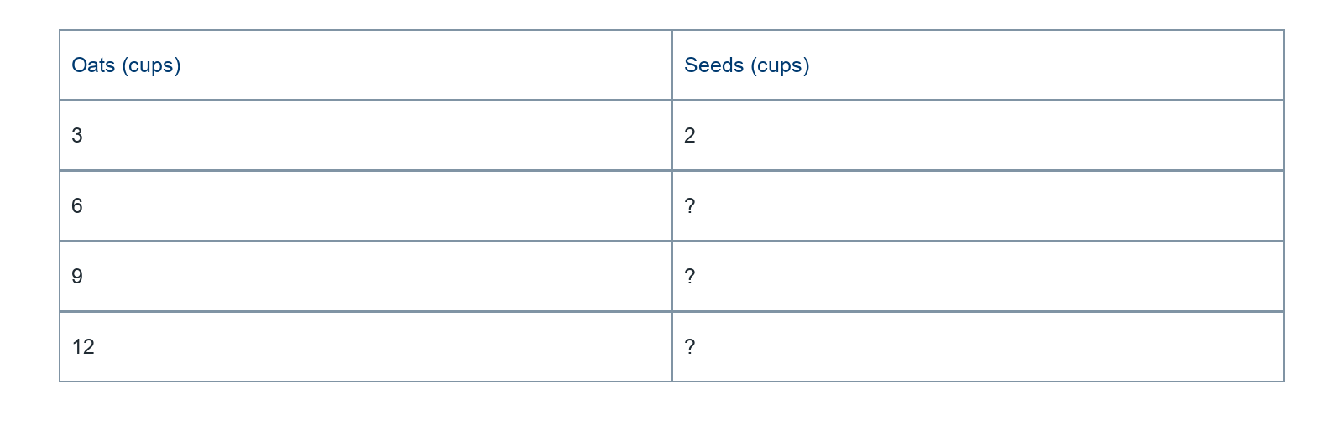
________________________________________________________________
________________________________________________________________
________________________________________________________________

Extend your reasoning
Find an equivalent pair with less than 3 cups of oats.
________________________________________________________________
________________________________________________________________
Self-check: Did my model, calculation, explanation, and units agree?

Session 2 · Model, reason, and explain
The Bridge Strategy (Scaling Ratios) · 6.RP.A.3a
Success: represent the quantities, justify the relationship, and check the result with the correct units.
A mixture uses 6 cups of nuts for 8 cups of raisins. Find the raisins for 15 cups of nuts using a bridge through 3 cups and using a scale factor. Compare the methods.
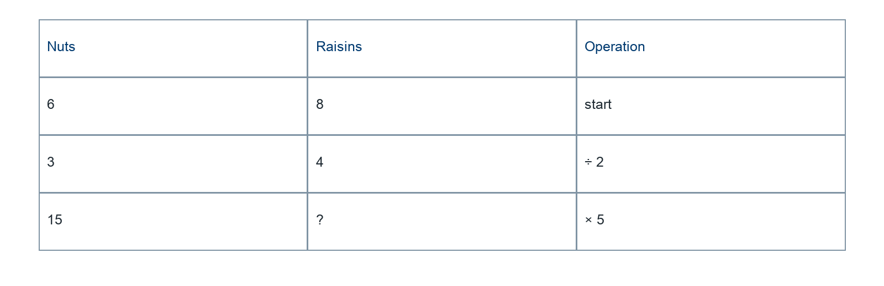
________________________________________________________________
________________________________________________________________
________________________________________________________________

Extend your reasoning
Which method is more efficient for 1.5 cups of nuts? Justify a valid method.
________________________________________________________________
________________________________________________________________
Self-check: Did my model, calculation, explanation, and units agree?

