Name Date Period
Lesson 3-4 · Session 1 · Guided Steps · Form A
Graphing Ratios on the Coordinate Plane
Learning target — I can turn a ratio into ordered pairs and plot them on a coordinate plane. · 6.RP.A.3a
REMEMBER
• An ordered pair (x, y) names one point. Go across x first, then up y.
• Each column of a ratio table is one point. Points from equivalent ratios form a straight line through (0, 0).
GUIDED PRACTICE fill in each blank — problems 1–4
1. Each bag holds 6 soccer balls (x = bags, y = balls). Write the ordered pair for:
a. 1 bag(s)  Step 1 1 × 6 = balls  Step 2 Pair: ( , ) | b. 3 bag(s)  Step 1 3 × 6 = balls  Step 2 Pair: ( , )

c. 4 bag(s)  Step 1 4 × 6 = balls  Step 2 Pair: ( , ) | d. 6 bag(s)  Step 1 6 × 6 = balls  Step 2 Pair: ( , )

2. Hiking Trail. Hikers climb 3 miles every hour (x = hours, y = miles).  Step 1 2 × 3 =  Step 2 3 × 3 =  Step 3 4 × 3 =  a. Complete: (1, 3), (2, ), (3, ), (4, )  Step 4 Plot each pair. Draw a line through (0, 0).  Step 5 6 × 3 =  c. Point for 6 hours: ( , ) | 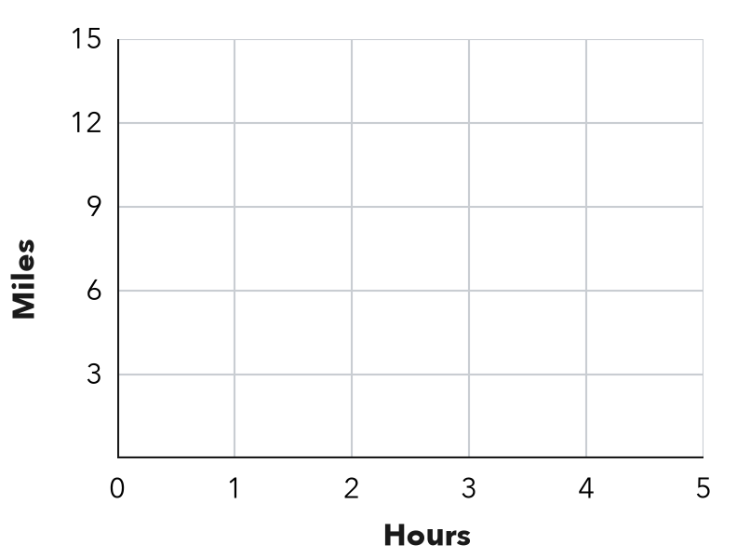

3. File Downloads. A computer downloads 5 GB every 2 minutes (x = minutes, y = GB).
Step 1 6 ÷ 2 = groups of 2 minutes
Step 2 × 5 = GB
a. Complete: (2, 5), (4, 10), (6, )
Step 3 10 ÷ 2 = groups of 2 minutes
Step 4 × 5 = GB
b. GB in 10 minutes: GB

4. Street Trees. A crew plants 7 trees on every block (x = blocks, y = trees).
Step 1 2 × 7 =
Step 2 3 × 7 =
Step 3 6 × 7 =
a. Complete: (1, 7), (2, ), (3, )
b. Point for 6 blocks: ( , )

ON YOUR OWN use the open space · show your work · label units
5. Allowance Savings. Maya saves $4 each week (x = weeks, y = dollars).  a. Complete: (1, 4), (2, ), (3, ), (5, )  b. Find y for the point (8, y). dollars  c. Plot your points and label the point for 8 weeks.  Show your work. | 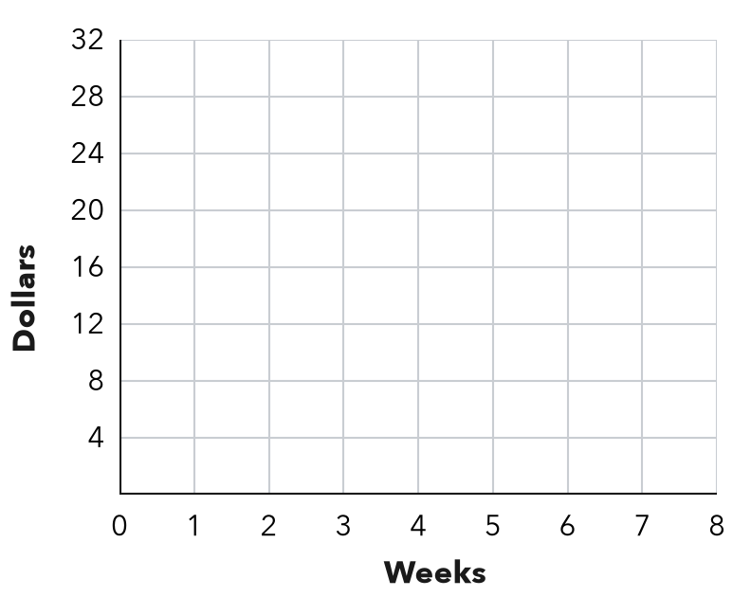

6. Poster Printing. A printer prints 8 posters each minute (x = minutes, y = posters).  a. Write the equation:  y =  b. What does (0, 0) mean here? | 7. Scooter Range. A scooter goes 15 miles on each battery charge (x = charges, y = miles). Which point is on its graph: (2, 25), (3, 45) or (4, 55)?  Show your work.  Answer Point ( , )

8. Two Stores. Store A sells notebooks at 3 for $6. Store B sells them at 4 for $10. Graph x = notebooks, y = cost.
a. Cost of 12 notebooks at each store:
Store A Store B
b. Whose line is steeper? What does steeper mean here?
Show your work.

FIND THE ERROR explain the mistake, then fix it
9. Chloe’s Work. A car travels 50 miles each hour (x = hours, y = miles). Chloe plotted the points (50, 1) and (100, 2). Explain her mistake and write the correct points.
Show your work.

TEST PRACTICE choose the best answer
10. In the ordered pair (4, 12), the number 4 is the —
A x-value B y-value C unit rate D origin

11. The ratio of x to y is 1 : 6. Which ordered pair has x = 3?
A (3, 9) B (3, 18) C (18, 3) D (6, 3)

CHECK YOURSELF
□ I can do this on my own □ I need a little help □ I have a question about #

