Name Date Period
Lesson 3-4 · Session 2 · Guided Steps · Form A
Interpreting Points on Ratio Graphs
Learning target — I can explain what a point on a ratio graph means in the situation it describes. · 6.RP.A.3a
REMEMBER
• A point (x, y) says x of one thing goes with y of another. Read the axis labels.
• The unit rate point is (1, r). If x is not 1, divide: for (3, 15), 15 ÷ 3 = 5, so (1, 5).
GUIDED PRACTICE fill in each blank — problems 1–4
1. Find the unit rate point (1, r) for a line through each point.
a. (3, 15)  Step 1 15 ÷ 3 =  Step 2 Point: ( 1 , ) | b. (4, 36)  Step 1 36 ÷ 4 =  Step 2 Point: ( 1 , )

c. (6, 15)  Step 1 15 ÷ 6 =  Step 2 Point: ( 1 , ) | d. (5, 40)  Step 1 40 ÷ 5 =  Step 2 Point: ( 1 , )

2. Lucy’s Charms. The graph shows bracelets (x) and charms (y).  a. (0, 0) means bracelets and charms  b. (1, 5) means bracelet and charms  Step 1 Unit rate: charms per bracelet  Step 2 9 × = charms  c. Charms for 9 bracelets: charms | 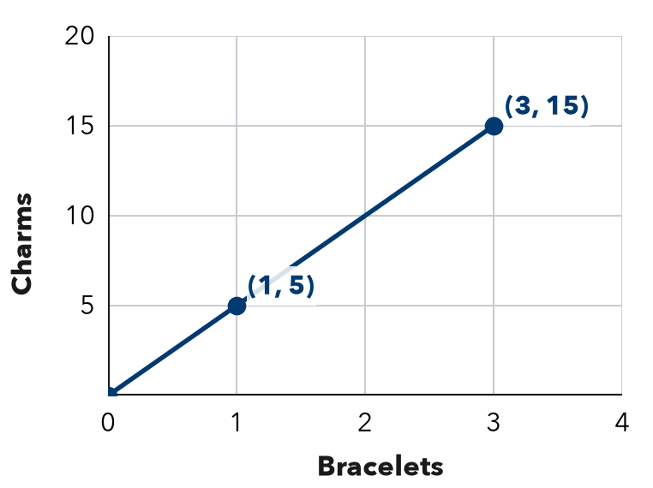

3. Water Pump. A graph of minutes (x) and gallons (y) passes through (1, 8) and (5, 40).
Step 1 40 ÷ 5 = gallons per minute
Step 2 5 minutes → gallons
Step 3 72 ÷ = minutes
a. Unit rate: gallons per minute
b. What does (5, 40) mean?
c. Minutes to pump 72 gallons: minutes

4. Snow Shoveling. A graph of driveways (x) and dollars (y) passes through (1, 9) and (4, 36). What is the pay for 11 driveways?
Step 1 36 ÷ 4 = (unit rate)
Step 2 11 × = dollars
Answer dollars

ON YOUR OWN use the open space · show your work · label units
5. Drone Flight. A graph of seconds (x) and meters (y) passes through (1, 12). What point shows 8 seconds?  Show your work.  Answer Point ( , ) | 6. Robot Speed. A graph of seconds (x) and meters (y) passes through (3, 12).  a. Unit rate point: ( 1 , )  b. Distance in 10 seconds: m  Show your work.

7. Bike Racks. A graph of racks (x) and spaces (y) passes through (4, 28). Find the unit rate point. Is (9, 63) on the line?  Show your work.  Unit rate point: ( 1 , )  Yes or no: | 8. Two Bike Riders. Both graphs show hours (x) and kilometers (y). Rider 1’s line passes through (3, 36). Rider 2’s passes through (4, 40).  a. Each rider’s unit rate: and  b. Whose line is steeper? What does that mean?  c. How far ahead is the faster rider after 6 hours? km  Show your work.

FIND THE ERROR explain the mistake, then fix it
9. Noah’s Work. A graph of items (x) and cost in dollars (y) passes through (1, 8). Noah says, “This means 8 items cost 1 dollar.” Explain his mistake and say what the point really means.
Show your work.

TEST PRACTICE choose the best answer
10. On a ratio graph, the point (1, 9) shows the —
A origin B x-value only C unit rate D total

11. A ratio graph passes through (5, 20). The unit rate is —
A 4 B 15 C 25 D 100

CHECK YOURSELF
□ I can do this on my own □ I need a little help □ I have a question about #

