Name Date Period
Lesson 3-4 · Session 2 · Guided Steps · Form B
Interpreting Points on Ratio Graphs
Learning target — I can explain what a point on a ratio graph means in the situation it describes. · 6.RP.A.3a
REMEMBER
• A point (x, y) says x of one thing goes with y of another. Read the axis labels.
• The unit rate point is (1, r). If x is not 1, divide: for (3, 15), 15 ÷ 3 = 5, so (1, 5).
GUIDED PRACTICE fill in each blank — problems 1–4
1. Find the unit rate point (1, r) for a line through each point.
a. (2, 14)  Step 1 14 ÷ 2 =  Step 2 Point: ( 1 , ) | b. (5, 30)  Step 1 30 ÷ 5 =  Step 2 Point: ( 1 , )

c. (4, 6)  Step 1 6 ÷ 4 =  Step 2 Point: ( 1 , ) | d. (3, 27)  Step 1 27 ÷ 3 =  Step 2 Point: ( 1 , )

2. Jalen’s Charms. The graph shows bracelets (x) and charms (y).  a. (0, 0) means bracelets and charms  b. (1, 4) means bracelet and charms  Step 1 Unit rate: charms per bracelet  Step 2 7 × = charms  c. Charms for 7 bracelets: charms | 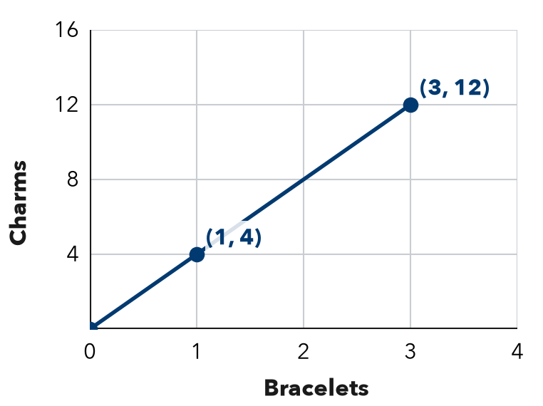

3. Water Pump. A graph of minutes (x) and gallons (y) passes through (1, 6) and (5, 30).
Step 1 30 ÷ 5 = gallons per minute
Step 2 5 minutes → gallons
Step 3 48 ÷ = minutes
a. Unit rate: gallons per minute
b. What does (5, 30) mean?
c. Minutes to pump 48 gallons: minutes

4. Snow Shoveling. A graph of driveways (x) and dollars (y) passes through (1, 12) and (4, 48). What is the pay for 7 driveways?
Step 1 48 ÷ 4 = (unit rate)
Step 2 7 × = dollars
Answer dollars

ON YOUR OWN use the open space · show your work · label units
5. Drone Flight. A graph of seconds (x) and meters (y) passes through (1, 11). What point shows 6 seconds?  Show your work.  Answer Point ( , ) | 6. Robot Speed. A graph of seconds (x) and meters (y) passes through (3, 15).  a. Unit rate point: ( 1 , )  b. Distance in 9 seconds: m  Show your work.

7. Bike Racks. A graph of racks (x) and spaces (y) passes through (3, 18). Find the unit rate point. Is (8, 48) on the line?  Show your work.  Unit rate point: ( 1 , )  Yes or no: | 8. Two Bike Riders. Both graphs show hours (x) and kilometers (y). Rider 1’s line passes through (2, 30). Rider 2’s passes through (3, 36).  a. Each rider’s unit rate: and  b. Whose line is steeper? What does that mean?  c. How far ahead is the faster rider after 5 hours? km  Show your work.

FIND THE ERROR explain the mistake, then fix it
9. Priya’s Work. A graph of tickets (x) and cost in dollars (y) passes through (1, 6). Priya says, “This means 6 tickets cost 1 dollar.” Explain her mistake and say what the point really means.
Show your work.

TEST PRACTICE choose the best answer
10. A point (3, 24) on a graph of boxes (x) and pens (y) means —
A 24 boxes hold 3 pens B 3 boxes hold 24 pens C each box holds 3 pens D there are 27 pens in all

11. A ratio graph passes through (6, 42). The unit rate is —
A 36 B 48 C 7 D 252

CHECK YOURSELF
□ I can do this on my own □ I need a little help □ I have a question about #

