Lesson 3.5 Guided Notes

Session 1 · Comparing Ratios with Common Terms
I can compare two ratios by scaling them until they share a common term. · 6.RP.A.3b
Word / Spanish | Meaning — complete the blank | Example
common multiple / múltiplo común | A number both terms can be ________ to. | 2 and 3 both reach 6
least common multiple / mínimo común múltiplo | The __________ number that is a multiple of both numbers. | LCM of 2 and 3 is 6
stronger / más fuerte | More of the main ingredient for the ______ amount of water. | 6 : 14 is stronger than 6 : 15

Key idea
To compare two ratios, scale them so one term is the ______ in both.
Then compare the _______ term. Less water for the same soap means a __________ mix.

Worked example
Mix A has 2 spoons of soap to 5 cups of water. Mix B has 3 spoons of soap to 7 cups of water. Which mix is stronger?
A common multiple of 2 and 3 is _____.
Mix A × 3 = 6 : _____. Mix B × 2 = 6 : _____.
Compare the water: 14 cups is less than 15 cups.
Answer: Mix _____ is stronger: less water for the same 6 spoons of soap.

You try
1. Tea A uses 2 bags for 9 cups of water. Tea B uses 3 bags for 12 cups. Scale both to 6 bags. Which tea is stronger?
________________________________________________________________
2. Scale each ratio so the first term is 20.
a. 4 : 7 = 20 : ______
b. 5 : 6 = 20 : ______
________________________________________________________________
Sum it up: To compare two ratios, I make ___ the same, and then I compare ___.
________________________________________________________________

Session 2 · Comparing Rates with Benchmarks
I can use a benchmark to compare two rates without dividing. · 6.RP.A.3b
Word / Spanish | Meaning — complete the blank | Example
benchmark / punto de referencia | A shared amount you scale ______ choices to. | 12 lb for both stores
rate / tasa | Compares two amounts with ___________ units. | $10 for 4 lb
unit rate / tasa unitaria | The amount for exactly _____. | $2.50 per lb

Key idea
Pick a benchmark that both amounts ________ into evenly, like 20 for 2 and 4.
Scale each rate to the benchmark, then _________ the results.

Worked example
Hose A fills 6 gallons in 2 minutes. Hose B fills 10 gallons in 4 minutes. Which hose fills faster?
Benchmark: _____ minutes for both hoses.
Hose A: 6 × 10 = _____ gallons. Hose B: 10 × 5 = _____ gallons.
Compare: 60 gallons > 50 gallons in the same 20 minutes.
Answer: Hose _____ fills faster.

You try
1. Store A: 3 lb for $8. Store B: 4 lb for $10. Use a 12-lb benchmark. Which is the better buy?
________________________________________________________________
2. Name a benchmark both amounts can reach.
a. 4 min and 6 min ______
b. 5 lb and 8 lb ______
________________________________________________________________
Sum it up: A benchmark helps me compare two rates because ___.
________________________________________________________________

Session 1 · Model, reason, and explain
Comparing Ratios with Common Terms · 6.RP.A.3b
Success: represent the quantities, justify the relationship, and check the result with the correct units.
Mix A uses 2 cups of concentrate for 5 cups of water. Mix B uses 3 cups for 7 cups of water. Compare them using 6 cups of concentrate in each. Which tastes stronger if strength means more concentrate per cup of water?
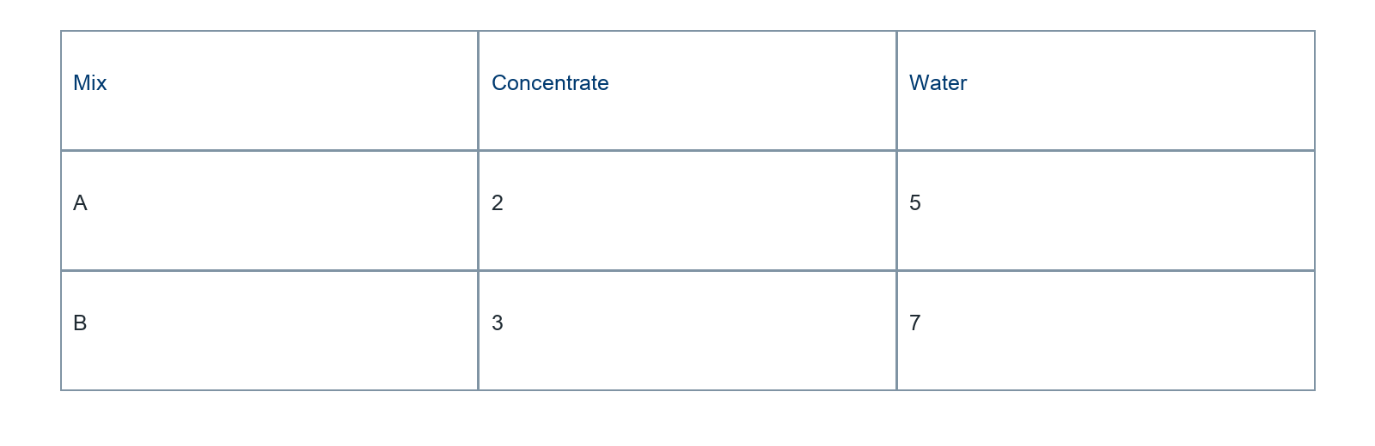
________________________________________________________________
________________________________________________________________
________________________________________________________________

Extend your reasoning
Could you compare using a common water amount instead? Show one valid comparison.
________________________________________________________________
________________________________________________________________
Self-check: Did my model, calculation, explanation, and units agree?

Session 2 · Model, reason, and explain
Comparing Rates with Benchmarks · 6.RP.A.3b
Success: represent the quantities, justify the relationship, and check the result with the correct units.
Hose A fills 8 gallons in 2 minutes; B fills 15 gallons in 5 minutes. Compare at 10 minutes and by unit rate. Explain why both methods agree.
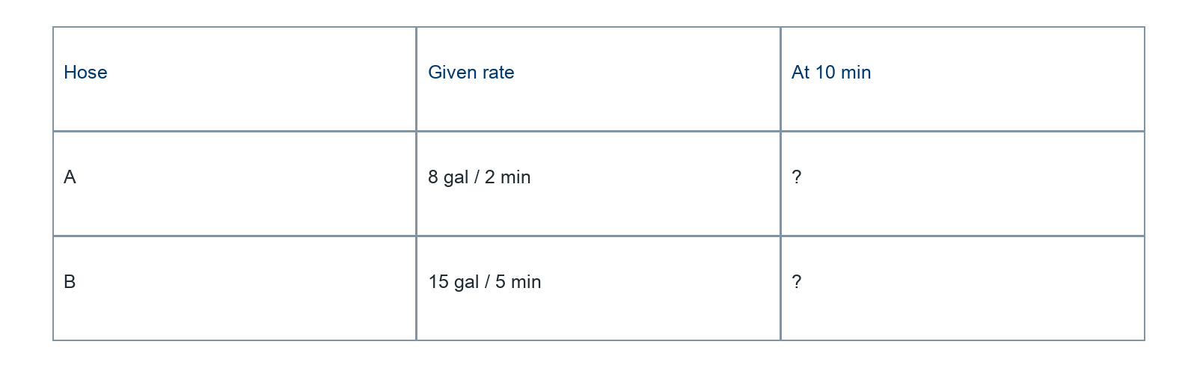
________________________________________________________________
________________________________________________________________
________________________________________________________________

Extend your reasoning
Give a different common-time benchmark and explain why it produces the same decision.
________________________________________________________________
________________________________________________________________
Self-check: Did my model, calculation, explanation, and units agree?

