Lesson 3.6 Guided Notes

Session 1 · Customary Unit Conversions
I can convert between customary units by multiplying or dividing by the conversion rate. · 6.RP.A.3d
Word / Spanish | Meaning — complete the blank | Example
customary units / unidades usuales | U.S. units like inches, ________, cups and gallons. | 12 in = 1 ft
convert / convertir | Write the same amount with a ___________ unit. | 6 ft = 72 in
conversion factor / factor de conversión | A fact that shows two _______ amounts. | 1 lb = 16 oz

Key idea
Big unit to small unit: __________. The number gets bigger.
Small unit to big unit: ________. The number gets smaller.

Worked example
A pitcher holds 2 quarts. How many fluid ounces is that? (1 qt = 4 cups, 1 cup = 8 fl oz)
Quarts to cups: 2 × 4 = _____ cups.
Cups to fluid ounces: 8 × 8 = _____ fl oz.
Check backward: 64 ÷ 8 = 8 cups, and 8 ÷ 4 = _____ quarts.
Answer: 2 quarts = _____ fluid ounces.

You try
1. Convert each measure.
a. 3 yd = ______ ft
b. 32 oz = ______ lb
________________________________________________________________
2. A banner needs 7 feet of fabric. Fabric is sold by the whole yard. How many yards should you buy? (1 yd = 3 ft)
________________________________________________________________
Sum it up: When I convert to a smaller unit, I ___ because ___.
________________________________________________________________

Session 2 · Metric Unit Conversions
I can convert between metric units by multiplying or dividing by powers of ten. · 6.RP.A.3d
Word / Spanish | Meaning — complete the blank | Example
metric units / unidades métricas | Meters, grams and liters, built on ______. | 1 km = 1,000 m
kilo- / centi- / milli- / kilo- / centi- / mili- | Kilo means _______ times. Centi means one hundredth. Milli means one thousandth. | km, cm, mL
powers of 10 / potencias de 10 | 10, 100, 1,000. Metric changes _______ the decimal point. | 3.5 m = 350 cm

Key idea
Big unit to small unit: __________ by 10, 100 or 1,000. Small to big: divide.
Make the units _______ before you divide or compare.

Worked example
A bag has 2.4 kg of flour. How many 300 g portions can you make? (1 kg = 1,000 g)
Make the units match: 2.4 × 1,000 = _______ g.
Divide: 2,400 ÷ 300 = _____.
Check: 8 × 300 = 2,400 g.
Answer: You can make _____ portions.

You try
1. Convert each measure.
a. 3.2 m = ______ cm
b. 750 g = ______ kg
________________________________________________________________
2. A tank holds 15 L of water. How many 750 mL jugs does it take to fill the tank? (1 L = 1,000 mL)
________________________________________________________________
Sum it up: To convert metric units, I move the decimal point because ___.
________________________________________________________________

Session 1 · Model, reason, and explain
Customary Unit Conversions · 6.RP.A.3d
Success: represent the quantities, justify the relationship, and check the result with the correct units.
A banner needs 8 feet of ribbon. Ribbon is sold only by the whole yard. Use 1 yard = 3 feet to find the exact length in yards and the purchase amount. Check whether 2 yards would be enough.

________________________________________________________________
________________________________________________________________
________________________________________________________________

Extend your reasoning
Explain why ounces of mass and fluid ounces of volume cannot be interchanged just because both use 'ounce'.
________________________________________________________________
________________________________________________________________
Self-check: Did my model, calculation, explanation, and units agree?

Session 2 · Model, reason, and explain
Metric Unit Conversions · 6.RP.A.3d
Success: represent the quantities, justify the relationship, and check the result with the correct units.
A container holds 1.5 liters. Cups hold 250 milliliters each. Complete the equivalent-measure table, find the number of cups, and explain why changing units does not change the amount of liquid.
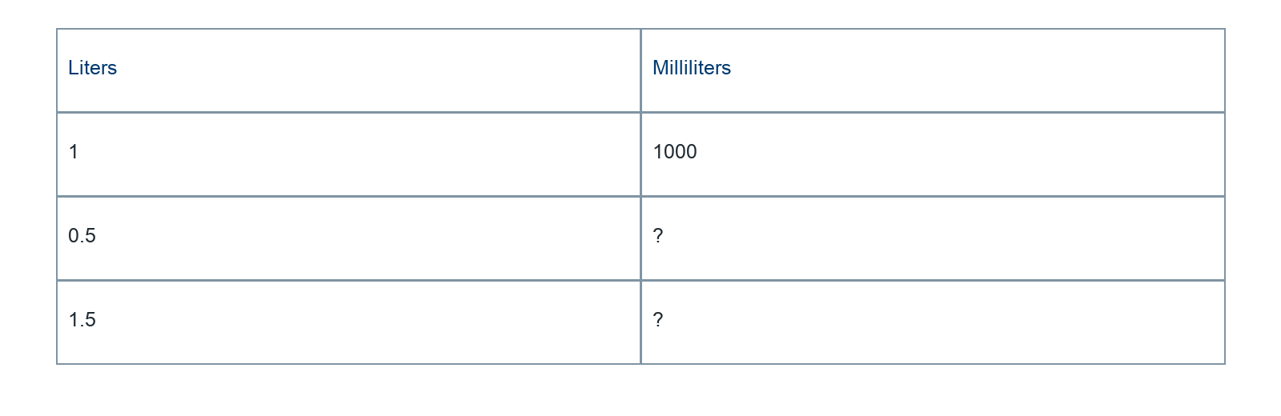
________________________________________________________________
________________________________________________________________
________________________________________________________________

Extend your reasoning
Explain 1.5 × 1000 by decomposing 1.5 into 1 + 0.5.
________________________________________________________________
________________________________________________________________
Self-check: Did my model, calculation, explanation, and units agree?

