Lesson 3.7 Guided Notes

Session 1 · Customary vs. Metric Conversions
I can convert a measurement between the customary and metric systems using a given rate. · 6.RP.A.3d
Word / Spanish | Meaning — complete the blank | Example
conversion factor / factor de conversión | A fact that _______ two units. | 1 m ≈ 3.28 ft
approximately / aproximadamente | About. The symbol ≈ means “about _______ to.” | 1 kg ≈ 2.2 lb
reasonableness / razonabilidad | Checking that your answer’s ______ makes sense. | bigger unit, smaller number

Key idea
Use the fact the problem gives. Many facts are rounded, so the answer is an __________.
Changing to a smaller unit, __________. Changing to a bigger unit, ________.

Worked example
A bag weighs 44 pounds. About how many kilograms is that? (1 kg ≈ 2.2 lb)
The fact: 1 kg ≈ _____ lb.
A kilogram is heavier than a pound, so the number gets smaller: ________.
44 ÷ 2.2 = 20. Check: 20 × 2.2 = 44.
Answer: 44 lb ≈ _____ kg.

You try
1. Convert. (1 kg ≈ 2.2 lb, 1 in = 2.54 cm)
a. 3 kg ≈ ______ lb
b. 10 in = ______ cm
________________________________________________________________
2. A fun run is 5 km long. About how many miles is that? (1 mi ≈ 1.6 km)
________________________________________________________________
Sum it up: To check that my conversion is reasonable, I ask ___.
________________________________________________________________

Session 2 · Multi-Step System Conversions and Dosage
I can solve a multi-step problem that requires converting units before using a rate. · 6.RP.A.3d
Word / Spanish | Meaning — complete the blank | Example
multi-step / de varios pasos | Do two or more operations in _______. | convert, then multiply
dose / dosis | The ________ of medicine to give. | 120 mg
per / por | For ______ one. | 4 mg per kg

Key idea
First change the given amount to the unit the ______ uses.
Write the ______ after every step so you know which operation comes next.

Worked example
A cat weighs 11 lb. The dose is 3 mg per kg. The syrup has 5 mg in each mL. How many mL? (1 kg ≈ 2.2 lb)
Pounds to kilograms: 11 ÷ 2.2 = _____ kg.
Dose: 5 kg × 3 mg per kg = _____ mg.
Syrup: 15 mg ÷ 5 mg per mL = _____ mL.
Answer: The cat gets _____ mL of syrup.

You try
1. Complete each step. (1 kg ≈ 2.2 lb)
a. 44 lb ≈ ______ kg
b. 20 kg × 3 mg per kg = ______ mg
________________________________________________________________
2. A garden bed is 4 ft by 6 ft. One bag of soil covers 8 square feet. How many bags are needed?
________________________________________________________________
Sum it up: In a multi-step problem, I convert first because ___.
________________________________________________________________

Session 1 · Model, reason, and explain
Customary vs. Metric Conversions · 6.RP.A.3d
Success: represent the quantities, justify the relationship, and check the result with the correct units.
Use 1 kilogram ≈ 2.2 pounds. A package weighs 15.4 pounds. Find its approximate mass in kilograms. Explain the operation, approximation symbol, and a reverse check.
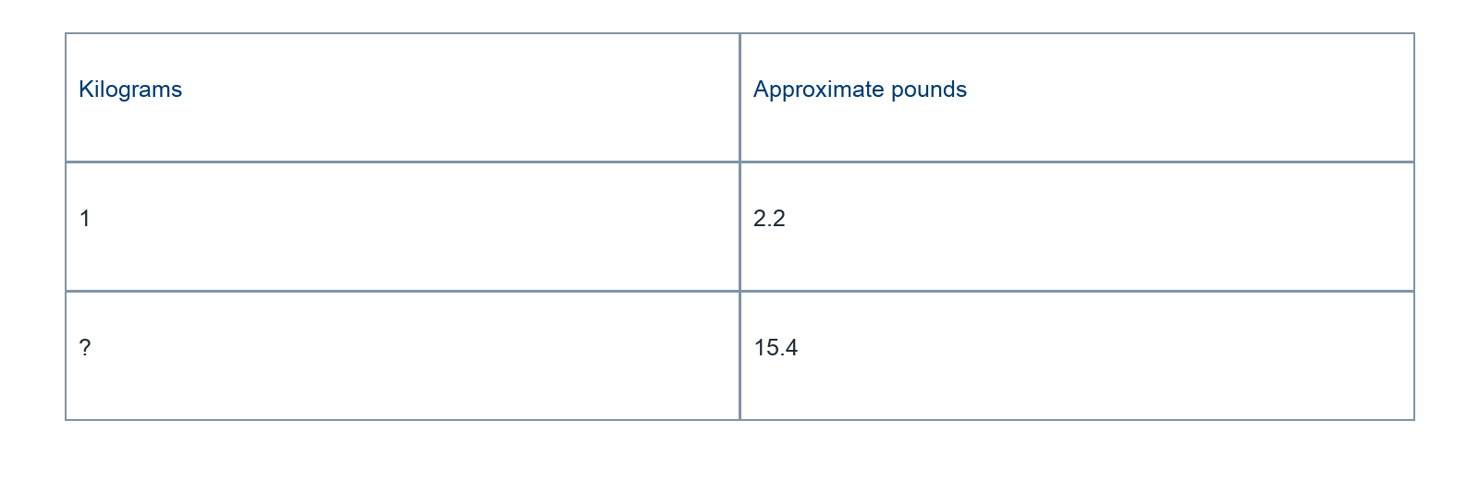
________________________________________________________________
________________________________________________________________
________________________________________________________________

Extend your reasoning
Why does exact division of the supplied numbers not make the real-world conversion exact?
________________________________________________________________
________________________________________________________________
Self-check: Did my model, calculation, explanation, and units agree?

Session 2 · Model, reason, and explain
Multi-Step System Conversions and Dosage · 6.RP.A.3d
Success: represent the quantities, justify the relationship, and check the result with the correct units.
A craft mixture uses 3 grams of pigment per kilogram of clay. You have 11 pounds of clay. Use 1 kg ≈ 2.2 lb. Pigment is supplied at 5 grams per scoop. About how many scoops are needed? Show a path through the units.
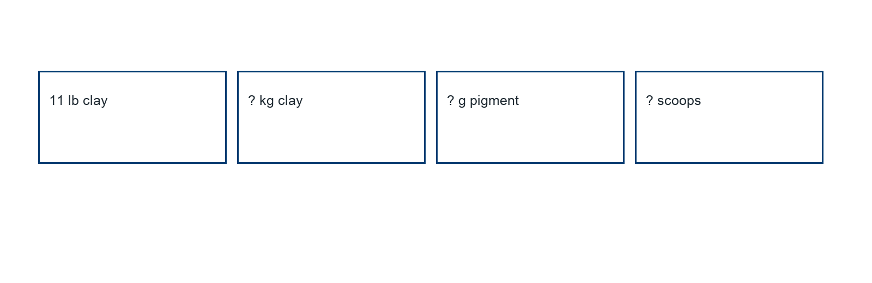
________________________________________________________________
________________________________________________________________
________________________________________________________________

Extend your reasoning
Explain why rounding a conversion too early can change the final amount in another problem.
________________________________________________________________
________________________________________________________________
Self-check: Did my model, calculation, explanation, and units agree?

