Name |  | Date |  | Period

Lesson 4-1 · Warm-Up

Warm-Up Practice
Understand Percent

The Move what this page practices
Write a hundredths amount as a fraction, a decimal, and a percent
Percent means per hundred. 37 out of 100 is 37/100, which is 0.37, which is 37%.
Simplify a fraction over 100
Divide the top and the bottom by the same number. 80/100 becomes 4/5 when both are divided by 20.
Worked Model we do this one together
Step 1 | 48 of the 100 squares on the grid are shaded.  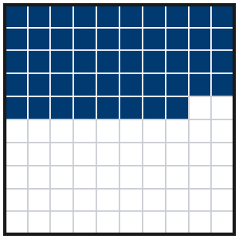
Step 2 | fraction = ______
Step 3 | decimal = ______
Step 4 | percent = ______
Your Turn 8 items · about 10 minutes
1. 29 of 100 squares are shaded. Fraction ______ Decimal ______ Percent ______
Answer
2. 7 of 100 squares are shaded. Fraction ______ Decimal ______ Percent ______
Answer
3. Write 0.83 as a percent. ______
Answer
4. Write 45% as a fraction over 100. ______
Answer
5. Write 60/100 in simplest form. ______
Answer
6. Write 8% as a decimal. ______
Answer
7. 20% of a 100-square grid is shaded. How many squares are NOT shaded? ______
Answer
8. One full 100-square grid is shaded, plus 25 squares on a second grid. Write the shaded amount as a percent. ______
Answer

