Name Date Period
Lesson 4-2 · Session 1 · Guided Steps · Form A
Fractions, Decimals, Percents
Learning target — I can write the same value as a fraction, a decimal, and a percent. · 6.AT.4
REMEMBER
• A percent means out of 100: 45% = 45/100 = 0.45.
• Fraction to percent: make the denominator 100. Simplify first if needed: 15/60 = 1/4 = 25%.
• Decimal to percent: read hundredths. 0.5 = 0.50 = 50%, not 5%.
GUIDED PRACTICE fill in each blank — problems 1–4
1. Write each value as a percent.
a. 0.6 =  Step 1 0.6 = 0.6  Step 2 0.6 = /100  Step 3 /100 = % | b. 9/20 =  Step 1 20 × = 100  Step 2 9 × =  Step 3 out of 100 = % | c. 0.08 =  Step 1 0.08 = hundredths  Step 2 out of 100 = %

d. 3/25 = % | e. 0.72 = % | f. 1/4 = %

2. Class Pet Vote. A class of 50 students voted for a class pet. 16 chose a hamster, 24 chose a fish, and the rest chose a turtle. Finish the bar, then complete the table.
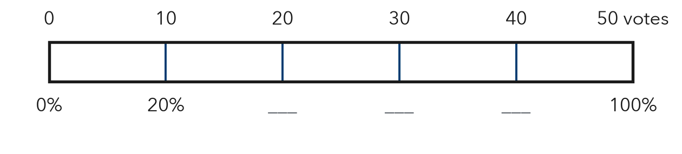
Step 1 Turtle votes: 50 − 16 − 24 =
 | Hamster | Fish | Turtle
Votes | 16 | 24
Fraction (simplest) | 16/50 = /25 | 24/50 = /25 | /50 = /
Decimal | 0. | 0. | 0.
Percent | % | % | %

3. Free Throws. Jordan made 12 of his 16 free throws.  a. Fraction in simplest form  Step 1 12 ÷ 4 = and 16 ÷ 4 =  Fraction:  b. Percent  Step 2 4 × = 100  Step 3 × =  Percent: % | 4. Phone Battery. Kayla’s phone shows 0.6 of a full charge.  a. Charge as a percent  Step 1 0.6 = hundredths  Step 2 out of 100 = %  Charge: %  b. Percent used up  Step 3 100 − = %  Used up: %

ON YOUR OWN use the open space · show your work · label units
5. Jacket Sale. A $40 jacket is on sale with a $26 discount (money taken off the price). Write the discount as a part of the price: a fraction in simplest form, a decimal, and a percent.  Show your work.  Answer , , % | 6. Bracelet Beads. A bracelet has 8 red beads and 12 blue beads.  a. Percent of the beads that are red %  b. That percent as a decimal  Show your work.

7. Step Counter. The grid shows how much of his step goal Naji reached.    a. Percent %  b. Decimal  c. Fraction in simplest form | 8. Three Surveys. Survey A: 0.45 of students ride the bus. B: 11/25 ride. C: 46% ride.  a. Write all three as percents.  A % B % C %  Show your work.  b. Order the surveys from least to greatest.  < <

FIND THE ERROR explain the mistake, then fix it
9. Priya’s Work. Priya wrote the decimal 0.08 as 80%. She said the digits look the same. Explain her mistake. Then write 0.08 correctly as a percent.
Show your work.

TEST PRACTICE choose the best answer
10. 0.8 written as a percent is —
A 8% B 0.8% C 80% D 800%

11. 1/4 written as a decimal is —
A 0.14 B 0.25 C 0.4 D 1.4

CHECK YOURSELF
□ I can do this on my own □ I need a little help □ I have a question about #

