Name Date Period
Lesson 4-2 · Session 1 · Guided Steps · Form B
Fractions, Decimals, Percents
Learning target — I can write the same value as a fraction, a decimal, and a percent. · 6.AT.4
REMEMBER
• A percent means out of 100: 45% = 45/100 = 0.45.
• Fraction to percent: make the denominator 100. Simplify first if needed: 15/60 = 1/4 = 25%.
• Decimal to percent: read hundredths. 0.5 = 0.50 = 50%, not 5%.
GUIDED PRACTICE fill in each blank — problems 1–4
1. Write each value as a percent.
a. 0.9 =  Step 1 0.9 = 0.9  Step 2 0.9 = /100  Step 3 /100 = % | b. 11/20 =  Step 1 20 × = 100  Step 2 11 × =  Step 3 out of 100 = % | c. 0.04 =  Step 1 0.04 = hundredths  Step 2 out of 100 = %

d. 6/25 = % | e. 0.38 = % | f. 3/4 = %

2. Field Trip Vote. A class of 40 students voted for a field trip. 14 chose a museum, 18 chose a zoo, and the rest chose a nature center. Finish the bar, then complete the table.
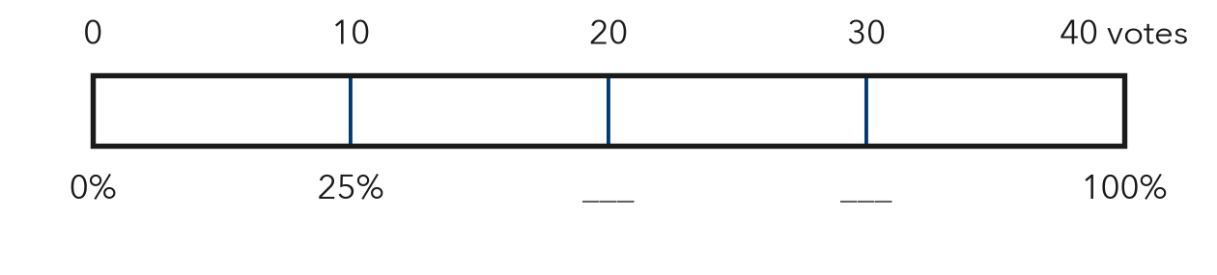
Step 1 Nature center votes: 40 − 14 − 18 =
 | Museum | Zoo | Nature center
Votes | 14 | 18
Fraction (simplest) | 14/40 = /20 | 18/40 = /20 | /40 = /
Decimal | 0. | 0. | 0.
Percent | % | % | %

3. Free Throws. Tasha made 15 of her 25 free throws.  a. Fraction in simplest form  Step 1 15 ÷ 5 = and 25 ÷ 5 =  Fraction:  b. Percent  Step 2 5 × = 100  Step 3 × =  Percent: % | 4. Phone Battery. Luis’s phone shows 0.35 of a full charge.  a. Charge as a percent  Step 1 0.35 = hundredths  Step 2 out of 100 = %  Charge: %  b. Percent used up  Step 3 100 − = %  Used up: %

ON YOUR OWN use the open space · show your work · label units
5. Jacket Sale. A $40 jacket is on sale with a $22 discount (money taken off the price). Write the discount as a part of the price: a fraction in simplest form, a decimal, and a percent.  Show your work.  Answer , , % | 6. Bracelet Beads. A bracelet has 6 green beads and 14 white beads.  a. Percent of the beads that are green %  b. That percent as a decimal  Show your work.

7. Step Counter. The grid shows how much of her step goal Imani reached.  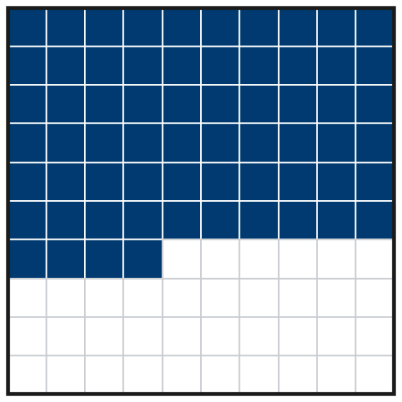  a. Percent %  b. Decimal  c. Fraction in simplest form | 8. Three Surveys. Survey A: 0.62 of students bring lunch. B: 3/5 bring lunch. C: 61% do.  a. Write all three as percents.  A % B % C %  Show your work.  b. Order the surveys from least to greatest.  < <

FIND THE ERROR explain the mistake, then fix it
9. Maya’s Work. Maya wrote the decimal 0.7 as 7%. She said the digit looks the same. Explain her mistake. Then write 0.7 correctly as a percent.
Show your work.

TEST PRACTICE choose the best answer
10. 0.3 written as a percent is —
A 3% B 0.3% C 30% D 300%

11. 3/4 written as a decimal is —
A 0.34 B 0.75 C 0.43 D 3.4

CHECK YOURSELF
□ I can do this on my own □ I need a little help □ I have a question about #

