Name Date Period
Lesson 4-2 · Session 2 · Guided Steps · Form A
Compare and Order
Learning target — I can compare and order values written as fractions, decimals, and percents. · 6.AT.4
REMEMBER
• To compare, write every value in the same form. Percents work well.
• Hundredths are the bridge: 0.6 = 0.60 = 60%, not 6%.
• If the denominator does not go into 100, divide: 3 ÷ 8 = 0.375 = 37.5%. Equal values tie.
GUIDED PRACTICE fill in each blank — problems 1–4
1. Write <, >, or = in each blank.
a. 0.8 79%  Step 1 0.8 = 0.8 = %  Step 2 0.8 79% | b. 2/5 0.45  Step 1 5 × = 100  Step 2 2/5 = %  Step 3 0.45 = %  Step 4 2/5 0.45 | c. 0.7 7/10  Step 1 0.7 = %  Step 2 7/10 = %  Step 3 0.7 7/10

d. 1/4 0.3 | e. 0.05 50% | f. 3/4 72%

2. Field Day Course. Four teams finished this much of an obstacle course: Red 0.9, Blue 4/5, Green 86%, Gold 7/10.
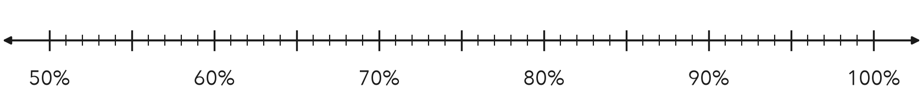
a. Write each team’s part as a percent. Mark it on the line.
 | Red | Blue | Green | Gold
Given | 0.9 | 4/5 | 86% | 7/10
Over 100 | 0.9 = /100 | 4/5 = /100 | 86/100 | 7/10 = /100
Percent | % | % | % | %

b. Order the teams from least finished to most finished.
< < <

3. Quiz Scores. Three quiz scores: 0.76, 18/25, and 79%.  a. All three as percents  Step 1 0.76 = %  Step 2 25 × = 100  Step 3 18 × = %  b. Which score is lowest?  Lowest: | 4. Rainfall. Three months got these parts of the year’s rain: 0.12, 3/20, 9%.  a. All three as percents  Step 1 0.12 = %  Step 2 20 × = 100  Step 3 3 × = %  b. Which share is greatest?  Greatest:

ON YOUR OWN use the open space · show your work · label units
5. Ordering Claim. Zoe says 0.4 is less than 39% because 4 is less than 39. Is Zoe right? Explain.  Show your work.  Zoe is | 6. Card Collection. In a card set, 0.35 of the cards are heroes, 2/5 are villains, and 25% are sidekicks. Which group is largest?  Show your work.  Largest group

7. Homework Turn-In. Three classes turned in 0.36, 9/25, and 34% of their work.  a. Write each value as a percent.  % % %  b. Order the values from least to greatest.  < <  c. Which two values tie? At what percent?  and ; %  Show your work. | 8. Reading Goals. Parts of a book finished: Ana 0.62, Ben 5/8, Cal 61%, Dee 3/5.  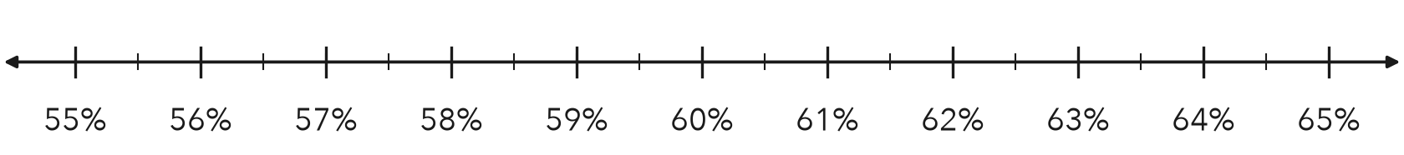  a. Write each part as a percent. Mark it on the line.  % % % %  b. Order the students from least to greatest.  < < <

FIND THE ERROR explain the mistake, then fix it
9. Owen’s Work. Owen ordered 0.55, 61%, and 3/5. He wrote: “3/5 is the smallest because 3 is the smallest number.” Explain his mistake. Then order the values correctly.
Show your work.

TEST PRACTICE choose the best answer
10. Which is greater, 0.9 or 85%?
A 0.9 B 85% C They are equal. D You cannot tell.

11. Which is least: 0.3, 1/4, or 28%?
A 0.3 B 28% C 1/4 D They are equal.

CHECK YOURSELF
□ I can do this on my own □ I need a little help □ I have a question about #

