Name Date Period
Lesson 4-2 · Session 2 · Practice · Form A

Compare and Order
Learning target — I can compare and order values written as fractions, decimals, and percents. · 6.AT.4

REMEMBER  • To compare, write every value in the same form. Percents work well.  • Hundredths are the bridge: 0.6 = 0.60 = 60%, not 6%.  • If the denominator does not go into 100, divide: 3 ÷ 8 = 0.375 = 37.5%. Equal values tie. | WORKED EXAMPLE  Order 0.7, 3/5, and 65% from least to greatest.  Step 1 0.7 = 0.70 = 70%  Step 2 3/5 = 60/100 = 60%  Step 3 Compare: 60% < 65% < 70%  Answer 3/5, 65%, 0.7
WORDS common form (forma común) · benchmark (punto de referencia) · order (orden)

PRACTICE show your work · label units

1. Write <, >, or = in each blank.
a. 0.8 79% | b. 2/5 0.45 | c. 0.7 7/10
d. 1/4 0.3 | e. 0.05 50% | f. 3/4 72%

2. Field Day Course. Four teams finished this much of an obstacle course: Red 0.9, Blue 4/5, Green 86%, Gold 7/10.
Hint Write 4/5 and 7/10 with a denominator of 100.
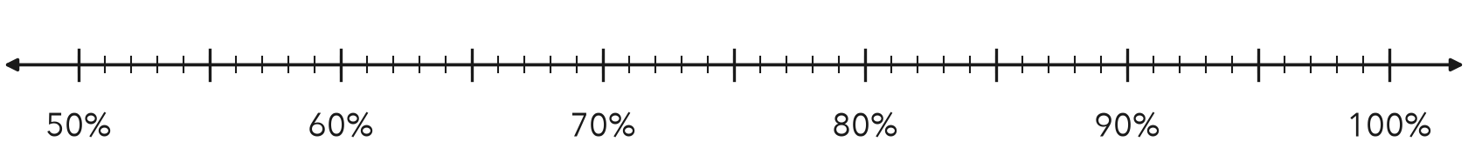
a. Write each team’s part as a percent. Mark it on the line.
b. Order the teams from least finished to most finished.

3. Quiz Scores. Three quiz scores: 0.76, 18/25, and 79%.  a. All three as percents  b. Which score is lowest? | 4. Rainfall. Three months got these parts of the year’s rain: 0.12, 3/20, 9%.  Hint 3/20 = 15/100.  a. All three as percents  b. Which share is greatest?
  Show your work.
  Show your work.

5. Ordering Claim. Zoe says 0.4 is less than 39% because 4 is less than 39. Is Zoe right? Explain.  Hint Write 0.4 as hundredths.  Zoe is | 6. Card Collection. In a card set, 0.35 of the cards are heroes, 2/5 are villains, and 25% are sidekicks. Which group is largest?  Hint Write each part as a percent.  Largest group
  Show your work.
  Show your work.

7. Homework Turn-In. Three classes turned in 0.36, 9/25, and 34% of their work.
a. Write each value as a percent.
b. Order the values from least to greatest.
c. Which two values tie? At what percent?

8. Reading Goals. Parts of a book finished: Ana 0.62, Ben 5/8, Cal 61%, Dee 3/5.
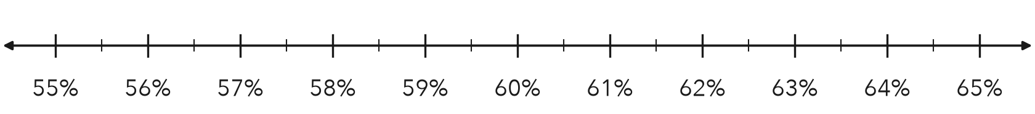
a. Write each part as a percent. Mark it on the line.
b. Order the students from least to greatest.

FIND THE ERROR explain the mistake, then fix it

9. Owen’s Work. Owen ordered 0.55, 61%, and 3/5. He wrote: “3/5 is the smallest because 3 is the smallest number.” Explain his mistake. Then order the values correctly.

TEST PRACTICE choose the best answer

10. Which is greater, 0.9 or 85%?
A 0.9 | B 85% | C They are equal. | D You cannot tell.

11. Which is least: 0.3, 1/4, or 28%?
A 0.3 | B 28% | C 1/4 | D They are equal.

SELF-CHECK CODE find your answer · copy its letter into that problem’s box · spell a math word
40%  L | 3/20  A | 18/25  V | villains  U | 62.5%  S | 36%  E | 58%  Q | heroes  Z | 39%  X

#3b | #4b | #5 | #6 | #7c | #8a

CHECK YOURSELF | □ I can do this on my own | □ I need a little help | □ I have a question about #

