Name Date Period
Lesson 4-2 · Session 2 · Guided Steps · Form B
Compare and Order
Learning target — I can compare and order values written as fractions, decimals, and percents. · 6.AT.4
REMEMBER
• To compare, write every value in the same form. Percents work well.
• Hundredths are the bridge: 0.6 = 0.60 = 60%, not 6%.
• If the denominator does not go into 100, divide: 3 ÷ 8 = 0.375 = 37.5%. Equal values tie.
GUIDED PRACTICE fill in each blank — problems 1–4
1. Write <, >, or = in each blank.
a. 0.9 89%  Step 1 0.9 = 0.9 = %  Step 2 0.9 89% | b. 3/5 0.65  Step 1 5 × = 100  Step 2 3/5 = %  Step 3 0.65 = %  Step 4 3/5 0.65 | c. 0.4 2/5  Step 1 0.4 = %  Step 2 2/5 = %  Step 3 0.4 2/5

d. 1/5 0.25 | e. 0.07 70% | f. 4/5 78%

2. Charity Walk. Four teams finished this much of a charity walk: Maple 0.85, Oak 9/10, Pine 83%, Cedar 3/4.
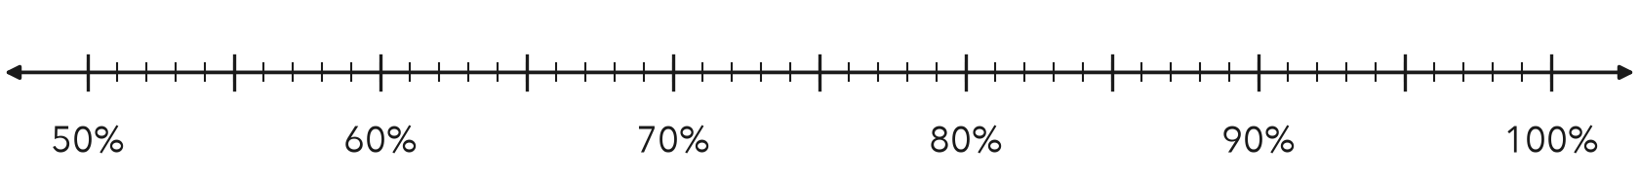
a. Write each team’s part as a percent. Mark it on the line.
 | Maple | Oak | Pine | Cedar
Given | 0.85 | 9/10 | 83% | 3/4
Over 100 | 0.85 = /100 | 9/10 = /100 | 83/100 | 3/4 = /100
Percent | % | % | % | %

b. Order the teams from least finished to most finished.
< < <

3. Test Scores. Three test scores: 0.88, 21/25, and 86%.  a. All three as percents  Step 1 0.88 = %  Step 2 25 × = 100  Step 3 21 × = %  b. Which score is lowest?  Lowest: | 4. Snowfall. Three months got these parts of the year’s snow: 0.14, 4/25, 11%.  a. All three as percents  Step 1 0.14 = %  Step 2 25 × = 100  Step 3 4 × = %  b. Which share is greatest?  Greatest:

ON YOUR OWN use the open space · show your work · label units
5. Ordering Claim. Malik says 0.3 is less than 29% because 3 is less than 29. Is Malik right? Explain.  Show your work.  Malik is | 6. Sticker Book. In a sticker book, 0.45 of the stickers are animals, 3/10 are stars, and 25% are hearts. Which group is largest?  Show your work.  Largest group

7. Library Returns. Three classes returned 0.48, 12/25, and 46% of their library books.  a. Write each value as a percent.  % % %  b. Order the values from least to greatest.  < <  c. Which two values tie? At what percent?  and ; %  Show your work. | 8. Reading Goals. Parts of a book finished: Eli 0.84, Fay 7/8, Gus 86%, Hana 4/5.  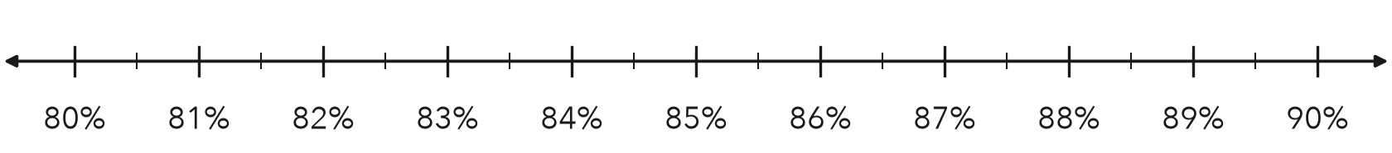  a. Write each part as a percent. Mark it on the line.  % % % %  b. Order the students from least to greatest.  < < <

FIND THE ERROR explain the mistake, then fix it
9. Nadia’s Work. Nadia ordered 0.75, 82%, and 4/5. She wrote: “4/5 is the smallest because 4 is the smallest number.” Explain her mistake. Then order the values correctly.
Show your work.

TEST PRACTICE choose the best answer
10. Which is greater, 0.4 or 38%?
A 0.4 B 38% C They are equal. D You cannot tell.

11. Which is least: 0.53, 1/2, or 51%?
A 0.53 B 51% C 1/2 D They are equal.

CHECK YOURSELF
□ I can do this on my own □ I need a little help □ I have a question about #

