Name Date Period
Lesson 4-2 · Session 2 · Practice · Form B

Compare and Order
Learning target — I can compare and order values written as fractions, decimals, and percents. · 6.AT.4

REMEMBER  • To compare, write every value in the same form. Percents work well.  • Hundredths are the bridge: 0.6 = 0.60 = 60%, not 6%.  • If the denominator does not go into 100, divide: 3 ÷ 8 = 0.375 = 37.5%. Equal values tie. | WORKED EXAMPLE  Order 0.7, 3/5, and 65% from least to greatest.  Step 1 0.7 = 0.70 = 70%  Step 2 3/5 = 60/100 = 60%  Step 3 Compare: 60% < 65% < 70%  Answer 3/5, 65%, 0.7
WORDS common form (forma común) · benchmark (punto de referencia) · order (orden)

PRACTICE show your work · label units

1. Write <, >, or = in each blank.
a. 0.9 89% | b. 3/5 0.65 | c. 0.4 2/5
d. 1/5 0.25 | e. 0.07 70% | f. 4/5 78%

2. Charity Walk. Four teams finished this much of a charity walk: Maple 0.85, Oak 9/10, Pine 83%, Cedar 3/4.
Hint Write 9/10 and 3/4 with a denominator of 100.
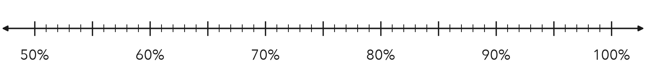
a. Write each team’s part as a percent. Mark it on the line.
b. Order the teams from least finished to most finished.

3. Test Scores. Three test scores: 0.88, 21/25, and 86%.  a. All three as percents  b. Which score is lowest? | 4. Snowfall. Three months got these parts of the year’s snow: 0.14, 4/25, 11%.  Hint 4/25 = 16/100.  a. All three as percents  b. Which share is greatest?
  Show your work.
  Show your work.

5. Ordering Claim. Malik says 0.3 is less than 29% because 3 is less than 29. Is Malik right? Explain.  Hint Write 0.3 as hundredths.  Malik is | 6. Sticker Book. In a sticker book, 0.45 of the stickers are animals, 3/10 are stars, and 25% are hearts. Which group is largest?  Hint Write each part as a percent.  Largest group
  Show your work.
  Show your work.

7. Library Returns. Three classes returned 0.48, 12/25, and 46% of their library books.
a. Write each value as a percent.
b. Order the values from least to greatest.
c. Which two values tie? At what percent?

8. Reading Goals. Parts of a book finished: Eli 0.84, Fay 7/8, Gus 86%, Hana 4/5.
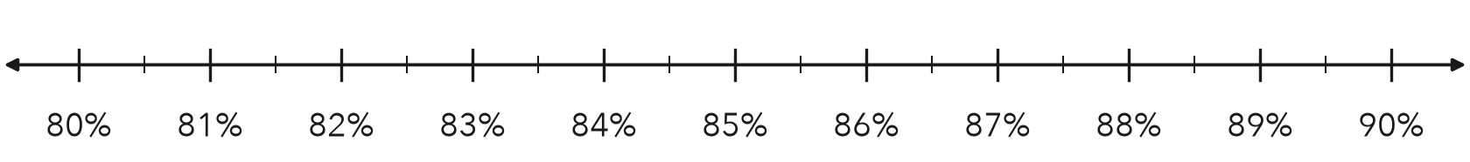
a. Write each part as a percent. Mark it on the line.
b. Order the students from least to greatest.

FIND THE ERROR explain the mistake, then fix it

9. Nadia’s Work. Nadia ordered 0.75, 82%, and 4/5. She wrote: “4/5 is the smallest because 4 is the smallest number.” Explain her mistake. Then order the values correctly.

TEST PRACTICE choose the best answer

10. Which is greater, 0.4 or 38%?
A 0.4 | B 38% | C They are equal. | D You cannot tell.

11. Which is least: 0.53, 1/2, or 51%?
A 0.53 | B 51% | C 1/2 | D They are equal.

SELF-CHECK CODE find your answer · copy its letter into that problem’s box · spell a math word
30%  A | 3%  X | 78%  Q | animals  R | 4/25  H | stars  Z | 48%  E | 21/25  S | 87.5%  S

#3b | #4b | #5 | #6 | #7c | #8a

CHECK YOURSELF | □ I can do this on my own | □ I need a little help | □ I have a question about #

