Name Date Period
Lesson 4-2 · Session 1 · Guided Notes

Fractions, Decimals, Percents
Learning target — I can write the same value as a fraction, a decimal, and a percent. · 6.AT.4

WORDS TO KNOW fill in the missing words
WORD | WHAT IT MEANS | EXAMPLE
percent  por ciento | A ratio that compares a number to . | 45% = 45/100 = 0.45
equivalent  equivalente | Names the amount in a different way. | 3/4 = 0.75 = 75%
hundredths  centésimas | Parts out of 100; the place after the point. | 0.09 = 9 hundredths = 9%

KEY IDEA complete each sentence
• Fraction to percent: make an equivalent fraction with a denominator of .
• Decimal to percent: read the decimal in , so 0.4 = 0.40 = 40%.
• Percent to fraction: write the percent over 100, then .

WORKED EXAMPLE fill in the blanks as we solve
20 students voted for a class color. 7 chose green. Write the green votes three ways.
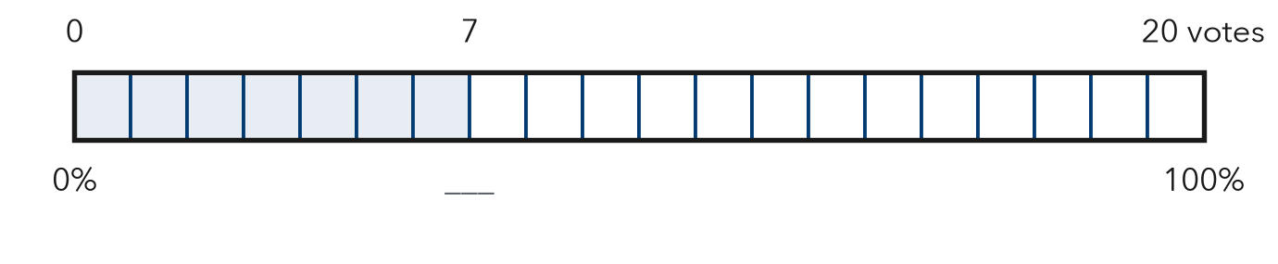
Step 1 Fraction, part over whole: .
Step 2 20 × = 100, so 7/20 = 35/100.
Step 3 35/100 = as a decimal.
Answer 7/20 = 0.35 =

YOU TRY use the example as a model

1. Write each value as a percent.
a. 3/5 = | b. 0.08 = | c. 0.7 =

2. A tank is 92% full, as the grid shows. Write 92% as a decimal and as a fraction in simplest form.  Decimal, fraction | 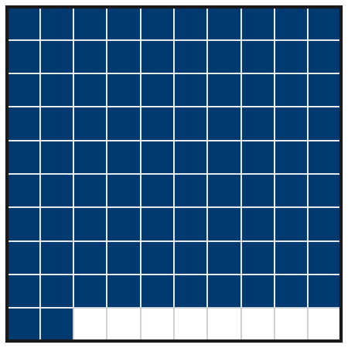

SUM IT UP in your own words
To write a fraction as a percent, I because .
Name Date Period
Lesson 4-2 · Session 2 · Guided Notes

Compare and Order
Learning target — I can compare and order values written as fractions, decimals, and percents. · 6.AT.4

WORDS TO KNOW fill in the missing words
WORD | WHAT IT MEANS | EXAMPLE
common form  forma común | Every value written the way before you compare. | 0.7, 3/5, 65% as 70%, 60%, 65%
benchmark  punto de referencia | An easy number you know well, used to other numbers. | 1/2 = 50%
order  orden | To list numbers from to greatest, or greatest to least. | 0.2, 35%, 1/2

KEY IDEA complete each sentence
• To compare a fraction, a decimal and a percent, first write them all as .
• After you order the percents, write the list with the numbers.

WORKED EXAMPLE fill in the blanks as we solve
Order 0.7, 3/5, and 65% from least to greatest.
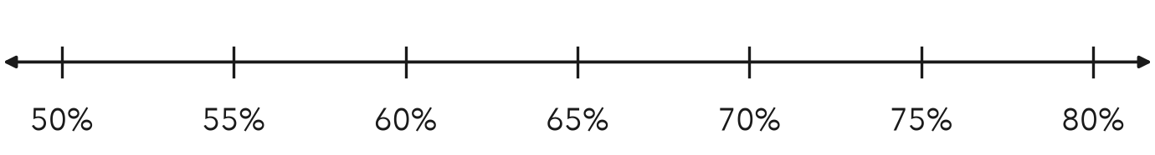
Step 1 0.7 = 0.70 =
Step 2 3/5 = 60/100 =
Step 3 Compare: 60% < 65% < 70%
Answer Least to greatest: , 65%, 0.7

YOU TRY use the example as a model

1. Write <, >, or = in each blank.
a. 0.3 1/4 | b. 0.45 45% | c. 7/20 0.4

2. Order 0.62, 3/5, and 61% from least to greatest.

Show your work.
Order

SUM IT UP in your own words
To order a fraction, a decimal, and a percent, I first because .
Name Date Period
Lesson 4-2 · Guided Notes · Model, Reason, Explain

Model It. Explain It.

SESSION 1 · FRACTIONS, DECIMALS, PERCENTS draw it · solve it · explain it
A pizza is cut into 8 equal slices. Mia eats 3 slices. Fill in the percent row on the bar. Then write the part she ate as a fraction, a decimal, and a percent.
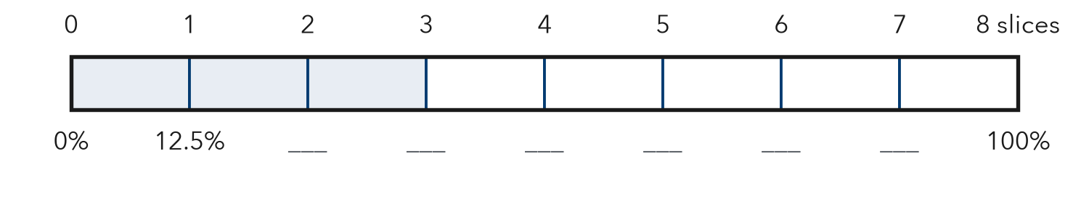
a. What percent is 1 slice? What percent are 3 slices?
b. Write 3/8 as a decimal.
c. Explain how you know.
Challenge Sam says 3/8 = 38% because you put the 3 and the 8 together. Use the bar to show why Sam is wrong.

SESSION 2 · COMPARE AND ORDER draw it · solve it · explain it
Class A recycled 0.45 of its bottles. Class B recycled 2/5. Class C recycled 48%. Mark each value on the number line. Then order the classes from least to greatest.
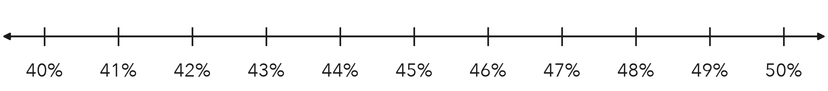
a. Write each value as a percent.
b. Order the classes from least to greatest.
c. Explain how you know.
Challenge Leo says 2/5 is greater than 0.45 because 5 is greater than 4. Show why Leo is wrong.
Check: Does my model match my numbers? Did I label units? Does my answer make sense?

