Name Date Period
Lesson 4-3 · Session 1 · Guided Steps · Form A
Estimate with Benchmarks
Learning target — I can estimate a percent by comparing an amount to benchmark percents. · 6.AT.4
REMEMBER
• Benchmarks: 10%, 25%, 50%, 75%, 100%. Build other benchmarks from 10%: 20% = 2 × 10%, 30% = 3 × 10%.
• Name the whole (100%). 50% = half, 25% = whole ÷ 4, 10% = whole ÷ 10.
• Pick the benchmark amount closest to the part. Percent left = 100% − percent used.
GUIDED PRACTICE fill in each blank — problems 1–4
1. About what percent? Name the closest benchmark: 10%, 25%, 50%, 75%, or 100%.
a. 41 out of 80 ≈  Step 1 50% of 80 =  Step 2 25% of 80 =  Step 3 41 is close to  Step 4 About % | b. 31 out of 120 ≈  Step 1 50% of 120 =  Step 2 25% of 120 =  Step 3 31 is close to  Step 4 About % | c. 19 out of 40 ≈  Step 1 50% of 40 =  Step 2 25% of 40 =  Step 3 19 is close to  Step 4 About %

d. 47 out of 64 ≈ % | e. 13 out of 120 ≈ % | f. 58 out of 60 ≈ %

2. Reading Goal. Ana’s goal is 240 pages this month. She has read 118 pages. Fill in the double number line. Then estimate the percent of her goal read.
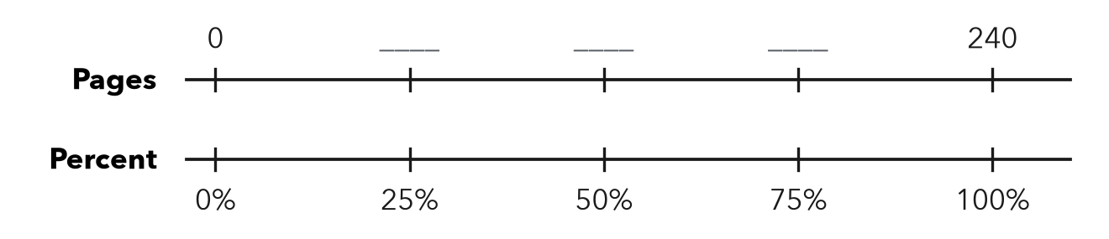
Step 1 240 ÷ 4 = pages
Step 2 50% of 240 = pages
Step 3 118 is close to pages
About %

3. Class Fundraiser. A class wants to raise $400. So far it has raised $310.  a. 10% of the goal  Step 1 400 ÷ 10 =  10% of the goal: $  b. About what percent?  Step 2 75% of $400 =  Step 3 $310 is close to $  About % | 4. Gym Water Jug. A water jug holds 32 cups. It has 17 cups left.  a. Half of the jug, in cups  Step 1 32 ÷ =  Half of the jug: cups  b. Percent left: about  Step 2 17 is close to cups  Step 3 That is about % left  About %

ON YOUR OWN use the open space · show your work · label units
5. Trail Progress. A hiking trail is 36 km long. A hiker has walked 27 km.  a. Percent walked: about %  b. Percent left: %  Show your work. | 6. Estimate Check. Kwame says 19 out of 60 is about 50%. Is he right? Use 10% of 60 to find a better estimate.  Show your work.  Better estimate %

7. Book List. Jo’s list has 40 books. She has read 34. Fill in the bar.  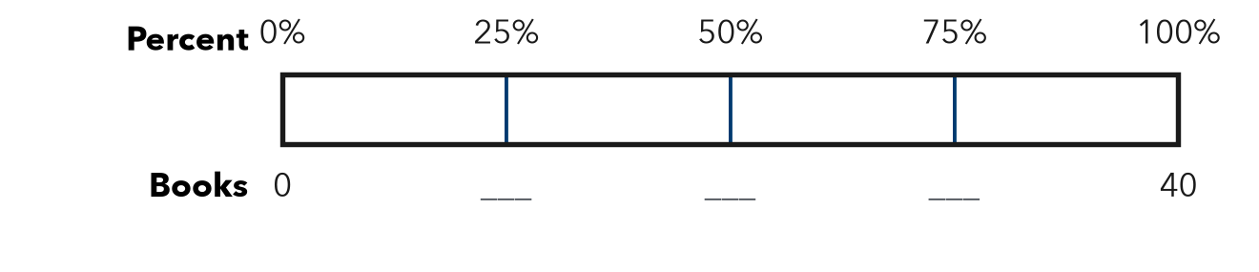  a. Between which two benchmarks is 34 out of 40?  between and  b. Which benchmark is it closer to?  closer to % | 8. Chorus Tickets. A chorus printed 480 tickets for its concert. It has sold 47 of them.  a. About what percent are sold? %  b. About what percent are not sold? %  Show your work.

FIND THE ERROR explain the mistake, then fix it
9. Elena’s Work. A 200 GB drive has 150 GB used. 30 GB of that is music. Elena says music is about 75% of the drive. Explain her mistake. Estimate the percent that is music.
Show your work.

TEST PRACTICE choose the best answer
10. 10% of an amount is the same as —
A one half B one tenth C one fourth D ten times it

11. 14 out of 60 is about —
A 10% B 25% C 50% D 75%

CHECK YOURSELF
□ I can do this on my own □ I need a little help □ I have a question about #

