Name Date Period
Lesson 4-3 · Session 1 · Guided Steps · Form B
Estimate with Benchmarks
Learning target — I can estimate a percent by comparing an amount to benchmark percents. · 6.AT.4
REMEMBER
• Benchmarks: 10%, 25%, 50%, 75%, 100%. Build other benchmarks from 10%: 20% = 2 × 10%, 30% = 3 × 10%.
• Name the whole (100%). 50% = half, 25% = whole ÷ 4, 10% = whole ÷ 10.
• Pick the benchmark amount closest to the part. Percent left = 100% − percent used.
GUIDED PRACTICE fill in each blank — problems 1–4
1. About what percent? Name the closest benchmark: 10%, 25%, 50%, 75%, or 100%.
a. 29 out of 60 ≈  Step 1 50% of 60 =  Step 2 25% of 60 =  Step 3 29 is close to  Step 4 About % | b. 21 out of 80 ≈  Step 1 50% of 80 =  Step 2 25% of 80 =  Step 3 21 is close to  Step 4 About % | c. 59 out of 120 ≈  Step 1 50% of 120 =  Step 2 25% of 120 =  Step 3 59 is close to  Step 4 About %

d. 37 out of 52 ≈ % | e. 17 out of 160 ≈ % | f. 39 out of 40 ≈ %

2. Reading Goal. Malik’s goal is 320 pages this month. He has read 162 pages. Fill in the double number line. Then estimate the percent of his goal read.
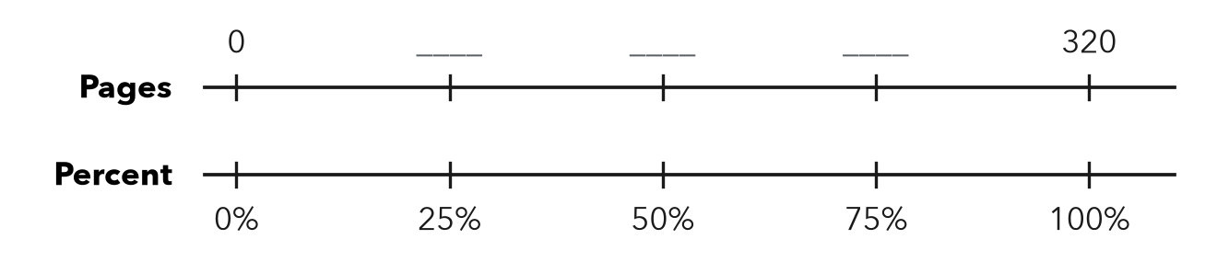
Step 1 320 ÷ 4 = pages
Step 2 50% of 320 = pages
Step 3 162 is close to pages
About %

3. Class Fundraiser. A class wants to raise $600. So far it has raised $452.  a. 10% of the goal  Step 1 600 ÷ 10 =  10% of the goal: $  b. About what percent?  Step 2 75% of $600 =  Step 3 $452 is close to $  About % | 4. Gym Water Jug. A water jug holds 48 cups. It has 23 cups left.  a. Half of the jug, in cups  Step 1 48 ÷ =  Half of the jug: cups  b. Percent left: about  Step 2 23 is close to cups  Step 3 That is about % left  About %

ON YOUR OWN use the open space · show your work · label units
5. Trail Progress. A bike trail is 40 km long. A rider has gone 30 km.  a. Percent done: about %  b. Percent left: %  Show your work. | 6. Estimate Check. Nia says 11 out of 40 is about 50%. Is she right? Use 25% of 40 to find a better estimate.  Show your work.  Better estimate %

7. Swim Laps. Omar’s goal is 60 laps. He has swum 41. Fill in the bar.  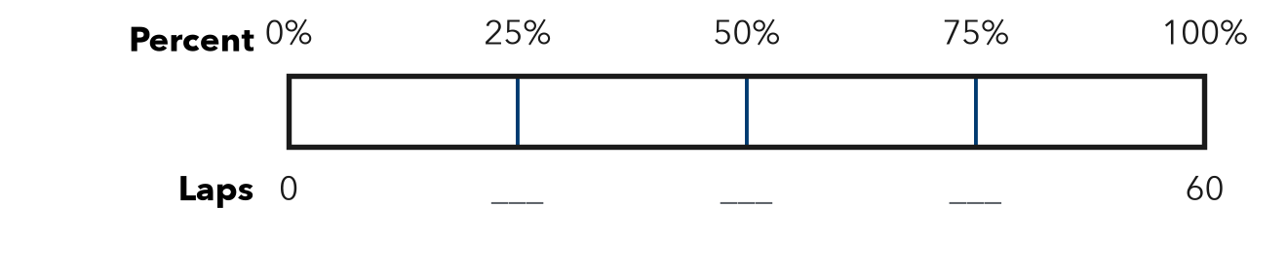  a. Between which two benchmarks is 41 out of 60?  between and  b. Which benchmark is it closer to?  closer to % | 8. Band Tickets. A band printed 360 tickets for its show. It has sold 37 of them.  a. About what percent are sold? %  b. About what percent are not sold? %  Show your work.

FIND THE ERROR explain the mistake, then fix it
9. Marcus’s Work. A 400 GB drive has 300 GB used. 40 GB of that is photos. Marcus says photos are about 75% of the drive. Explain his mistake. Estimate the percent that is photos.
Show your work.

TEST PRACTICE choose the best answer
10. 50% of an amount is the same as —
A one tenth B one half C one fourth D twice it

11. 9 out of 40 is about —
A 10% B 25% C 50% D 75%

CHECK YOURSELF
□ I can do this on my own □ I need a little help □ I have a question about #

