Name Date Period
Lesson 4-3 · Session 2 · Guided Steps · Form A
Estimate a Percent of a Number
Learning target — I can estimate a percent of a number using friendly percents and rounded amounts. · 6.AT.4
REMEMBER
• Round to compatible (friendly) numbers: 312 is about 300, 39% is about 40%.
• 10% = divide by 10. 20% = 2 × 10%, 30% = 3 × 10%, 5% = half of 10%.
• Write about. Did you round up (estimate high) or down (estimate low)?
GUIDED PRACTICE fill in each blank — problems 1–4
1. Estimate. Round to compatible (friendly) numbers first.
a. 9% of 205 ≈  Step 1 205 is about  Step 2 9% is about %  Step 3 % of = | b. 21% of 152 ≈  Step 1 152 is about  Step 2 21% is about %  Step 3 % of = | c. 26% of 79 ≈  Step 1 79 is about  Step 2 26% is about %  Step 3 % of =

d. 49% of 612 ≈ | e. 32% of 89 ≈ | f. 76% of 119 ≈

2. Supply Drive. A supply drive collected 183 pounds of supplies. The circle graph shows the percents. Round 183 to 180. Estimate the pounds of each kind.  Step 1 10% of 180 = lb | 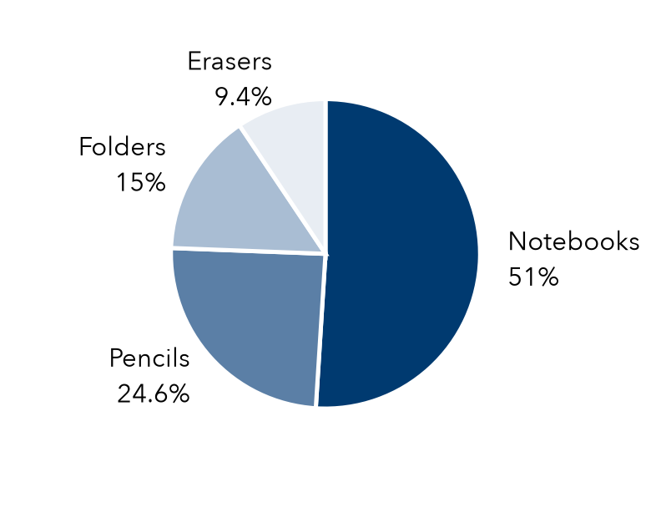
   | Notebooks | Pencils | Folders | Erasers
  Percent | 51% | 24.6% | 15% | 9.4%
  Friendly % | % | % | 10% + % | %
  Pounds | lb | lb | lb | lb

3. Tip Estimate. A dinner bill is $58.40. The family wants to leave about a 15% tip. Round the bill to $60. Then estimate.  Step 1 10% of 60 =  Step 2 5% of 60 =  Step 3 15% = + =  About $ | 4. Can Drive Goal. Last year a can drive collected 195 cans. This year’s goal is 140% of that. Round to 200. About how many cans is the goal?  Step 1 100% of 200 =  Step 2 10% of 200 =  Step 3 40% = 4 × =  Step 4 140% = + =  About cans

ON YOUR OWN use the open space · show your work · label units
5. Field Trip Coupon. A field trip costs $237. A coupon takes off about 19%. Estimate the dollars taken off.  Show your work.  About $ | 6. Estimate Claim. Ravi says 9% of 418 is about 200. Is he right? Use 10% of 420 to estimate and explain.  Show your work.  Better estimate

7. Garden Beds. A garden has 158 plants. About 74% are flowering. Estimate how many. Is your estimate high or low?  Show your work.  About plants | 8. Jacket Sale. A jacket costs $78.90. It is 40% off. Round the price to $80. Then estimate.  a. Estimate 10% of the price.  b. Estimate the amount saved.  c. Estimate the sale price. Is it a little high or a little low?  Show your work.

FIND THE ERROR explain the mistake, then fix it
9. Jamal’s Work. Jamal rounded 19% of 285 to 20% of 300. Then he wrote: “That is about 6 items.” Explain his mistake. Give a good estimate.
Show your work.

TEST PRACTICE choose the best answer
10. 10% of 250 is —
A 2.5 B 25 C 250 D 2,500

11. About 25% of 812 is —
A 20 B 80 C 200 D 400

CHECK YOURSELF
□ I can do this on my own □ I need a little help □ I have a question about #

