Name Date Period
Lesson 4-3 · Session 2 · Practice · Form A

Estimate a Percent of a Number
Learning target — I can estimate a percent of a number using friendly percents and rounded amounts. · 6.AT.4

REMEMBER  • Round to compatible (friendly) numbers: 312 is about 300, 39% is about 40%.  • 10% = divide by 10. 20% = 2 × 10%, 30% = 3 × 10%, 5% = half of 10%.  • Write about. Did you round up (estimate high) or down (estimate low)? | WORKED EXAMPLE  Estimate 20% of 312 bottles.  Step 1 312 is about 300.  Step 2 10% of 300 = 30.  Step 3 20% = 30 + 30 = 60.  Answer about 60 bottles
WORDS estimate (estimación) · compatible (friendly) numbers (números compatibles) · ten percent (diez por ciento)

PRACTICE show your work · label units

1. Estimate. Round to compatible (friendly) numbers first.
a. 9% of 205 ≈ | b. 21% of 152 ≈ | c. 26% of 79 ≈
d. 49% of 612 ≈ | e. 32% of 89 ≈ | f. 76% of 119 ≈

2. Supply Drive. A supply drive collected 183 pounds of supplies. The circle graph shows the percents. Round 183 to 180. Estimate the pounds of each kind.  Hint Folders: 15% = 10% + 5%. 5% is half of 10%.  a. Notebooks lb  b. Pencils lb  c. Folders lb  d. Erasers lb | 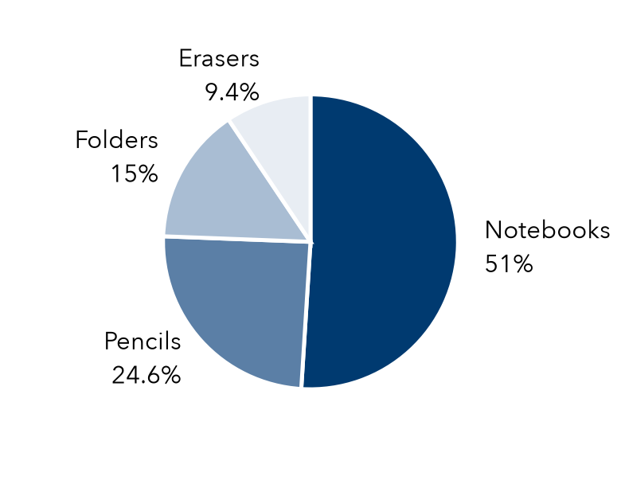

3. Tip Estimate. A dinner bill is $58.40. The family wants to leave about a 15% tip. Round the bill to $60. Then estimate.  Hint 15% = 10% + 5%. 5% is half of 10%.  About | 4. Can Drive Goal. Last year a can drive collected 195 cans. This year’s goal is 140% of that. Round to 200. About how many cans is the goal?  Hint 140% = 100% + 40%.  About
  Show your work.
  Show your work.

5. Field Trip Coupon. A field trip costs $237. A coupon takes off about 19%. Estimate the dollars taken off.  Hint Round to 20% of $240.  About | 6. Estimate Claim. Ravi says 9% of 418 is about 200. Is he right? Use 10% of 420 to estimate and explain.  Better estimate
  Show your work.
  Show your work.

7. Garden Beds. A garden has 158 plants. About 74% are flowering. Estimate how many. Is your estimate high or low?

Show your work.
About

8. Jacket Sale. A jacket costs $78.90. It is 40% off. Round the price to $80. Then estimate.
a. Estimate 10% of the price.
b. Estimate the amount saved.
c. Estimate the sale price. Is it a little high or a little low?

FIND THE ERROR explain the mistake, then fix it

9. Jamal’s Work. Jamal rounded 19% of 285 to 20% of 300. Then he wrote: “That is about 6 items.” Explain his mistake. Give a good estimate.

TEST PRACTICE choose the best answer

10. 10% of 250 is —
A 2.5 | B 25 | C 250 | D 2,500

11. About 25% of 812 is —
A 20 | B 80 | C 200 | D 400

SELF-CHECK CODE find your answer · copy its letter into that problem’s box · spell a math word
$32  D | 42  N | 120  D | $48  U | $9  R | $90  Q | 80  X | 280  O | 420  Z | $8  E

#3 | #4 | #5 | #6 | #7 | #8a | #8b

CHECK YOURSELF | □ I can do this on my own | □ I need a little help | □ I have a question about #

