Name Date Period
Lesson 4-3 · Session 2 · Guided Steps · Form B
Estimate a Percent of a Number
Learning target — I can estimate a percent of a number using friendly percents and rounded amounts. · 6.AT.4
REMEMBER
• Round to compatible (friendly) numbers: 312 is about 300, 39% is about 40%.
• 10% = divide by 10. 20% = 2 × 10%, 30% = 3 × 10%, 5% = half of 10%.
• Write about. Did you round up (estimate high) or down (estimate low)?
GUIDED PRACTICE fill in each blank — problems 1–4
1. Estimate. Round to compatible (friendly) numbers first.
a. 9% of 310 ≈  Step 1 310 is about  Step 2 9% is about %  Step 3 % of = | b. 19% of 248 ≈  Step 1 248 is about  Step 2 19% is about %  Step 3 % of = | c. 24% of 161 ≈  Step 1 161 is about  Step 2 24% is about %  Step 3 % of =

d. 52% of 398 ≈ | e. 29% of 61 ≈ | f. 74% of 81 ≈

2. Food Drive. A food drive collected 238 pounds of food. The circle graph shows the percents. Round 238 to 240. Estimate the pounds of each kind.  Step 1 10% of 240 = lb | 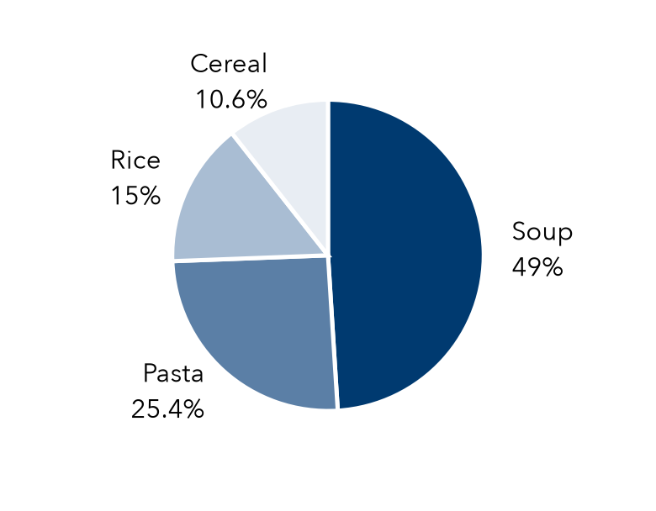
   | Soup | Pasta | Rice | Cereal
  Percent | 49% | 25.4% | 15% | 10.6%
  Friendly % | % | % | 10% + % | %
  Pounds | lb | lb | lb | lb

3. Tip Estimate. A lunch bill is $51.80. The family wants to leave about a 15% tip. Round the bill to $50. Then estimate.  Step 1 10% of 50 =  Step 2 5% of 50 =  Step 3 15% = + =  About $ | 4. Coat Drive Goal. Last year a coat drive collected 410 coats. This year’s goal is 130% of that. Round to 400. About how many coats is the goal?  Step 1 100% of 400 =  Step 2 10% of 400 =  Step 3 30% = 3 × =  Step 4 130% = + =  About coats

ON YOUR OWN use the open space · show your work · label units
5. Helmet Coupon. A bike helmet costs $62. A coupon takes off about 19%. Estimate the dollars taken off.  Show your work.  About $ | 6. Estimate Claim. Kira says 8% of 512 is about 400. Is she right? Use 10% of 500 to estimate and explain.  Show your work.  Better estimate

7. Garden Beds. A garden has 122 plants. About 76% are flowering. Estimate how many. Is your estimate high or low?  Show your work.  About plants | 8. Coat Sale. A coat costs $59.80. It is 30% off. Round the price to $60. Then estimate.  a. Estimate 10% of the price.  b. Estimate the amount saved.  c. Estimate the sale price. Is it a little high or a little low?  Show your work.

FIND THE ERROR explain the mistake, then fix it
9. Lee’s Work. Lee estimated 25% of 396. He found 10% of 400 = 40 and wrote: “About 40.” Explain his mistake. Give a good estimate.
Show your work.

TEST PRACTICE choose the best answer
10. 10% of 840 is —
A 8.4 B 84 C 840 D 8,400

11. About 30% of 290 is —
A 9 B 30 C 90 D 900

CHECK YOURSELF
□ I can do this on my own □ I need a little help □ I have a question about #

