Name Date Period
Lesson 4-3 · Session 2 · Practice · Form B

Estimate a Percent of a Number
Learning target — I can estimate a percent of a number using friendly percents and rounded amounts. · 6.AT.4

REMEMBER  • Round to compatible (friendly) numbers: 312 is about 300, 39% is about 40%.  • 10% = divide by 10. 20% = 2 × 10%, 30% = 3 × 10%, 5% = half of 10%.  • Write about. Did you round up (estimate high) or down (estimate low)? | WORKED EXAMPLE  Estimate 20% of 312 bottles.  Step 1 312 is about 300.  Step 2 10% of 300 = 30.  Step 3 20% = 30 + 30 = 60.  Answer about 60 bottles
WORDS estimate (estimación) · compatible (friendly) numbers (números compatibles) · ten percent (diez por ciento)

PRACTICE show your work · label units

1. Estimate. Round to compatible (friendly) numbers first.
a. 9% of 310 ≈ | b. 19% of 248 ≈ | c. 24% of 161 ≈
d. 52% of 398 ≈ | e. 29% of 61 ≈ | f. 74% of 81 ≈

2. Food Drive. A food drive collected 238 pounds of food. The circle graph shows the percents. Round 238 to 240. Estimate the pounds of each kind.  Hint Rice: 15% = 10% + 5%. 5% is half of 10%.  a. Soup lb  b. Pasta lb  c. Rice lb  d. Cereal lb | 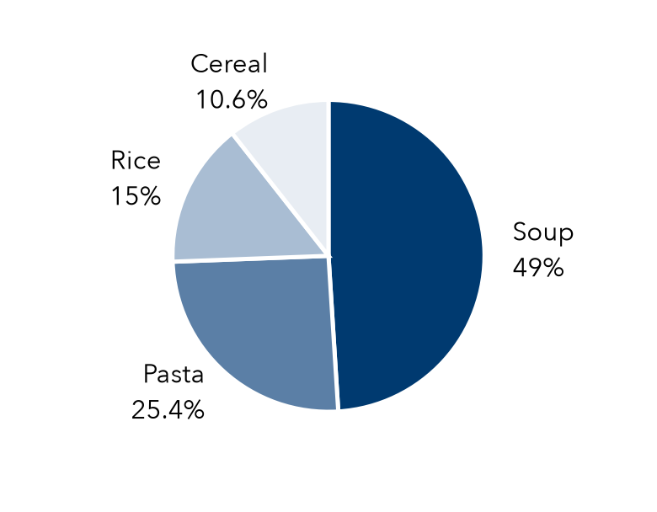

3. Tip Estimate. A lunch bill is $51.80. The family wants to leave about a 15% tip. Round the bill to $50. Then estimate.  Hint 15% = 10% + 5%. 5% is half of 10%.  About | 4. Coat Drive Goal. Last year a coat drive collected 410 coats. This year’s goal is 130% of that. Round to 400. About how many coats is the goal?  Hint 130% = 100% + 30%.  About
  Show your work.
  Show your work.

5. Helmet Coupon. A bike helmet costs $62. A coupon takes off about 19%. Estimate the dollars taken off.  Hint Round to 20% of $60.  About | 6. Estimate Claim. Kira says 8% of 512 is about 400. Is she right? Use 10% of 500 to estimate and explain.  Better estimate
  Show your work.
  Show your work.

7. Garden Beds. A garden has 122 plants. About 76% are flowering. Estimate how many. Is your estimate high or low?

Show your work.
About

8. Coat Sale. A coat costs $59.80. It is 30% off. Round the price to $60. Then estimate.
a. Estimate 10% of the price.
b. Estimate the amount saved.
c. Estimate the sale price. Is it a little high or a little low?

FIND THE ERROR explain the mistake, then fix it

9. Lee’s Work. Lee estimated 25% of 396. He found 10% of 400 = 40 and wrote: “About 40.” Explain his mistake. Give a good estimate.

TEST PRACTICE choose the best answer

10. 10% of 840 is —
A 8.4 | B 84 | C 840 | D 8,400

11. About 30% of 290 is —
A 9 | B 30 | C 90 | D 900

SELF-CHECK CODE find your answer · copy its letter into that problem’s box · spell a math word
90  U | $12  M | 520  O | $18  E | 50  P | $1.20  X | 500  Z | $7.50  C | $75  Q | $6  T

#3 | #4 | #5 | #6 | #7 | #8a | #8b

CHECK YOURSELF | □ I can do this on my own | □ I need a little help | □ I have a question about #

