Name Date Period
Lesson 4-4 · Session 1 · Guided Notes

Find the Percent of a Number
Learning target — I can find the percent of a number exactly. · 6.AT.4

WORDS TO KNOW fill in the missing words
WORD | WHAT IT MEANS | EXAMPLE
part  parte | The piece of the whole that the tells about. | 25% of 80 is 20
whole  entero | The full amount. It comes right after the word “ .” | in 45% of 140, the whole is 140
equation  ecuación | A math sentence with an sign. | part = 0.45 × 140

KEY IDEA complete each sentence
• Write the percent as a : 45% = 0.45 and 6% = 0.06.
• Multiply: part = percent × .
• If the percent is less than 100%, the part is than the whole.

WORKED EXAMPLE fill in the blanks as we solve
A school sold 140 tickets. 45% were student tickets. How many were student tickets?
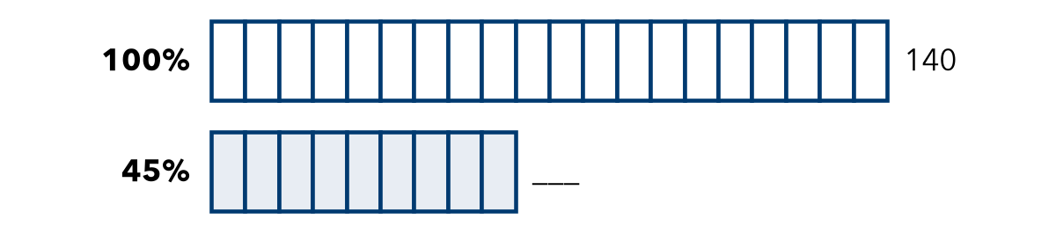
Step 1 The whole is tickets. Each of the 20 parts is 5%.
Step 2 45% =
Step 3 0.45 × 140 =
Answer student tickets

YOU TRY use the example as a model

1. Find each part.
a. 30% of 40 = | b. 8% of 250 = | c. 75% of 36 =

2. A school of 640 students had 15% absent (not at school).
a. How many were absent? students
b. How many were present? students

Show your work.

SUM IT UP in your own words
To find a percent of a number, I because .
Name Date Period
Lesson 4-4 · Session 2 · Guided Notes

Compare Percents
Learning target — I can compare two records fairly by converting each one to a percent. · 6.AT.4

WORDS TO KNOW fill in the missing words
WORD | WHAT IT MEANS | EXAMPLE
part-to-whole ratio  razón de parte al entero | Compares part of a group to the group. | 18 out of 24 shots
common whole  entero común | The same total, like , used for every group. | 75/100 and 80/100
compare  comparar | To decide which amount is or less. | 80% > 75%

KEY IDEA complete each sentence
• A record (how many out of how many) can fool you when the are different.
• Write each record as a , then compare the percents.

WORKED EXAMPLE fill in the blanks as we solve
Mia made 21 of 28 shots. Leo made 16 of 20 shots. Who has the better rate?
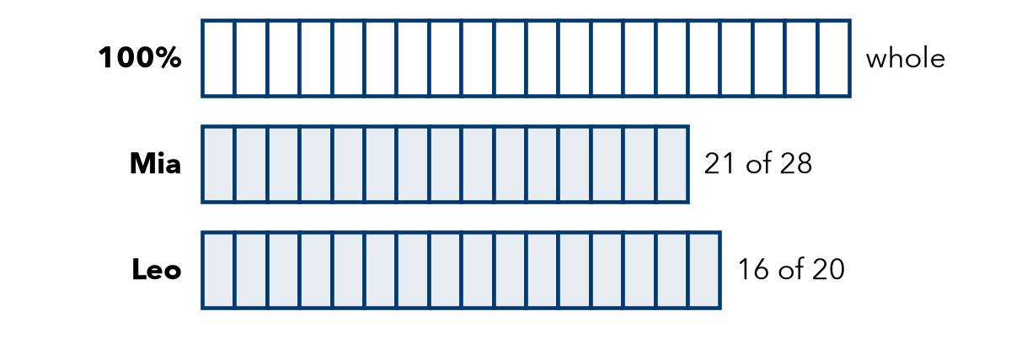
Step 1 Mia: 21 ÷ 28 = = 75%
Step 2 Leo: 16 ÷ 20 = = 80%
Step 3 Compare: 80% > 75%. Each small part of a bar is 5%.
Answer has the better rate, even though Mia made more shots.

YOU TRY use the example as a model

1. Write each record as a percent.
a. 9 out of 12 = % | b. 18 out of 25 = %

2. Ana made 14 of 20 shots. Ben made 17 of 25 shots. Who has the better rate?

Show your work.
Better rate

SUM IT UP in your own words
To compare two records fairly, I because .
Name Date Period
Lesson 4-4 · Guided Notes · Model, Reason, Explain

Model It. Explain It.

SESSION 1 · FIND THE PERCENT OF A NUMBER draw it · solve it · explain it
A theater has 360 seats. 35% of the seats are in the balcony. Use the percent bar and an equation to find how many seats are in the balcony.
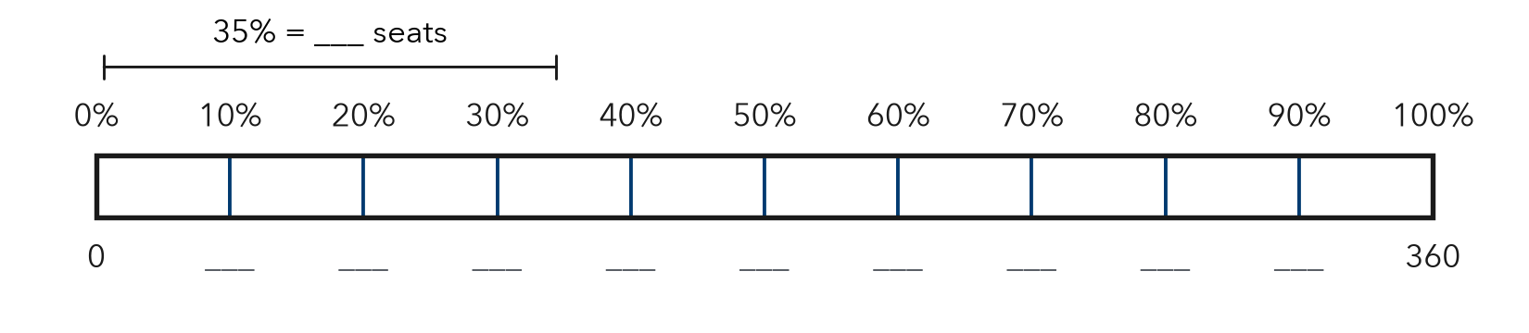
a. Fill in the bar. What are 10% and 5% of 360? Use them to find 35%.
b. Write and solve an equation: part = percent × whole.
c. Explain how you know both ways give the same answer.
Challenge Sam says 35% of 360 is 35 × 360 = 12,600. Show why that is too big.

SESSION 2 · COMPARE PERCENTS draw it · solve it · explain it
Kira made 36 of 60 free throws. Dev made 32 of 40. Kira made more. Shade each bar to show each percent. Who is the better shooter?
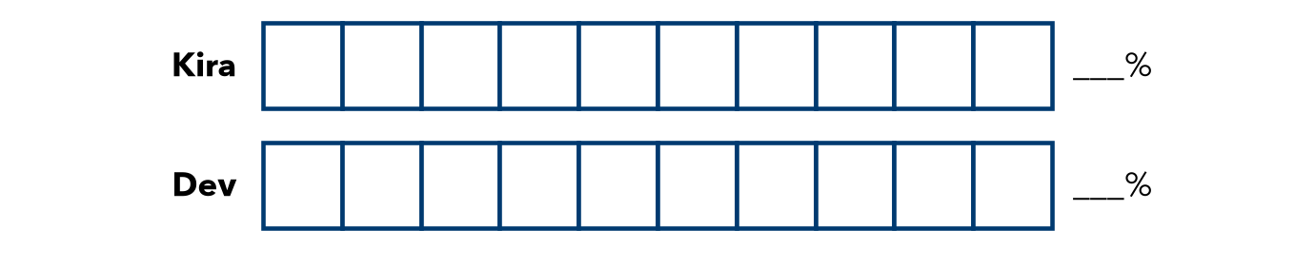
a. Write each record (how many out of how many) as a percent.
b. Who has the better rate?
c. Explain how you know.
Challenge Lin says 54 out of 60 is better than 9 out of 10 because 54 is more than 9. Show why she is wrong.
Check: Does my model match my numbers? Did I label units? Does my answer make sense?

