Name Date Period
Lesson 5-1 · Session 1 · Guided Steps · Form B
Area of Parallelograms
Learning target — I can find the area of a parallelogram by multiplying the base by the perpendicular height. · 6.G.A.1
REMEMBER
• Area of a parallelogram: A = b × h.
• The height makes a square corner with the base. The slanted side is not the height.
• Missing measure: divide the area by the one you know (90 ÷ 18 = 5). Label square units.
GUIDED PRACTICE fill in each blank — problems 1–4
1. Find the area of each parallelogram with base b and height h.
a. b = 16 cm, h = 5 cm  Step 1 A = b × h = 16 ×  Step 2 A = cm² | b. b = 13 in, h = 4 in  Step 1 A = b × h = 13 ×  Step 2 A = in²

c. b = 9 ft, h = 8 ft  Step 1 A = b × h = 9 ×  Step 2 A = ft² | d. b = 30 m, h = 3 m  Step 1 A = b × h = 30 ×  Step 2 A = m²

2. School Banner. A banner is a parallelogram.
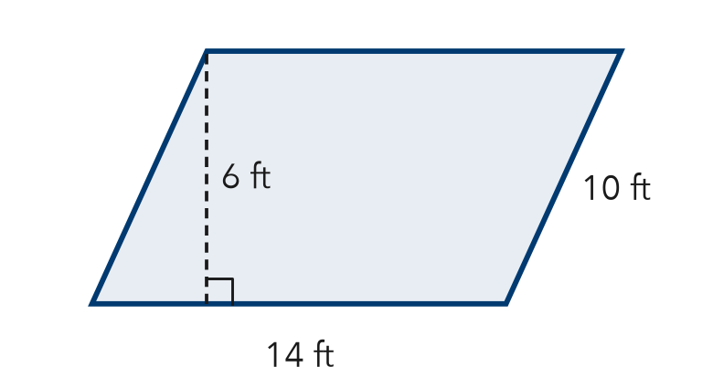
Step 1 Base = ft, height = ft
Step 2 Skip the 10 ft slanted side.
Step 3 A = × =
a. Find the area. ft²
b. Why is the 10 ft side not used?

3. Floor Tile. A tile has a base of 12 cm and a height of 9 cm.
a. Area of one tile
Step 1 12 × 9 =
Step 2 A = cm²
b. Area of 3 tiles
Step 3 3 × = cm²

4. Missing Height. A sign has an area of 84 in² and a base of 12 in. Find its height.
Step 1 = × h
Step 2 h = ÷
Answer in.

ON YOUR OWN use the open space · show your work · label units
5. Paper Strip. Find the area of the paper strip.  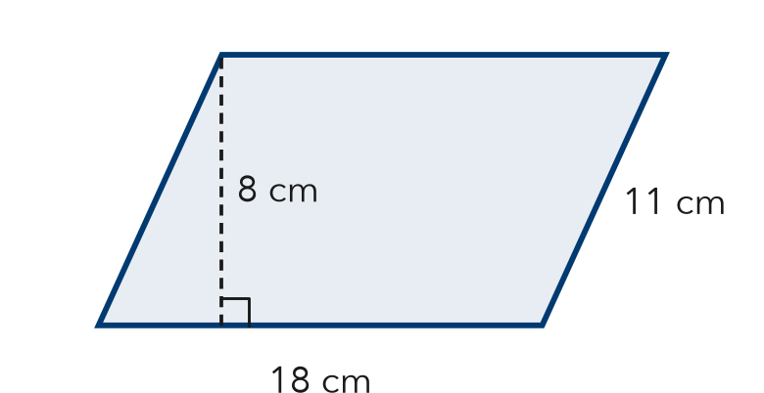  Show your work.  Answer cm² | 6. Window Pane. A window pane is a parallelogram. Its area is 117 in² and its base is 9 in. Find the height.  Show your work.  Answer in.

7. Two Panels. Panel X has base 9 cm and height 14 cm. Panel Y has base 18 cm and height 7 cm. Find each area. Which covers more space?  Show your work.  Areas X: Y:  Covers more space Panel | 8. Hallway Mural. A mural is a parallelogram with a base of 20 ft and a height of 6 ft. One can of paint covers 50 ft².  a. Find the area. ft²  b. How many cans are needed? Explain.  c. A second mural has the same height and double the base. Find its area. ft²  Show your work.

FIND THE ERROR explain the mistake, then fix it
9. Deshawn’s Work. A parallelogram has base 14 m, slanted side 10 m, and height 8 m. Deshawn wrote: “A = 14 × 10 = 140 m².” Explain his mistake. Then find the area.
Show your work.

TEST PRACTICE choose the best answer
10. A parallelogram has a base of 25 ft and a height of 4 ft. What is its area?
A 29 ft² B 50 ft² C 100 ft² D 200 ft²

11. A parallelogram has an area of 63 m² and a base of 7 m. What is its height?
A 9 m B 56 m C 70 m D 441 m

CHECK YOURSELF
□ I can do this on my own □ I need a little help □ I have a question about #

