Name Date Period
Lesson 5-2 · Session 1 · Guided Steps · Form A
Area of Triangles
Learning target — I can find the area of a triangle using one half the base times the height. · 6.G.A.1
REMEMBER
• Two matching triangles make a parallelogram, so a triangle is half: A = ½ × b × h.
• The height makes a square corner with the base.
• In a right triangle, the two legs at the square corner are the base and height.
GUIDED PRACTICE fill in each blank — problems 1–4
1. Find the area of each triangle with base b and height h.
a. b = 12 cm, h = 5 cm  Step 1 12 × 5 =  Step 2 ÷ 2 = cm² | b. b = 14 in, h = 3 in  Step 1 14 × 3 =  Step 2 ÷ 2 = in²

c. b = 20 ft, h = 7 ft  Step 1 20 × 7 =  Step 2 ÷ 2 = ft² | d. b = 11 m, h = 8 m  Step 1 11 × 8 =  Step 2 ÷ 2 = m²

2. Pennant Flag. Two copies of this flag fit together to make a parallelogram.  a. Area of the parallelogram  Step 1 b × h = ×  Step 2 Parallelogram = in²  b. Area of one flag  Step 3 ÷ 2 = in² | 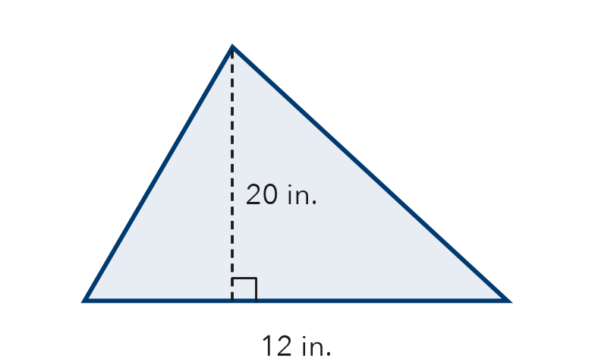

3. Cut Sandwich. A sandwich is cut on a diagonal into two equal triangles. Each has a base of 10 cm and a height of 8 cm.
a. Area of one triangle
Step 1 10 × 8 =
Step 2 ÷ 2 = cm²
b. Whole sandwich
Step 3 2 × = cm²

4. Right-Triangle Sail. A sail is a right triangle. Its two legs are 6 ft and 11 ft. Find its area.
Step 1 The legs are b = and h =
Step 2 × =
Step 3 ÷ 2 =
Answer ft²

ON YOUR OWN use the open space · show your work · label units
5. Warning Sign. Find the area of the sign.  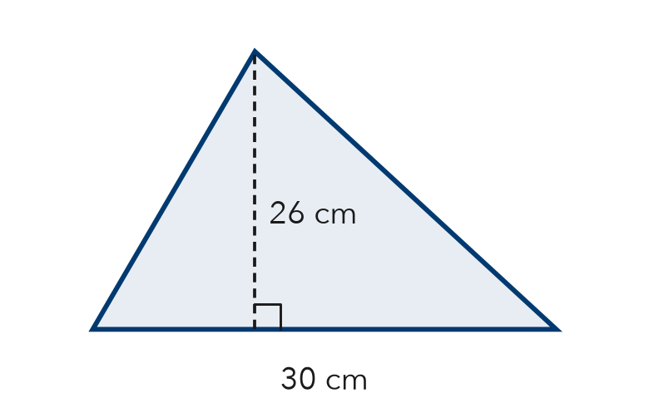  Show your work.  Answer cm² | 6. Recess Wedge. A wedge of the recess yard is a right triangle. Find its area.  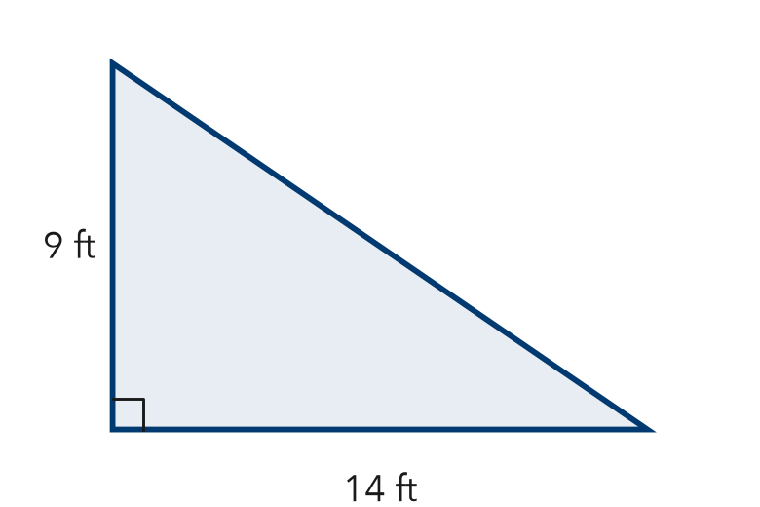  Show your work.  Answer ft²

7. Two Banners. Banner P is a triangle with base 18 m and height 10 m. Banner Q has base 12 m and height 13 m. Find each area. Which covers more space?  Show your work.  Areas P: m² Q: m²  Covers more space Banner | 8. Garden Plot. A triangular garden has a base of 24 ft and a height of 15 ft. One bag of mulch covers 30 ft² and costs $6.  a. Find the area. ft²  b. How many bags are needed?  c. Find the total cost. What happens to the cost if the base is doubled?  Show your work.

FIND THE ERROR explain the mistake, then fix it
9. Andre’s Work. A triangle has a base of 22 cm and a height of 10 cm. Andre wrote: “A = 22 × 10 = 220 cm².” Explain his mistake. Then find the area.
Show your work.

TEST PRACTICE choose the best answer
10. A triangle with base 14 in. and height 6 in. has area —
A 20 in² B 42 in² C 84 in² D 168 in²

11. The area of a triangle is what fraction of a rectangle with the same base and height?
A 1/4 B 1/3 C 1/2 D 2

CHECK YOURSELF
□ I can do this on my own □ I need a little help □ I have a question about #

