Name Date Period
Lesson 5-2 · Session 1 · Guided Steps · Form B
Area of Triangles
Learning target — I can find the area of a triangle using one half the base times the height. · 6.G.A.1
REMEMBER
• Two matching triangles make a parallelogram, so a triangle is half: A = ½ × b × h.
• The height makes a square corner with the base.
• In a right triangle, the two legs at the square corner are the base and height.
GUIDED PRACTICE fill in each blank — problems 1–4
1. Find the area of each triangle with base b and height h.
a. b = 16 cm, h = 5 cm  Step 1 16 × 5 =  Step 2 ÷ 2 = cm² | b. b = 9 in, h = 4 in  Step 1 9 × 4 =  Step 2 ÷ 2 = in²

c. b = 22 ft, h = 6 ft  Step 1 22 × 6 =  Step 2 ÷ 2 = ft² | d. b = 13 m, h = 8 m  Step 1 13 × 8 =  Step 2 ÷ 2 = m²

2. Pennant Flag. Two copies of this flag fit together to make a parallelogram.  a. Area of the parallelogram  Step 1 b × h = ×  Step 2 Parallelogram = in²  b. Area of one flag  Step 3 ÷ 2 = in² | 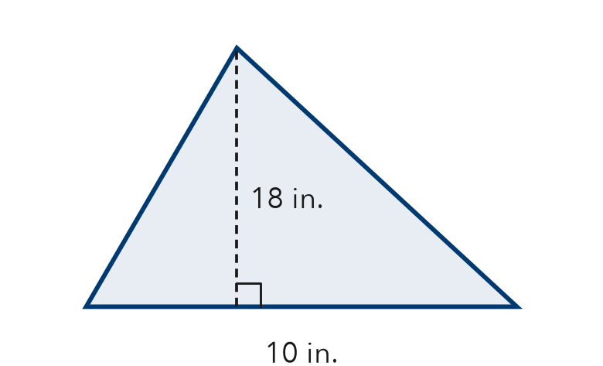

3. Cut Sandwich. A sandwich is cut on a diagonal into two equal triangles. Each has a base of 12 cm and a height of 9 cm.
a. Area of one triangle
Step 1 12 × 9 =
Step 2 ÷ 2 = cm²
b. Whole sandwich
Step 3 2 × = cm²

4. Right-Triangle Sail. A sail is a right triangle. Its two legs are 8 ft and 15 ft. Find its area.
Step 1 The legs are b = and h =
Step 2 × =
Step 3 ÷ 2 =
Answer ft²

ON YOUR OWN use the open space · show your work · label units
5. Warning Sign. Find the area of the sign.  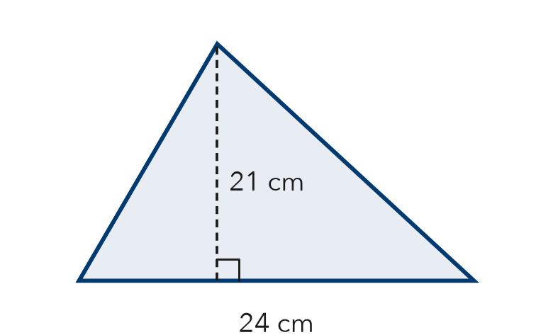  Show your work.  Answer cm² | 6. Recess Wedge. A wedge of the recess yard is a right triangle. Find its area.  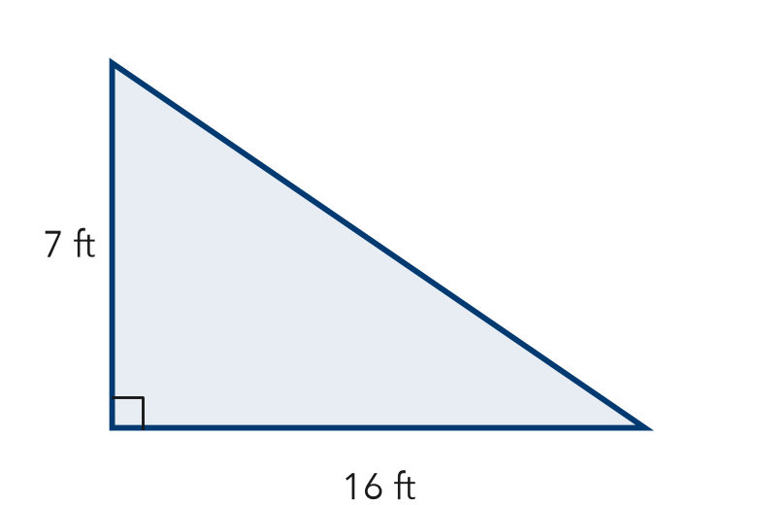  Show your work.  Answer ft²

7. Two Banners. Banner P is a triangle with base 16 m and height 9 m. Banner Q has base 12 m and height 14 m. Find each area. Which covers more space?  Show your work.  Areas P: m² Q: m²  Covers more space Banner | 8. Garden Plot. A triangular garden has a base of 20 ft and a height of 18 ft. One bag of mulch covers 30 ft² and costs $5.  a. Find the area. ft²  b. How many bags are needed?  c. Find the total cost. What happens to the cost if the base is doubled?  Show your work.

FIND THE ERROR explain the mistake, then fix it
9. Marta’s Work. A triangle has a base of 20 m and a height of 7 m. Marta wrote: “A = 20 × 7 = 140 m².” Explain her mistake. Then find the area.
Show your work.

TEST PRACTICE choose the best answer
10. A triangle with base 16 m and height 5 m has area —
A 21 m² B 40 m² C 80 m² D 160 m²

11. The height of a triangle must meet the base at —
A a square corner (right angle) B the longest side C the middle of the base D any angle

CHECK YOURSELF
□ I can do this on my own □ I need a little help □ I have a question about #

