Name Date Period
Lesson 5-2 · Session 2 · Guided Steps · Form B
Missing Measures in Triangles
Learning target — I can find a missing base or height of a triangle when I know its area. · 6.G.A.1
REMEMBER
• Work backward from A = ½ × b × h.
• Double the area to undo the half, then divide by the measure you know.
• Check: ½ × b × h gives the area. A base or height is in cm, not cm².
GUIDED PRACTICE fill in each blank — problems 1–4
1. Find the missing measure of each triangle.
a. A = 24 cm², h = 6 cm; b =  Step 1 2 × 24 =  Step 2 ÷ 6 = cm | b. A = 40 in², b = 10 in; h =  Step 1 2 × 40 =  Step 2 ÷ 10 = in

c. A = 35 m², h = 7 m; b =  Step 1 2 × 35 =  Step 2 ÷ 7 = m | d. A = 27 ft², b = 9 ft; h =  Step 1 2 × 27 =  Step 2 ÷ 9 = ft

2. Park Lot. A triangular lot covers 132 yd². Its height is 12 yd.  a. Fill in the formula: 132 = ½ × ×  b. Find the base b.  Step 1 2 × 132 =  Step 2 = b ×  Step 3 b = ÷  Base b = yd | 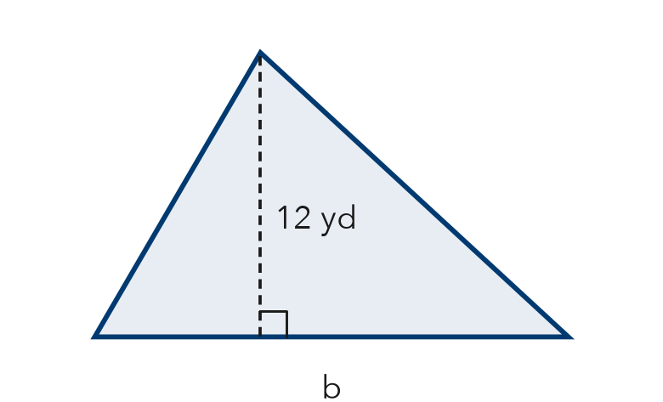

3. Quilt Piece. A triangular quilt piece has an area of 42 in² and a base of 7 in. Find the height.
Step 1 42 = ½ × 7 × h
Step 2 2 × 42 =
Step 3 ÷ 7 =
Answer in.

4. Roof Gable. A triangular gable covers 135 ft². Its height is 15 ft. Find the base.
Step 1 135 = ½ × b × 15
Step 2 2 × 135 =
Step 3 ÷ 15 =
Answer ft

ON YOUR OWN use the open space · show your work · label units
5. Awning Panel. The awning panel covers 70 ft². Find the height h.  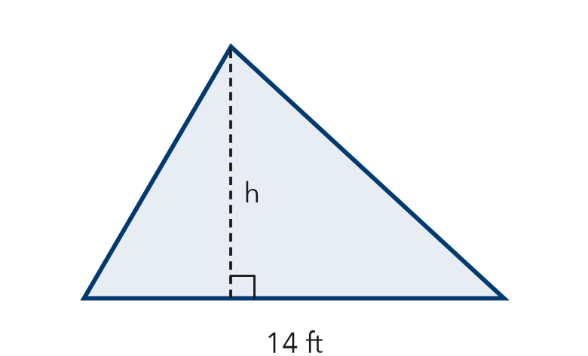  Show your work.  Answer ft | 6. Banner Claim. A triangular banner has an area of 90 ft² and a height of 9 ft. Deshawn says the base must be 10 ft. Is he right? Use the formula.  Show your work.  Is Deshawn right? Yes No Base ft

7. Sandbox Wedge. A triangular wedge of a sandbox covers 52 m². Its height is 8 m. Find the base.  Show your work.  Base m | 8. Two Signs. Sign A is a triangle with area 150 ft² and base 20 ft. Sign B is a triangle with area 150 ft² and height 10 ft.  a. Find the height of Sign A. ft  b. Find the base of Sign B. ft  c. Both signs have the same area. How can their shapes be different?  Show your work.

FIND THE ERROR explain the mistake, then fix it
9. Ravi’s Work. A triangle has an area of 90 cm² and a base of 15 cm. Ravi wrote: “90 ÷ 15 = 6, so the height is 6 cm.” Explain his mistake. Then find the height.
Show your work.

TEST PRACTICE choose the best answer
10. A triangle has area 48 m² and base 12 m. Its height is —
A 4 m B 8 m C 36 m D 576 m

11. A triangle has area 100 in² and height 20 in. Its base is —
A 5 in. B 80 in. C 10 in. D 2,000 in.

CHECK YOURSELF
□ I can do this on my own □ I need a little help □ I have a question about #

