Name Date Period
Lesson 5-3 · Session 1 · Guided Steps · Form A
Trapezoids by Decomposing
Learning target — I can find the area of a trapezoid by decomposing it into a rectangle and triangles. · 6.G.A.1
REMEMBER
• A trapezoid has one pair of parallel sides, called the bases. The height meets the bases at a square corner.
• Decompose: cut it into a rectangle and one or two triangles. Find each area, then add.
• The triangle bases together equal the long base − short base. Two matching triangles split it in half.
GUIDED PRACTICE fill in each blank — problems 1–4
1. Each trapezoid is cut into a rectangle and two matching triangles. Find the base of one triangle.
a. bases 10 in and 22 in  Step 1 22 − 10 =  Step 2 ÷ 2 = in | b. bases 8 m and 18 m  Step 1 18 − 8 =  Step 2 ÷ 2 = m

c. bases 12 cm and 20 cm  Step 1 20 − 12 =  Step 2 ÷ 2 = cm | d. bases 17 m and 27 m  Step 1 27 − 17 =  Step 2 ÷ 2 = m

2. Craft Tabletop. A craft tabletop is an isosceles trapezoid. It is cut into a rectangle and two matching triangles.  a. Area of the rectangle  Step 1 10 × = in²  b. Area of both triangles  Step 2 Triangle base: (22 − 10) ÷ 2 =  Step 3 2 × (½ × × ) = in²  c. Area of the tabletop  Step 4 + = in² | 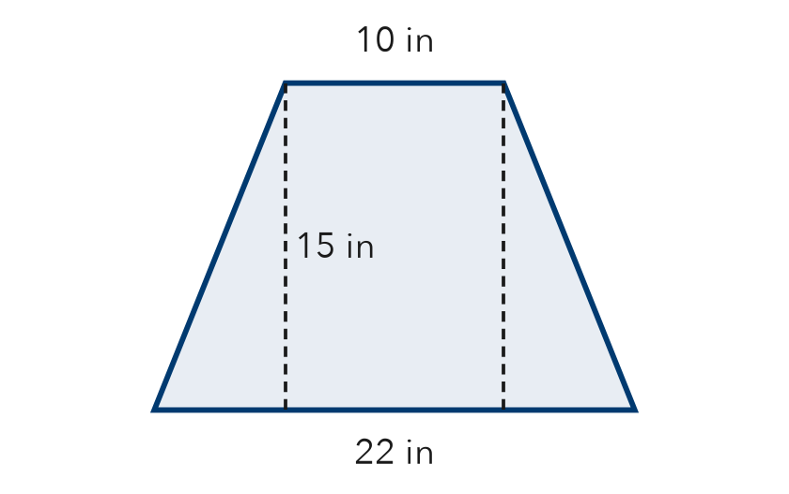

3. Right-Angle Deck. A deck is a trapezoid with one square corner. Decompose it into a rectangle and a triangle. Find its area.
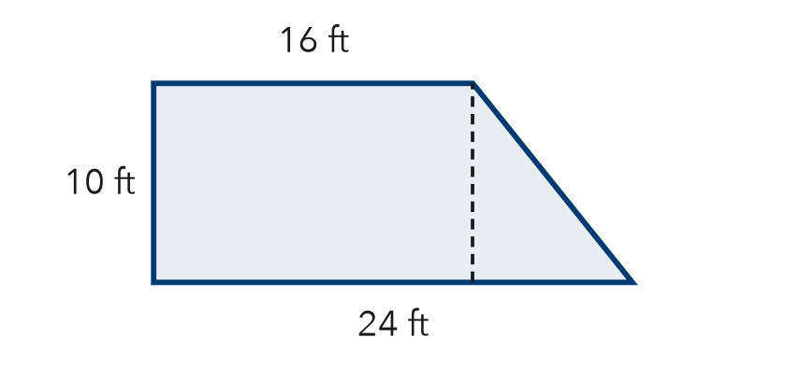
Step 1 Rectangle: 16 × = ft²
Step 2 Triangle base: 24 − 16 = ft
Step 3 Triangle: ½ × × = ft²
Step 4 Total: + = ft²

4. Bus Shelter Roof. A roof panel is an isosceles trapezoid with bases 8 m and 18 m and a height of 6 m. Find its area.
Step 1 Rectangle: 8 × 6 = m²
Step 2 Each triangle base: (18 − 8) ÷ 2 = m
Step 3 Triangles: 2 × (½ × × 6) = m²
Step 4 Total: + = m²

ON YOUR OWN use the open space · show your work · label units
5. Corner Garden. A garden is a trapezoid with one square corner. Its parallel sides are 11 yd and 19 yd, and the height is 13 yd. Find its area.  Show your work.  Answer yd² | 6. Tray and Mat. A lunch tray is an isosceles trapezoid with bases 19 in and 29 in and a height of 16 in. A placemat is a rectangle 24 in by 16 in. Find each area. Do they cover the same space?  Show your work.  Tray in² Mat in²  Same or not?

7. Stage Apron. A stage apron is an isosceles trapezoid with bases 17 m and 27 m and a height of 10 m. Decompose it and find its total area.  Show your work.  Answer m² | 8. Deck Plan. A deck is a trapezoid with bases 10 ft and 18 ft and a height of 6 ft. Decking costs $8 per square foot.  Show your work.  a. Area of each piece  b. Total area ft²  c. Total cost $

FIND THE ERROR explain the mistake, then fix it
9. Kwame’s Work. A trapezoid has bases 11 m and 21 m and a height of 10 m. Kwame cut it into a rectangle and two triangles, then wrote: “Area = 11 × 10 = 110 m².” Explain the mistake and find the correct area.
Show your work.

TEST PRACTICE choose the best answer
10. A trapezoid can be decomposed into a rectangle and —
A one circle B one or two triangles C two squares D a hexagon

11. A rectangle 9 cm by 4 cm plus a triangle with area 10 cm² gives a total area of —
A 23 cm² B 36 cm² C 46 cm² D 56 cm²

CHECK YOURSELF
□ I can do this on my own □ I need a little help □ I have a question about #

