Name Date Period
Lesson 5-3 · Session 1 · Guided Steps · Form B
Trapezoids by Decomposing
Learning target — I can find the area of a trapezoid by decomposing it into a rectangle and triangles. · 6.G.A.1
REMEMBER
• A trapezoid has one pair of parallel sides, called the bases. The height meets the bases at a square corner.
• Decompose: cut it into a rectangle and one or two triangles. Find each area, then add.
• The triangle bases together equal the long base − short base. Two matching triangles split it in half.
GUIDED PRACTICE fill in each blank — problems 1–4
1. Each trapezoid is cut into a rectangle and two matching triangles. Find the base of one triangle.
a. bases 12 in and 20 in  Step 1 20 − 12 =  Step 2 ÷ 2 = in | b. bases 6 m and 16 m  Step 1 16 − 6 =  Step 2 ÷ 2 = m

c. bases 9 cm and 21 cm  Step 1 21 − 9 =  Step 2 ÷ 2 = cm | d. bases 15 ft and 23 ft  Step 1 23 − 15 =  Step 2 ÷ 2 = ft

2. Craft Tabletop. A craft tabletop is an isosceles trapezoid. It is cut into a rectangle and two matching triangles.
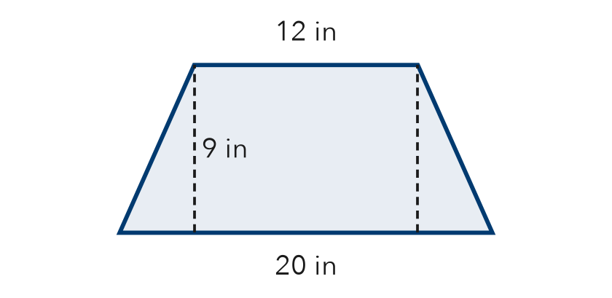
a. Area of the rectangle
Step 1 12 × = in²
b. Area of both triangles
Step 2 Triangle base: (20 − 12) ÷ 2 =
Step 3 2 × (½ × × ) = in²
c. Area of the tabletop
Step 4 + = in²

3. Right-Angle Deck. A deck is a trapezoid with one square corner. Decompose it into a rectangle and a triangle. Find its area.
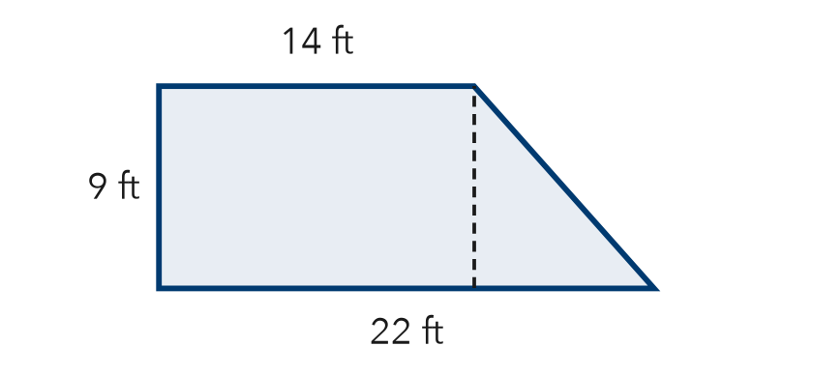
Step 1 Rectangle: 14 × = ft²
Step 2 Triangle base: 22 − 14 = ft
Step 3 Triangle: ½ × × = ft²
Step 4 Total: + = ft²

4. Bus Shelter Roof. A roof panel is an isosceles trapezoid with bases 6 m and 16 m and a height of 8 m. Find its area.
Step 1 Rectangle: 6 × 8 = m²
Step 2 Each triangle base: (16 − 6) ÷ 2 = m
Step 3 Triangles: 2 × (½ × × 8) = m²
Step 4 Total: + = m²

ON YOUR OWN use the open space · show your work · label units
5. Corner Garden. A garden is a trapezoid with one square corner. Its parallel sides are 9 yd and 15 yd, and the height is 14 yd. Find its area.  Show your work.  Answer yd² | 6. Tray and Mat. A lunch tray is an isosceles trapezoid with bases 14 in and 24 in and a height of 12 in. A placemat is a rectangle 19 in by 12 in. Find each area. Do they cover the same space?  Show your work.  Tray in² Mat in²  Same or not?

7. Stage Apron. A stage apron is an isosceles trapezoid with bases 15 m and 25 m and a height of 8 m. Decompose it and find its total area.  Show your work.  Answer m² | 8. Deck Plan. A deck is a trapezoid with bases 12 ft and 20 ft and a height of 5 ft. Decking costs $9 per square foot.  Show your work.  a. Area of each piece  b. Total area ft²  c. Total cost $

FIND THE ERROR explain the mistake, then fix it
9. Amina’s Work. A trapezoid has bases 13 m and 23 m and a height of 8 m. Amina cut it into a rectangle and two triangles, then wrote: “Area = 13 × 8 = 104 m².” Explain the mistake and find the correct area.
Show your work.

TEST PRACTICE choose the best answer
10. Every piece of a decomposed trapezoid has the same —
A base B area C height D slanted side

11. A rectangle 8 cm by 5 cm plus a triangle with area 12 cm² gives a total area of —
A 25 cm² B 40 cm² C 52 cm² D 64 cm²

CHECK YOURSELF
□ I can do this on my own □ I need a little help □ I have a question about #

