Name Date Period
Lesson 5-3 · Session 2 · Guided Steps · Form A
The Trapezoid Area Formula
Learning target — I can find the area of a trapezoid using the trapezoid area formula. · 6.G.A.1
REMEMBER
• A = ½ × (b1 + b2) × h. The bases b1 and b2 are the two parallel sides.
• Add the bases first, multiply by the height, then take half. Slanted sides are not used.
• Missing base: double the area, divide by the height, then subtract the base you know.
GUIDED PRACTICE fill in each blank — problems 1–4
1. Find the area of each trapezoid with bases b1 and b2 and height h.
a. 9 cm, 15 cm; h = 8 cm  Step 1 9 + 15 =  Step 2 × 8 =  Step 3 ÷ 2 = cm² | b. 20 in, 28 in; h = 15 in  Step 1 20 + 28 =  Step 2 × 15 =  Step 3 ÷ 2 = in²

c. 12 ft, 18 ft; h = 4 ft  Step 1 12 + 18 =  Step 2 × 4 =  Step 3 ÷ 2 = ft² | d. 6 m, 10 m; h = 5 m  Step 1 6 + 10 =  Step 2 × 5 =  Step 3 ÷ 2 = m²

2. County Land. A county is shaped like this right trapezoid.
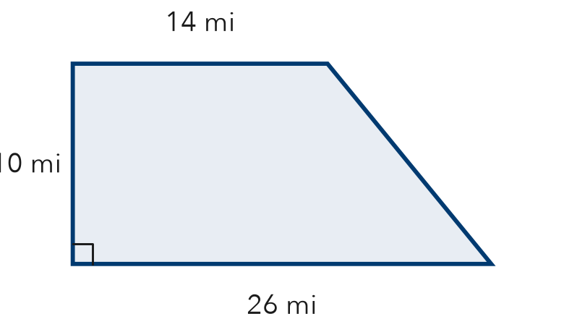
a. Sum of the bases
Step 1 14 + 26 = mi
b. Area of the county
Step 2 × 10 =
Step 3 ÷ 2 = mi²
c. Two copies make a rectangle. How long is it?
Step 4 Length = + = mi

3. Table Runner. A table runner has the trapezoid shape shown. Find its area.
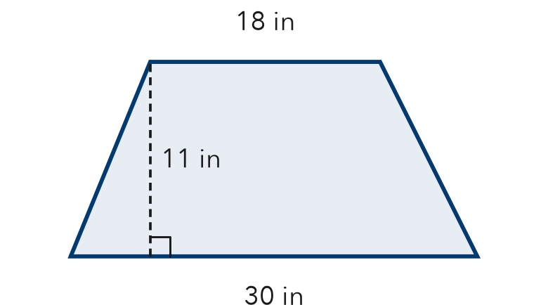
Step 1 Add the bases: 18 + 30 =
Step 2 Multiply by the height: × 11 =
Step 3 Take half: ÷ 2 = in²

4. Sidewalk Panel. A sidewalk panel is a trapezoid with parallel sides 8 m and 20 m and a height of 7 m. Find its area.
Step 1 Add the bases: 8 + 20 =
Step 2 Multiply by the height: × 7 =
Step 3 Take half: ÷ 2 = m²

ON YOUR OWN use the open space · show your work · label units
5. Talia’s Answer. A trapezoid has bases 11 cm and 17 cm and a height of 20 cm. Talia says its area is 560 cm². Is Talia right?  Show your work.  Area cm²  □ Yes □ No | 6. Pool Cover. Bases 16 ft and 22 ft, height 10 ft. Fabric costs $2 per ft². Find the area and cost.  Show your work.  Area ft² Cost $

7. Two Signs. Sign M has bases 10 cm and 26 cm. Sign N has bases 14 cm and 22 cm. Both are 8 cm tall. Find each area. What do you notice?  Show your work.  Sign M cm² Sign N cm²  Notice | 8. Missing Base. A trapezoid has an area of 84 m² and a height of 7 m. One base is 10 m.  Show your work.  a. What is the sum of the two bases? m  b. Find the other base. m

FIND THE ERROR explain the mistake, then fix it
9. Sofia’s Work. A trapezoid has bases 7 m and 21 m and a height of 5 m. Sofia wrote: “A = ½ × 7 × 5 = 17.5 m².” Explain the mistake and find the correct area.
Show your work.

TEST PRACTICE choose the best answer
10. A trapezoid has bases 5 cm and 11 cm and a height of 6 cm. Its area is —
A 22 cm² B 48 cm² C 96 cm² D 165 cm²

11. In A = ½ × (b1 + b2) × h, the first step is to —
A multiply b1 by h B divide by 2 C add the bases D multiply the bases

CHECK YOURSELF
□ I can do this on my own □ I need a little help □ I have a question about #

