Name Date Period
Lesson 5-3 · Session 2 · Guided Steps · Form B
The Trapezoid Area Formula
Learning target — I can find the area of a trapezoid using the trapezoid area formula. · 6.G.A.1
REMEMBER
• A = ½ × (b1 + b2) × h. The bases b1 and b2 are the two parallel sides.
• Add the bases first, multiply by the height, then take half. Slanted sides are not used.
• Missing base: double the area, divide by the height, then subtract the base you know.
GUIDED PRACTICE fill in each blank — problems 1–4
1. Find the area of each trapezoid with bases b1 and b2 and height h.
a. 7 cm, 13 cm; h = 6 cm  Step 1 7 + 13 =  Step 2 × 6 =  Step 3 ÷ 2 = cm² | b. 14 in, 22 in; h = 10 in  Step 1 14 + 22 =  Step 2 × 10 =  Step 3 ÷ 2 = in²

c. 18 ft, 26 ft; h = 5 ft  Step 1 18 + 26 =  Step 2 × 5 =  Step 3 ÷ 2 = ft² | d. 4 m, 12 m; h = 9 m  Step 1 4 + 12 =  Step 2 × 9 =  Step 3 ÷ 2 = m²

2. County Land. A county is shaped like this right trapezoid.
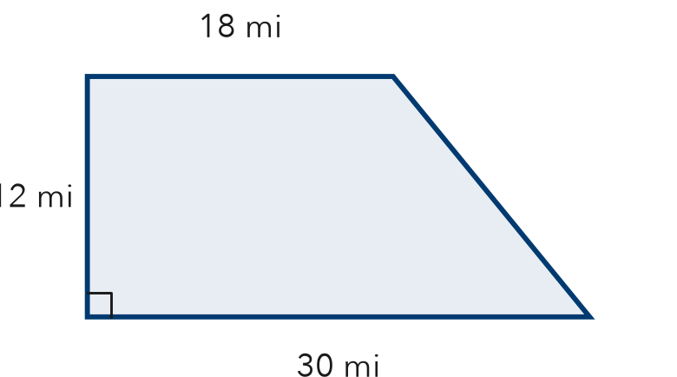
a. Sum of the bases
Step 1 18 + 30 = mi
b. Area of the county
Step 2 × 12 =
Step 3 ÷ 2 = mi²
c. Two copies make a rectangle. How long is it?
Step 4 Length = + = mi

3. Table Runner. A table runner has the trapezoid shape shown. Find its area.
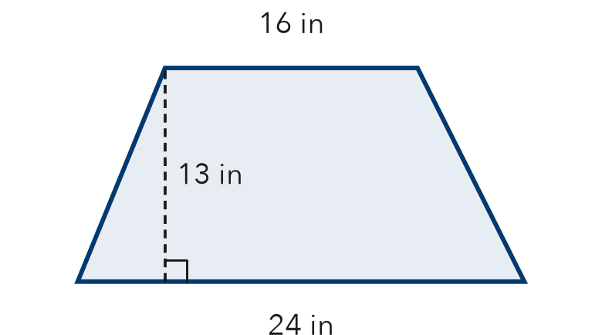
Step 1 Add the bases: 16 + 24 =
Step 2 Multiply by the height: × 13 =
Step 3 Take half: ÷ 2 = in²

4. Sidewalk Panel. A sidewalk panel is a trapezoid with parallel sides 6 m and 18 m and a height of 9 m. Find its area.
Step 1 Add the bases: 6 + 18 =
Step 2 Multiply by the height: × 9 =
Step 3 Take half: ÷ 2 = m²

ON YOUR OWN use the open space · show your work · label units
5. Marcus’s Answer. A trapezoid has bases 13 cm and 19 cm and a height of 15 cm. Marcus says its area is 480 cm². Is Marcus right?  Show your work.  Area cm²  □ Yes □ No | 6. Pool Cover. Bases 18 ft and 26 ft, height 10 ft. Fabric costs $3 per ft². Find the area and cost.  Show your work.  Area ft² Cost $

7. Two Signs. Sign M has bases 8 cm and 28 cm. Sign N has bases 12 cm and 24 cm. Both are 7 cm tall. Find each area. What do you notice?  Show your work.  Sign M cm² Sign N cm²  Notice | 8. Missing Base. A trapezoid has an area of 90 m² and a height of 6 m. One base is 11 m.  Show your work.  a. What is the sum of the two bases? m  b. Find the other base. m

FIND THE ERROR explain the mistake, then fix it
9. Andre’s Work. A trapezoid has bases 9 m and 15 m and a height of 6 m. Andre wrote: “A = ½ × 9 × 6 = 27 m².” Explain the mistake and find the correct area.
Show your work.

TEST PRACTICE choose the best answer
10. A trapezoid has bases 4 in and 12 in and a height of 7 in. Its area is —
A 112 in² B 168 in² C 23 in² D 56 in²

11. The trapezoid formula uses the average of the —
A two bases B two slanted sides C height and one base D four sides

CHECK YOURSELF
□ I can do this on my own □ I need a little help □ I have a question about #

