Name Date Period
Lesson 5-4 · Session 1 · Guided Steps · Form A
Area of Regular Polygons
Learning target — I can find the area of a regular polygon by finding the area of one triangle and multiplying. · 6.G.A.1
REMEMBER
• A regular polygon has equal sides and equal angles. Lines from the center make congruent triangles.
• Each triangle’s base is one side. Its height is the apothem.
• Area = n × (½ × side × apothem). Use ≈ when the apothem is rounded.
GUIDED PRACTICE fill in each blank — problems 1–4
1. Find the area of one center triangle: ½ × side × apothem.
a. side 10 cm, apothem 7 cm  Step 1 10 × 7 =  Step 2 ÷ 2 = cm² | b. side 16 in, apothem 11 in  Step 1 16 × 11 =  Step 2 ÷ 2 = in²

c. side 7 m, apothem 8 m  Step 1 7 × 8 =  Step 2 ÷ 2 = m² | d. side 6 ft, apothem 9 ft  Step 1 6 × 9 =  Step 2 ÷ 2 = ft²

2. Gazebo Floor. A gazebo floor is a regular hexagon with sides of 9 ft. The apothem is about 7.8 ft.  a. How many center triangles?  Step 1 A hexagon has sides, so triangles.  b. Area of one triangle  Step 2 9 × 7.8 =  Step 3 ÷ 2 = ft²  c. Area of the floor  Step 4 × = ft² | 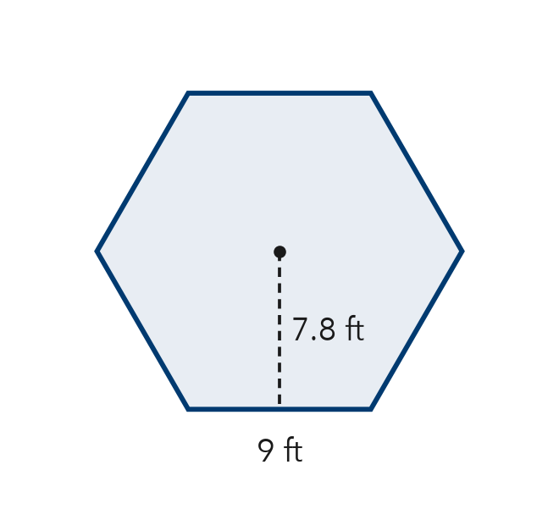

3. Pentagon Sign. A regular pentagon road sign has sides of 16 in and an apothem of about 11 in. Find its area.
Step 1 A pentagon has center triangles.
Step 2 One triangle: ½ × 16 × 11 = in²
Step 3 Whole sign: × = in²

4. Stepping Stone. A stepping stone is a regular octagon with sides of 7 cm and an apothem of about 8 cm. Find its area.
Step 1 An octagon has center triangles.
Step 2 One triangle: ½ × 7 × 8 = cm²
Step 3 Whole stone: × = cm²

ON YOUR OWN use the open space · show your work · label units
5. Flower Bed. A flower bed is a regular hexagon with sides of 24 ft. Each center triangle has a height of about 21 ft. Find the area of the flower bed.  Show your work.  Answer ft² | 6. Pentagon Patio. A patio is a regular pentagon. Decompose it into center triangles and find its area.  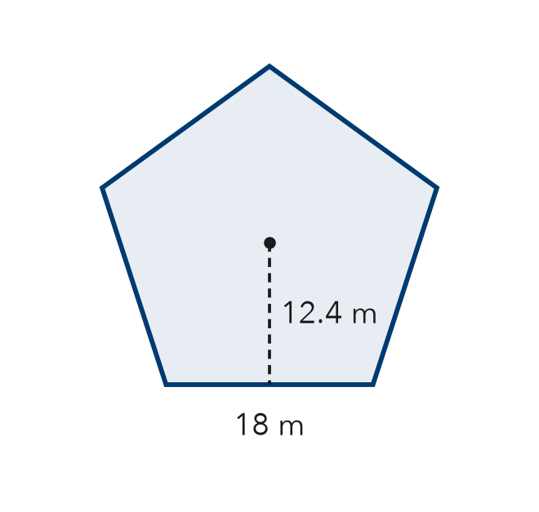  Show your work.  Answer m²

7. Jamal’s Tile. A tile is a regular hexagon with sides of 10 cm and an apothem of about 9 cm. Jamal says the tile’s area is 45 cm². Is Jamal right? Explain.  Show your work.  True area cm²  □ Yes □ No | 8. Tile Design. A floor uses regular hexagon tiles with sides of 8 cm and an apothem of 6.9 cm.  Show your work.  a. Find the area of one tile. cm²  b. Find the area covered by 25 tiles. cm²

FIND THE ERROR explain the mistake, then fix it
9. Lena’s Work. A regular pentagon has sides of 22 in and an apothem of 15 in. Lena wrote: “A = 22 × 15 × 5 = 1,650 in².” Explain the mistake and find the correct area.
Show your work.

TEST PRACTICE choose the best answer
10. A regular hexagon splits into how many congruent center triangles?
A 4 B 5 C 6 D 8

11. One center triangle of a regular pentagon has an area of 20 cm². The pentagon’s area is —
A 25 cm² B 40 cm² C 100 cm² D 120 cm²

CHECK YOURSELF
□ I can do this on my own □ I need a little help □ I have a question about #

