Name Date Period
Lesson 5-4 · Session 1 · Guided Steps · Form B
Area of Regular Polygons
Learning target — I can find the area of a regular polygon by finding the area of one triangle and multiplying. · 6.G.A.1
REMEMBER
• A regular polygon has equal sides and equal angles. Lines from the center make congruent triangles.
• Each triangle’s base is one side. Its height is the apothem.
• Area = n × (½ × side × apothem). Use ≈ when the apothem is rounded.
GUIDED PRACTICE fill in each blank — problems 1–4
1. Find the area of one center triangle: ½ × side × apothem.
a. side 12 cm, apothem 8 cm  Step 1 12 × 8 =  Step 2 ÷ 2 = cm² | b. side 14 in, apothem 9 in  Step 1 14 × 9 =  Step 2 ÷ 2 = in²

c. side 5 m, apothem 6 m  Step 1 5 × 6 =  Step 2 ÷ 2 = m² | d. side 9 ft, apothem 10 ft  Step 1 9 × 10 =  Step 2 ÷ 2 = ft²

2. Gazebo Floor. A gazebo floor is a regular hexagon with sides of 12 ft. The apothem is about 10.4 ft.  a. How many center triangles?  Step 1 A hexagon has sides, so triangles.  b. Area of one triangle  Step 2 12 × 10.4 =  Step 3 ÷ 2 = ft²  c. Area of the floor  Step 4 × = ft² | 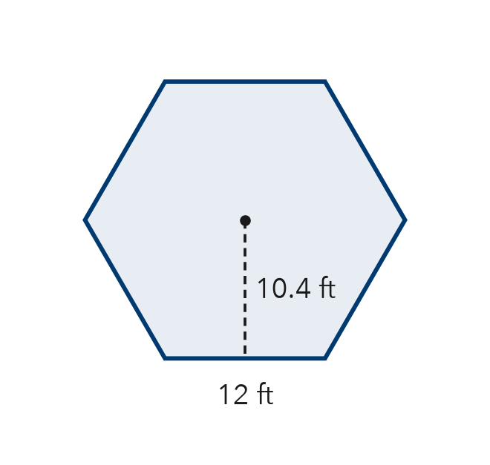

3. Pentagon Sign. A regular pentagon road sign has sides of 14 in and an apothem of about 9.6 in. Find its area.
Step 1 A pentagon has center triangles.
Step 2 One triangle: ½ × 14 × 9.6 = in²
Step 3 Whole sign: × = in²

4. Stepping Stone. A stepping stone is a regular octagon with sides of 6 cm and an apothem of about 7.2 cm. Find its area.
Step 1 An octagon has center triangles.
Step 2 One triangle: ½ × 6 × 7.2 = cm²
Step 3 Whole stone: × = cm²

ON YOUR OWN use the open space · show your work · label units
5. Flower Bed. A flower bed is a regular hexagon with sides of 20 ft. Each center triangle has a height of about 17.3 ft. Find the area of the flower bed.  Show your work.  Answer ft² | 6. Pentagon Patio. A patio is a regular pentagon. Decompose it into center triangles and find its area.  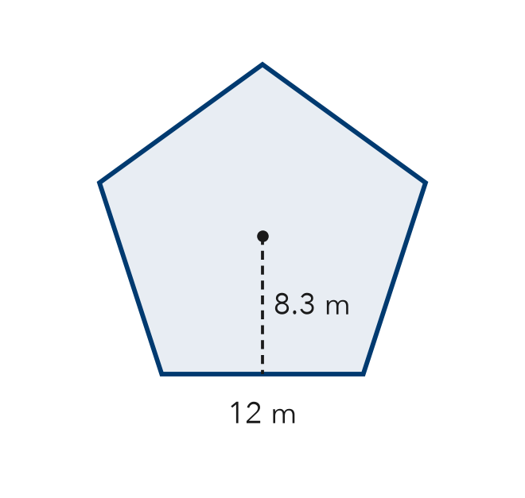  Show your work.  Answer m²

7. Keisha’s Tile. A tile is a regular hexagon with sides of 8 cm and an apothem of about 7 cm. Keisha says the tile’s area is 28 cm². Is Keisha right? Explain.  Show your work.  True area cm²  □ Yes □ No | 8. Tile Design. A floor uses regular hexagon tiles with sides of 6 cm and an apothem of 5.2 cm.  Show your work.  a. Find the area of one tile. cm²  b. Find the area covered by 30 tiles. cm²

FIND THE ERROR explain the mistake, then fix it
9. Mateo’s Work. A regular octagon has sides of 10 in and an apothem of 12 in. Mateo wrote: “A = 10 × 12 × 8 = 960 in².” Explain the mistake and find the correct area.
Show your work.

TEST PRACTICE choose the best answer
10. A regular octagon splits into how many congruent center triangles?
A 6 B 7 C 8 D 10

11. To find a regular polygon’s area, multiply one triangle’s area by the —
A apothem B number of sides C side length D perimeter

CHECK YOURSELF
□ I can do this on my own □ I need a little help □ I have a question about #

