Name Date Period
Lesson 5-4 · Session 2 · Guided Steps · Form A
Composite Figures
Learning target — I can find the area of a composite figure by adding or subtracting the areas of simpler shapes. · 6.G.A.1
REMEMBER
• A composite figure is made of simpler shapes: rectangles, triangles, squares.
• Add the areas of pieces that are joined. Subtract the area of a piece that is cut out.
• Use each piece’s own formula: rectangle l × w, triangle ½ × b × h.
GUIDED PRACTICE fill in each blank — problems 1–4
1. Decide whether to add or subtract. Then find each area.
a. 40 cm² rectangle + 12 cm² triangle  Step 1 Add or subtract?  Step 2 40 12 = cm² | b. 100 in² square, 16 in² cut out  Step 1 Add or subtract?  Step 2 100 16 = in²

c. 9 ft square, 3 ft square cut out  Step 1 Big square: 9 × 9 =  Step 2 Cut-out: 3 × 3 =  Step 3 Add or subtract?  Step 4 = ft² | d. 10 m × 4 m, 2 m square cut out  Step 1 Rectangle: 10 × 4 =  Step 2 Cut-out: 2 × 2 =  Step 3 Add or subtract?  Step 4 = m²

2. Swallowtail Flag. A flag starts as a rectangle 20 in by 14 in. A triangle notch 5 in deep is cut out of the right edge.  a. Area of the whole rectangle  Step 1 20 × 14 = in²  b. Area of the notch  Step 2 Notch: ½ × × 5 = in²  c. Area of the flag  Step 3 Subtract: − = in² | 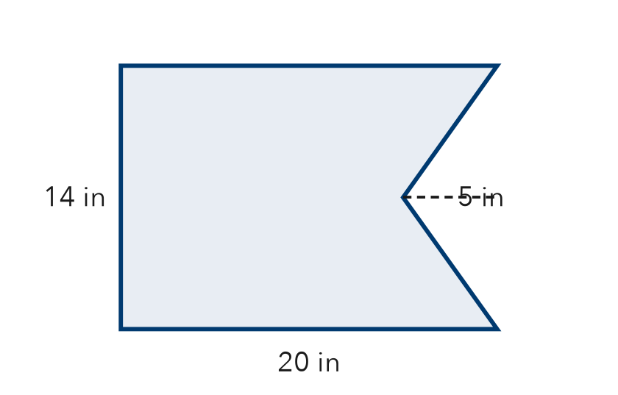

3. L-Shaped Room. An L-shaped floor splits into a 13 ft by 10 ft rectangle and a 5 ft by 11 ft rectangle. Find the floor area.  Step 1 Rectangle 1: 13 × 10 = ft²  Step 2 Rectangle 2: 5 × 11 = ft²  Step 3 Joined, so add: + = ft² | 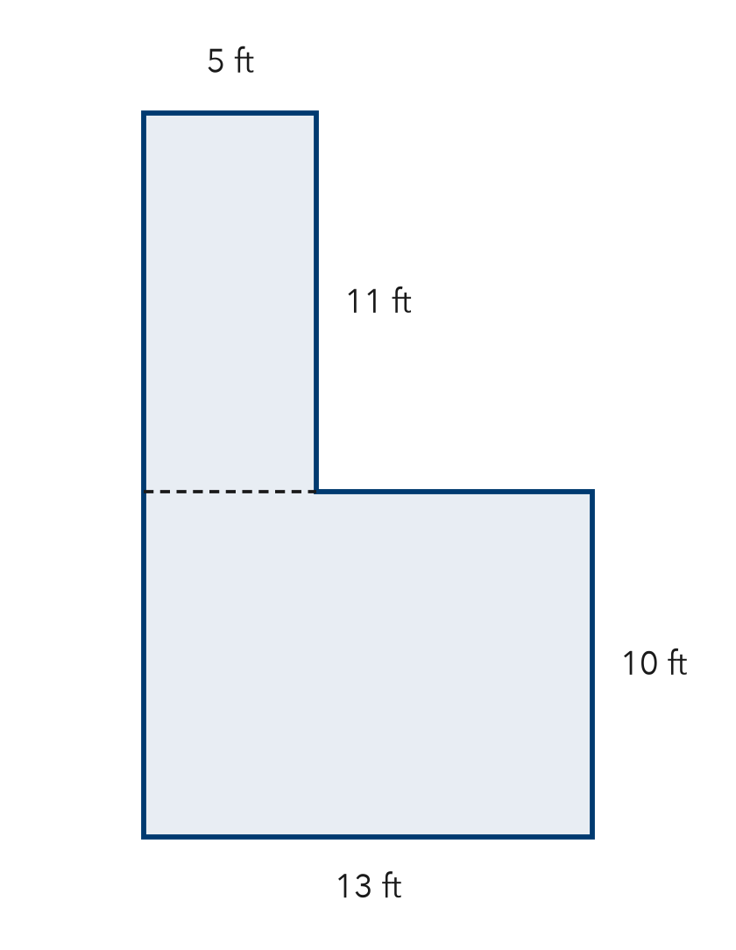

4. Wall and Window. A wall is 22 ft long and 10 ft tall. A square window 5 ft on each side is not painted. Find the painted area.
Step 1 Wall: 22 × 10 = ft²
Step 2 Window: 5 × 5 = ft²
Step 3 Not painted, so subtract: − = ft²

ON YOUR OWN use the open space · show your work · label units
5. Plywood Sheet. A plywood sheet is 24 ft by 9 ft. A 6 ft by 3 ft opening is cut out. How much plywood is left?  Show your work.  Answer ft² | 6. House Front. A house front is a rectangle with a triangle roof. Find the total area.  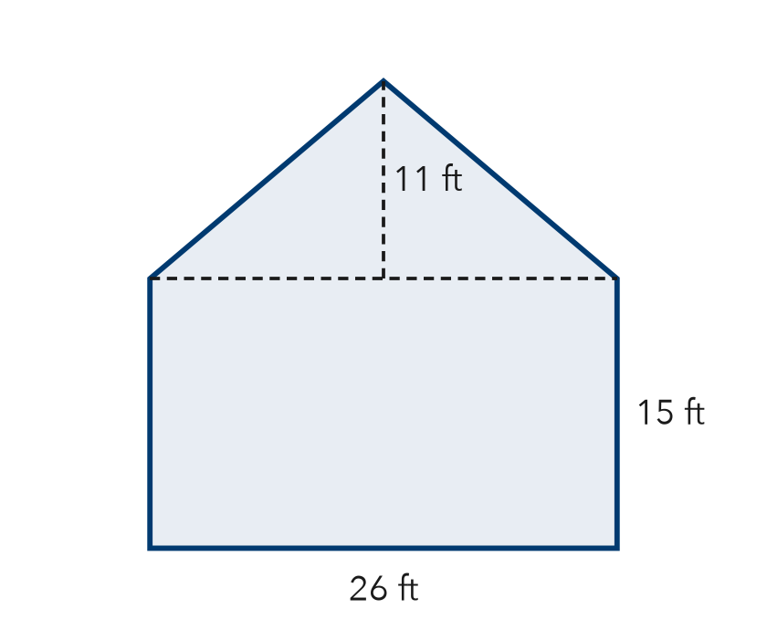  Show your work.  Answer ft²

7. Deja’s Poster. A poster is 32 in by 25 in. A 10 in square is cut from one corner. Deja says 800 in² is left. Is Deja right?  Show your work.  Area left in²  □ Yes □ No | 8. Playground Plan. A playground is 30 m by 20 m. Rubber covers all of it except a triangle sandbox (base 12 m, height 10 m). Rubber costs $14 per m².  Show your work.  a. Area of the whole rectangle m²  b. Area covered with rubber m²  c. Cost of the rubber $

FIND THE ERROR explain the mistake, then fix it
9. Omar’s Work. A wall is 19 ft by 11 ft with a 5 ft by 5 ft vent that is not painted. Omar wrote: “Painted area = 209 + 25 = 234 ft².” Explain the mistake and fix it.
Show your work.

TEST PRACTICE choose the best answer
10. When a piece is cut out of a figure, you —
A add its area B subtract its area C multiply by its area D ignore it

11. A composite figure is made of —
A only triangles B one rectangle C two or more simpler shapes D curved lines only

CHECK YOURSELF
□ I can do this on my own □ I need a little help □ I have a question about #

