Name Date Period
Lesson 5-4 · Session 2 · Guided Steps · Form B
Composite Figures
Learning target — I can find the area of a composite figure by adding or subtracting the areas of simpler shapes. · 6.G.A.1
REMEMBER
• A composite figure is made of simpler shapes: rectangles, triangles, squares.
• Add the areas of pieces that are joined. Subtract the area of a piece that is cut out.
• Use each piece’s own formula: rectangle l × w, triangle ½ × b × h.
GUIDED PRACTICE fill in each blank — problems 1–4
1. Decide whether to add or subtract. Then find each area.
a. 36 cm² rectangle + 10 cm² triangle  Step 1 Add or subtract?  Step 2 36 10 = cm² | b. 81 in² square, 25 in² cut out  Step 1 Add or subtract?  Step 2 81 25 = in²

c. 8 ft square, 2 ft square cut out  Step 1 Big square: 8 × 8 =  Step 2 Cut-out: 2 × 2 =  Step 3 Add or subtract?  Step 4 = ft² | d. 12 m × 5 m, 3 m square cut out  Step 1 Rectangle: 12 × 5 =  Step 2 Cut-out: 3 × 3 =  Step 3 Add or subtract?  Step 4 = m²

2. Swallowtail Flag. A flag starts as a rectangle 24 in by 16 in. A triangle notch 6 in deep is cut out of the right edge.  a. Area of the whole rectangle  Step 1 24 × 16 = in²  b. Area of the notch  Step 2 Notch: ½ × × 6 = in²  c. Area of the flag  Step 3 Subtract: − = in² | 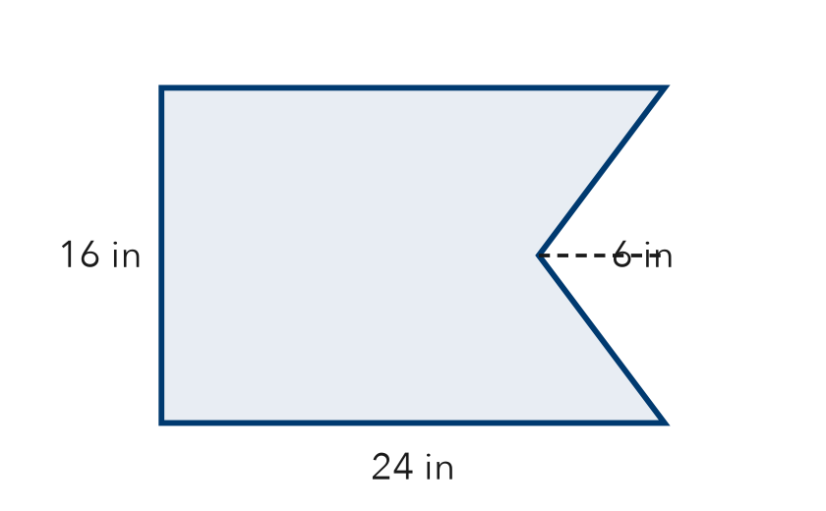

3. L-Shaped Room. An L-shaped floor splits into a 12 ft by 9 ft rectangle and a 4 ft by 10 ft rectangle. Find the floor area.  Step 1 Rectangle 1: 12 × 9 = ft²  Step 2 Rectangle 2: 4 × 10 = ft²  Step 3 Joined, so add: + = ft² | 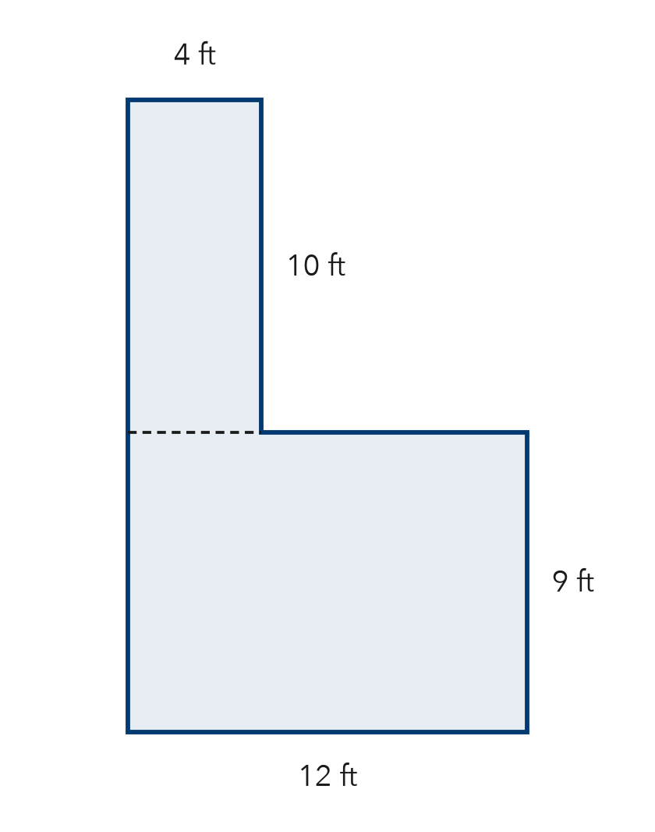

4. Wall and Window. A wall is 18 ft long and 9 ft tall. A square window 4 ft on each side is not painted. Find the painted area.
Step 1 Wall: 18 × 9 = ft²
Step 2 Window: 4 × 4 = ft²
Step 3 Not painted, so subtract: − = ft²

ON YOUR OWN use the open space · show your work · label units
5. Plywood Sheet. A plywood sheet is 20 ft by 8 ft. A 5 ft by 3 ft opening is cut out. How much plywood is left?  Show your work.  Answer ft² | 6. House Front. A house front is a rectangle with a triangle roof. Find the total area.  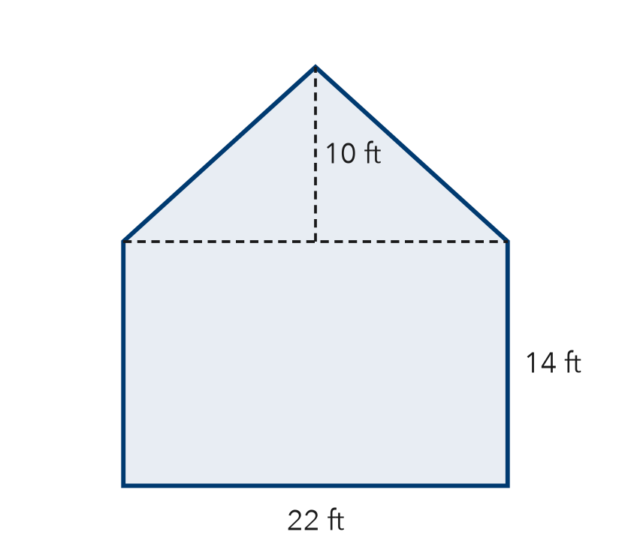  Show your work.  Answer ft²

7. Nico’s Poster. A poster is 30 in by 24 in. An 8 in square is cut from one corner. Nico says 720 in² is left. Is Nico right?  Show your work.  Area left in²  □ Yes □ No | 8. Playground Plan. A playground is 28 m by 18 m. Rubber covers all of it except a triangle sandbox (base 10 m, height 8 m). Rubber costs $12 per m².  Show your work.  a. Area of the whole rectangle m²  b. Area covered with rubber m²  c. Cost of the rubber $

FIND THE ERROR explain the mistake, then fix it
9. Lila’s Work. A wall is 17 ft by 10 ft with a 4 ft by 4 ft vent that is not painted. Lila wrote: “Painted area = 170 + 16 = 186 ft².” Explain the mistake and fix it.
Show your work.

TEST PRACTICE choose the best answer
10. A 64 in² square with a 9 in² square cut out has an area of —
A 55 in² B 73 in² C 61 in² D 576 in²

11. A 50 cm² rectangle joined to a 15 cm² triangle has a total area of —
A 35 cm² B 50 cm² C 65 cm² D 750 cm²

CHECK YOURSELF
□ I can do this on my own □ I need a little help □ I have a question about #

