Name Date Period
Lesson 5-5 · Session 1 · Guided Steps · Form A
Volume of Rectangular Prisms
Learning target — I can find the volume of a rectangular prism by multiplying length, width, and height. · 6.G.A.2
REMEMBER
• Volume is the space inside a solid, counted in unit cubes. Write cubic units: cm³, in³, ft³.
• One layer = length × width = base area B. The height counts the layers.
• V = l × w × h or V = B × h.
GUIDED PRACTICE fill in each blank — problems 1–4
1. Find the volume of each rectangular prism.
a. 8 cm × 6 cm × 9 cm  Step 1 8 × 6 =  Step 2 × 9 = cm³ | b. 7 ft × 4 ft × 3 ft  Step 1 7 × 4 =  Step 2 × 3 = ft³

c. 9 ft × 6 ft × 2 ft  Step 1 9 × 6 =  Step 2 × 2 = ft³ | d. B = 42 in², h = 7 in  Step 1 V = B × h  Step 2 × = in³

2. Toy Chest. A toy chest is packed with cubes 1 ft on each edge, as shown.  a. Cubes in the bottom layer  Step 1 Length × width: × =  b. Number of layers  Step 2 The height counts the layers:  c. Volume of the chest  Step 3 × = ft³ | 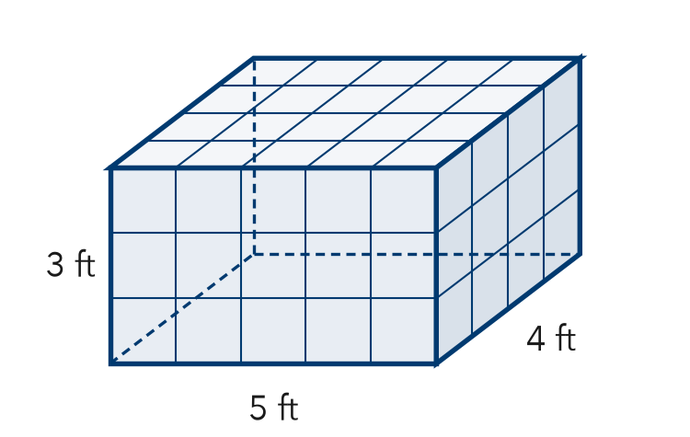

3. Fish Tank. A fish tank is 16 in long, 11 in wide, and 5 in tall.
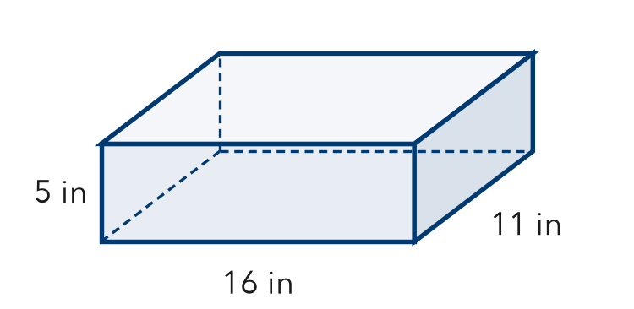
a. Area of the base
Step 1 16 × 11 = in²
b. Volume of the tank
Step 2 × 5 = in³

4. Locker Space. A locker is 12 in wide, 15 in deep, and 48 in tall. Find its volume.
Step 1 Base: 12 × 15 = in²
Step 2 Volume: × 48 = in³

ON YOUR OWN use the open space · show your work · label units
5. Sandbox Fill. A sandbox is 26 ft long and 11 ft wide. Sand is poured in 2 ft deep. How much sand is needed?  Show your work.  Answer ft³ | 6. Ian’s Box. A box is 17 cm long, 13 cm wide, and 5 cm tall. Ian says its volume is 221 cm³. Is Ian right?  Show your work.  True volume cm³  □ Yes □ No

7. Two Cartons. Carton A is 18 cm by 5 cm by 11 cm. Carton B is 15 cm by 11 cm by 5 cm. Which carton holds more? How much more?  Show your work.  Carton How much more cm³ | 8. Aquarium. An aquarium is 60 cm long, 30 cm wide, and 40 cm tall. One liter of water fills 1,000 cm³.  Show your work.  a. Find the volume. cm³  b. How many liters fill it? L  c. It is filled only 35 cm deep. How many liters? L

FIND THE ERROR explain the mistake, then fix it
9. Tomás’s Work. A crate is 15 ft long, 11 ft wide, and 4 ft tall. Tomás wrote: “V = 15 + 11 + 4 = 30 ft³.” Explain the mistake and find the correct volume.
Show your work.

TEST PRACTICE choose the best answer
10. A prism is 3 cm by 4 cm by 5 cm. Its volume is —
A 12 cm³ B 47 cm³ C 60 cm³ D 60 cm²

11. Volume is measured in —
A units B square units C cubic units D degrees

CHECK YOURSELF
□ I can do this on my own □ I need a little help □ I have a question about #

