Name Date Period
Lesson 5-5 · Session 2 · Guided Steps · Form A
Missing Fractional Edges
Learning target — I can find a missing edge of a prism and find volumes with fractional edge lengths. · 6.G.A.2
REMEMBER
• V = l × w × h works with fractions: 12 × 10 × 3/4 = 120 × 3/4 = 90.
• 1 1/2 of a number is the number plus half of it.
• Missing edge: multiply the two known edges, then divide the volume by that product.
GUIDED PRACTICE fill in each blank — problems 1–4
1. Find each volume or missing edge.
a. 1/2 ft × 3/4 ft × 2 ft  Step 1 1/2 × 3/4 =  Step 2 × 2 = ft³ | b. 14 in × 11 in × 1/2 in  Step 1 14 × 11 =  Step 2 Half of = in³

c. V = 336 in³, w = 8 in, h = 6 in; l =  Step 1 8 × 6 =  Step 2 336 ÷ = in | d. V = 96 in³, B = 12 in²; h =  Step 1 V = B × h, so h = V ÷ B  Step 2 ÷ = in

2. Shipping Box Limit. A shipping box holds 990 in³. It is 9 in wide and 10 in tall. Boxes may be at most 13 in long.
a. Multiply the two known edges.
Step 1 9 × 10 = in²
b. Find the length.
Step 2 990 ÷ = in
c. Does the box meet the rule?
Step 3 Is the length at most 13 in?

3. Planter Depth. A planter holds 1,170 cm³ of soil. Its base is 13 cm by 10 cm. How tall is it?  Step 1 Base: 13 × 10 = cm²  Step 2 1170 ÷ = cm  Step 3 Check: 13 × 10 × = | 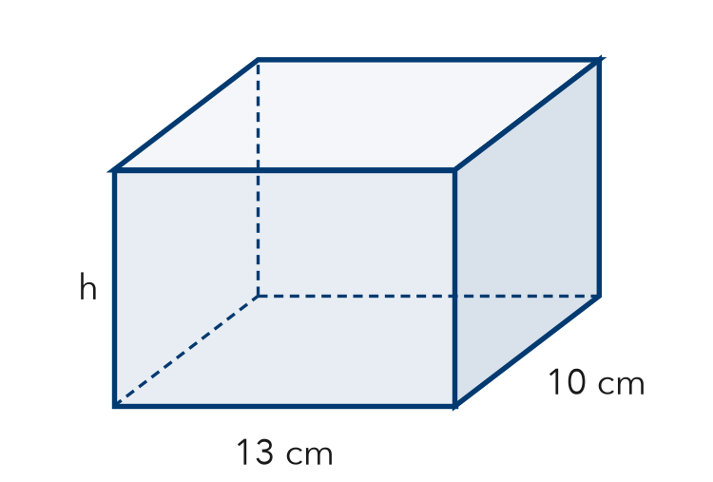

4. Thin Box. A flat box is 20 in long, 16 in wide, and 3/4 in tall. Find its volume.
Step 1 Base: 20 × 16 = in²
Step 2 Divide by 4: ÷ 4 =
Step 3 Times 3: × 3 = in³

ON YOUR OWN use the open space · show your work · label units
5. Seed Flat. A seed flat is 20 in long, 12 in wide, and 1 1/2 in deep. Find its volume.  Show your work.  Answer in³ | 6. Concrete Slab. A concrete slab is 22 ft long, 9 ft wide, and 1/2 ft thick. Concrete costs $5 per ft³. Find the volume and the cost.  Show your work.  Volume ft³ Cost $

7. Aquarium Width. An aquarium holds 5,400 in³ of water. It is 30 in long and 18 in tall. The width label wore off. Find the width.  Show your work.  Answer in | 8. Planter Box. A planter is 3/4 m long, 1/2 m wide, and 2 m tall. Soil costs $18 per m³.  Show your work.  a. Find the volume. m³  b. Find the cost to fill it. $  c. A second planter is twice as tall. Find its volume. m³

FIND THE ERROR explain the mistake, then fix it
9. Hana’s Work. A box holds 1,980 cm³. It is 11 cm wide and 9 cm tall. Hana wrote: “1,980 ÷ 11 = 180, so the length is 180 cm.” Explain the mistake and find the length.
Show your work.

TEST PRACTICE choose the best answer
10. A prism has a volume of 120 cm³, a length of 5 cm, and a width of 4 cm. Its height is —
A 6 cm B 20 cm C 24 cm D 111 cm

11. A block is 1/2 m by 1/2 m by 4 m. Its volume is —
A 1 m³ B 2 m³ C 4 m³ D 5 m³

CHECK YOURSELF
□ I can do this on my own □ I need a little help □ I have a question about #

