Name Date Period
Lesson 5-5 · Session 2 · Guided Steps · Form B
Missing Fractional Edges
Learning target — I can find a missing edge of a prism and find volumes with fractional edge lengths. · 6.G.A.2
REMEMBER
• V = l × w × h works with fractions: 12 × 10 × 3/4 = 120 × 3/4 = 90.
• 1 1/2 of a number is the number plus half of it.
• Missing edge: multiply the two known edges, then divide the volume by that product.
GUIDED PRACTICE fill in each blank — problems 1–4
1. Find each volume or missing edge.
a. 1/2 m × 1/2 m × 6 m  Step 1 1/2 × 1/2 =  Step 2 × 6 = m³ | b. 12 in × 9 in × 1/2 in  Step 1 12 × 9 =  Step 2 Half of = in³

c. V = 240 in³, w = 6 in, h = 5 in; l =  Step 1 6 × 5 =  Step 2 240 ÷ = in | d. V = 105 in³, B = 15 in²; h =  Step 1 V = B × h, so h = V ÷ B  Step 2 ÷ = in

2. Shipping Box Limit. A shipping box holds 1,080 in³. It is 8 in wide and 9 in tall. Boxes may be at most 13 in long.
a. Multiply the two known edges.
Step 1 8 × 9 = in²
b. Find the length.
Step 2 1080 ÷ = in
c. Does the box meet the rule?
Step 3 Is the length at most 13 in?

3. Planter Depth. A planter holds 1,008 cm³ of soil. Its base is 12 cm by 7 cm. How tall is it?  Step 1 Base: 12 × 7 = cm²  Step 2 1008 ÷ = cm  Step 3 Check: 12 × 7 × = | 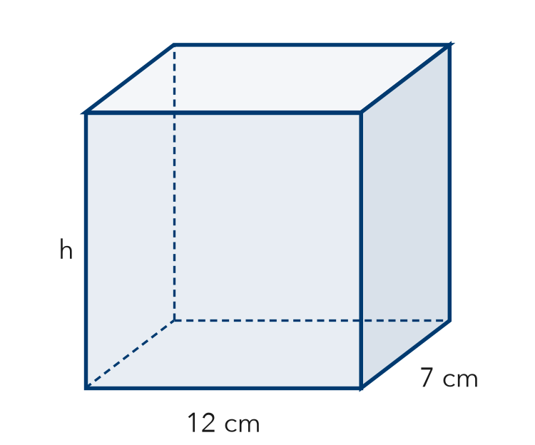

4. Thin Box. A flat box is 24 in long, 12 in wide, and 3/4 in tall. Find its volume.
Step 1 Base: 24 × 12 = in²
Step 2 Divide by 4: ÷ 4 =
Step 3 Times 3: × 3 = in³

ON YOUR OWN use the open space · show your work · label units
5. Seed Flat. A seed flat is 18 in long, 10 in wide, and 1 1/2 in deep. Find its volume.  Show your work.  Answer in³ | 6. Concrete Slab. A concrete slab is 20 ft long, 8 ft wide, and 1/2 ft thick. Concrete costs $6 per ft³. Find the volume and the cost.  Show your work.  Volume ft³ Cost $

7. Aquarium Width. An aquarium holds 4,500 in³ of water. It is 25 in long and 20 in tall. The width label wore off. Find the width.  Show your work.  Answer in | 8. Planter Box. A planter is 3/4 m long, 1/2 m wide, and 4 m tall. Soil costs $20 per m³.  Show your work.  a. Find the volume. m³  b. Find the cost to fill it. $  c. A second planter is twice as tall. Find its volume. m³

FIND THE ERROR explain the mistake, then fix it
9. Jonah’s Work. A box holds 2,520 cm³. It is 12 cm wide and 10 cm tall. Jonah wrote: “2,520 ÷ 12 = 210, so the length is 210 cm.” Explain the mistake and find the length.
Show your work.

TEST PRACTICE choose the best answer
10. A prism has a volume of 96 in³ and a base area of 12 in². Its height is —
A 8 in B 84 in C 108 in D 1,152 in

11. A block is 1/2 ft by 1/2 ft by 8 ft. Its volume is —
A 2 ft³ B 4 ft³ C 8 ft³ D 9 ft³

CHECK YOURSELF
□ I can do this on my own □ I need a little help □ I have a question about #

