5.6 Compare and Explain Nets
Student activity · square faces have side length 2 cm

Predict before cutting
These drawings contain six congruent squares. Which drawing folds into a cube without overlap? Mark the square you would use as the base, then trace where the other faces would go.
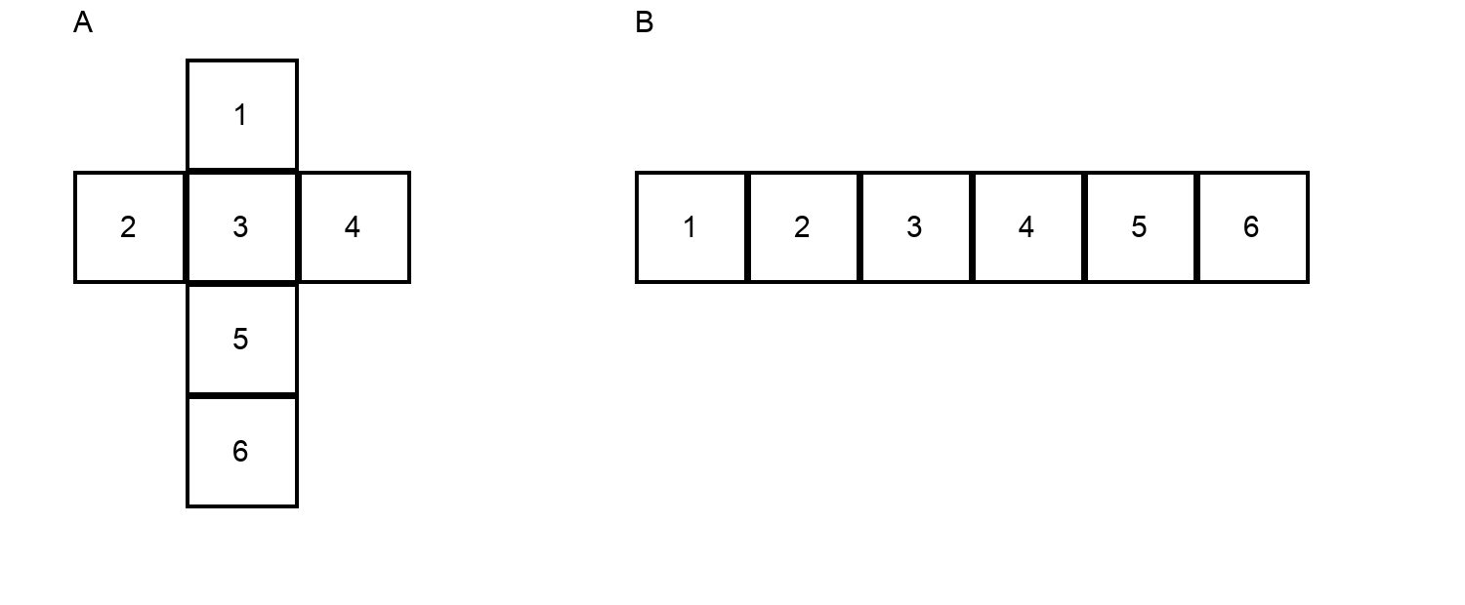
1. Predict A or B. Explain which faces meet or overlap.
________________________________________________________________________
________________________________________________________________________
2. Test with a paper copy, or sketch the fold paths. Revise your explanation using evidence.
________________________________________________________________________
________________________________________________________________________
3. Find the surface area of the cube represented by the valid net. Include units. Does the total area of the six squares prove a net will fold correctly? Explain.
________________________________________________________________________
________________________________________________________________________

