Name Date Period
Lesson 5-6 · Session 1 · Guided Steps · Form A
Drawing Nets of Solids
Learning target — I can draw the net of a solid by unfolding its faces onto a flat surface. · 6.G.A.4
REMEMBER
• A net is a flat pattern that folds into a solid. Each face appears once, with no overlaps.
• Edges that fold together must be the same length.
GUIDED PRACTICE fill in each blank — problems 1–4
1. How many of each shape are in the net?
a. rectangular prism: rectangles  Step 1 Solid has faces  Step 2 are rectangles | b. square pyramid: all shapes  Step 1 1 base + sides  Step 2 Total = 1 + =

c. triangular prism: triangles  Step 1 A prism has bases  Step 2 Ends here: | d. hexagonal pyramid: triangles  Step 1 Base has sides  Step 2 Triangles:

2. Paper Pyramid. Yuri is folding a paper square pyramid. Its net is shown.  Step 1 1 square + triangles  Step 2 Flat pieces:  a. Flat pieces in the net:  Step 3 Base: × =  b. Area of the square base: in²  Step 4 ½ × × =  c. Area of one triangle: in² | 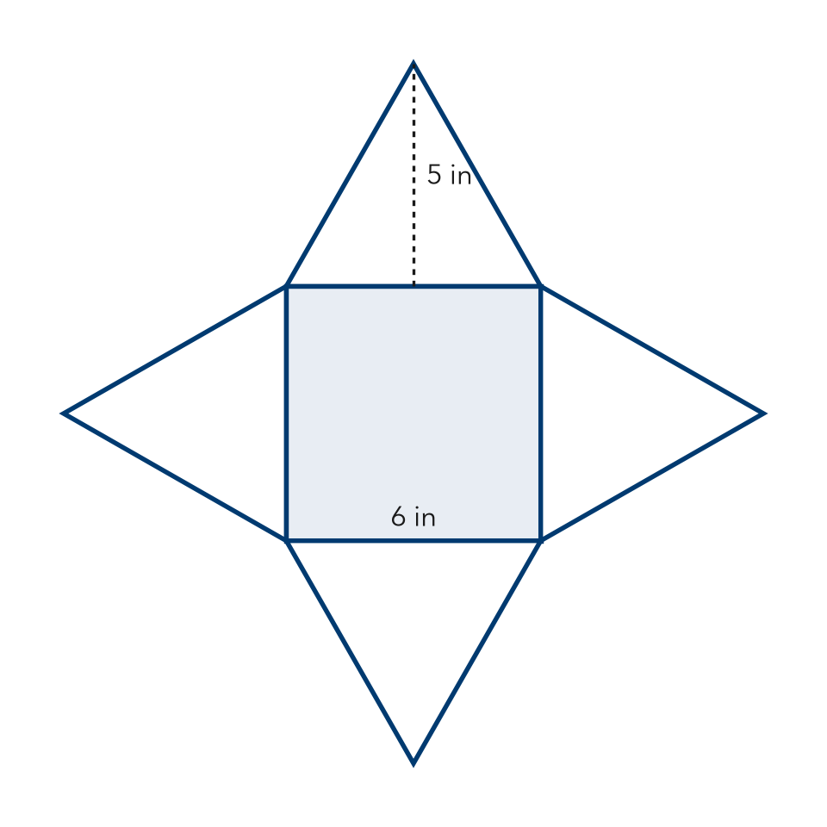

3. Cereal Box. A cereal box is a rectangular prism 8 in by 2 in by 12 in.  Step 1 A rectangular prism has faces  Step 2 Two longest edges: and  Step 3 × = in²  a. Rectangles in the net:  b. Area of the largest face: in² | 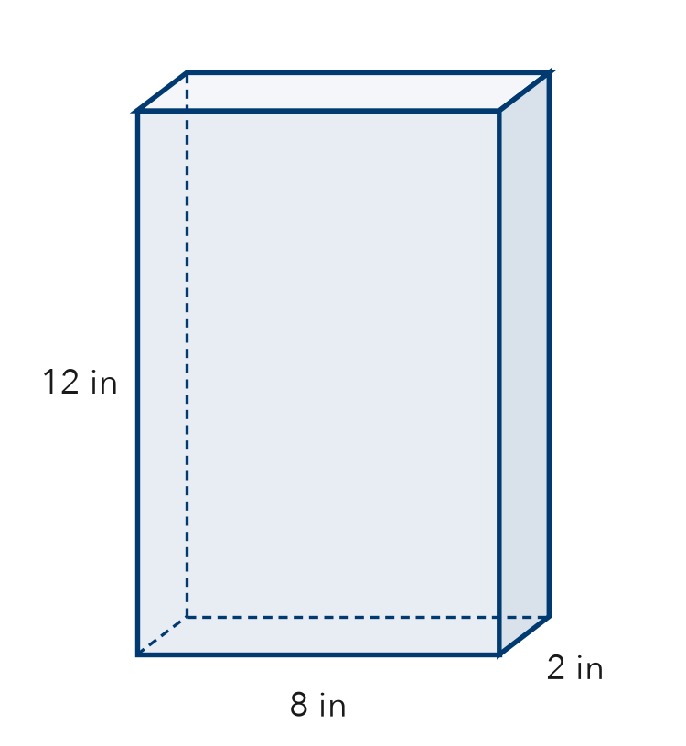

4. Tent Net. A tent is a triangular prism. Each triangle end has a base of 7 ft and a height of 4 ft. The tent is 10 ft long.  Step 1 Triangle ends:  Step 2 ½ × × = ft²  a. Triangles in the net:  b. Area of one triangle end: ft² | 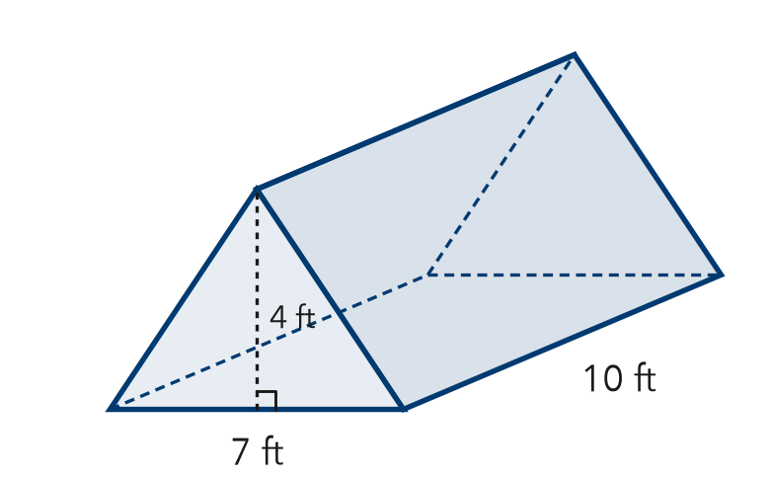

ON YOUR OWN use the open space · show your work · label units
5. Gift Cube. A gift box is a cube with 9 cm edges. How many faces? Area of one face?  Show your work.  Answer faces, cm² | 6. Display Pyramid. A square pyramid has a 14 in base edge. Each triangle is 11 in tall. Find one triangle’s area.  Show your work.  Answer in²

7. Maya’s Net. Maya drew a net of 5 squares, all the same size. Maya says it folds into a cube. Is Maya right? Explain.  Show your work. | 8. Wrapping Plan. A gift box is 10 in long, 5 in wide, and 4 in tall.  a. List the three pairs of matching rectangles.  b. Area of the largest face: in²  Show your work.

FIND THE ERROR explain the mistake, then fix it
9. Caleb’s Net. Caleb drew a net for a square pyramid: one square with 3 triangles attached to its sides. Caleb says it will fold up correctly. Explain the mistake.
Show your work.

TEST PRACTICE choose the best answer
10. A net is a flat pattern that folds into a —
A solid B line C circle D number line

11. A square pyramid’s net contains —
A 4 squares and 1 triangle B 1 square and 4 triangles C 2 squares and 4 rectangles D 6 squares

CHECK YOURSELF
□ I can do this on my own □ I need a little help □ I have a question about #

