Name Date Period
Lesson 5-6 · Session 1 · Guided Steps · Form B
Drawing Nets of Solids
Learning target — I can draw the net of a solid by unfolding its faces onto a flat surface. · 6.G.A.4
REMEMBER
• A net is a flat pattern that folds into a solid. Each face appears once, with no overlaps.
• Edges that fold together must be the same length.
GUIDED PRACTICE fill in each blank — problems 1–4
1. How many of each shape are in the net?
a. rectangular prism: faces  Step 1 Solid has faces  Step 2 are faces | b. pentagonal pyramid: triangles  Step 1 1 base + sides  Step 2 Total = 1 + =

c. triangular prism: rectangles  Step 1 A prism has bases  Step 2 Ends here: | d. square pyramid: squares  Step 1 Base has sides  Step 2 Triangles:

2. Paper Pyramid. Ines is folding a paper square pyramid. Its net is shown.  Step 1 1 square + triangles  Step 2 Flat pieces:  a. Flat pieces in the net:  Step 3 Base: × =  b. Area of the square base: in²  Step 4 ½ × × =  c. Area of one triangle: in² | 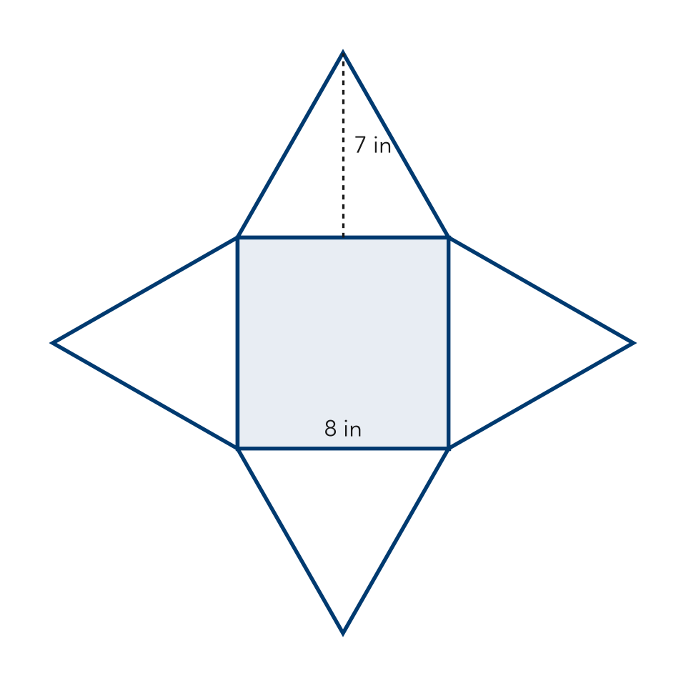

3. Juice Carton. A juice carton is a rectangular prism 6 in by 4 in by 15 in.  Step 1 A rectangular prism has faces  Step 2 Two longest edges: and  Step 3 × = in²  a. Rectangles in the net:  b. Area of the largest face: in² | 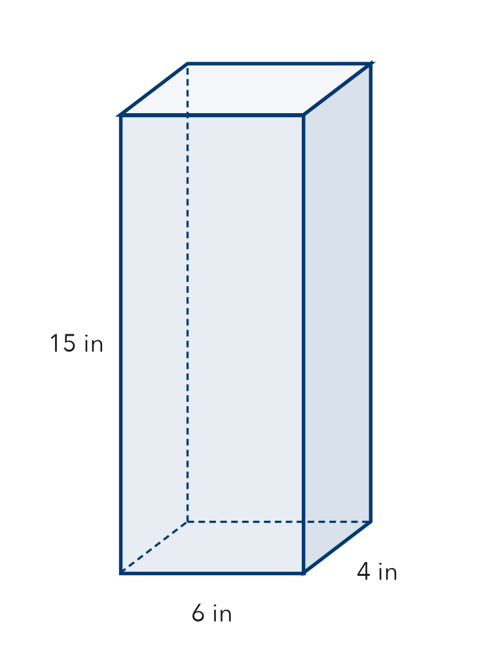

4. Tent Net. A tent is a triangular prism. Each triangle end has a base of 6 ft and a height of 5 ft. The tent is 9 ft long.  Step 1 Triangle ends:  Step 2 ½ × × = ft²  a. Triangles in the net:  b. Area of one triangle end: ft² | 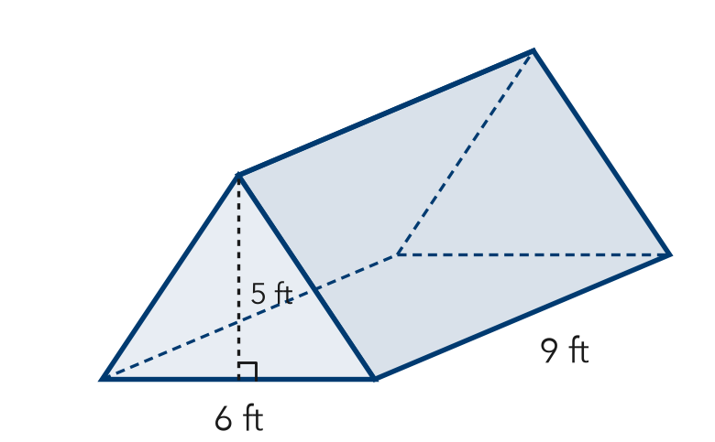

ON YOUR OWN use the open space · show your work · label units
5. Gift Cube. A gift box is a cube with 7 cm edges. How many faces? Area of one face?  Show your work.  Answer faces, cm² | 6. Display Pyramid. A square pyramid has a 10 in base edge. Each triangle is 7 in tall. Find one triangle’s area.  Show your work.  Answer in²

7. Leo’s Net. Leo drew a net of 7 squares, all the same size. Leo says it folds into a cube. Is Leo right? Explain.  Show your work. | 8. Wrapping Plan. A gift box is 10 in long, 7 in wide, and 3 in tall.  a. List the three pairs of matching rectangles.  b. Area of the largest face: in²  Show your work.

FIND THE ERROR explain the mistake, then fix it
9. Zara’s Net. Zara drew a net for a triangular prism with 2 triangles and 2 rectangles. Zara says it folds into the prism. Explain the mistake.
Show your work.

TEST PRACTICE choose the best answer
10. The number of shapes in a net equals the number of the solid’s —
A edges B vertices C faces D bases

11. A cube’s net contains how many squares?
A 4 B 5 C 6 D 8

CHECK YOURSELF
□ I can do this on my own □ I need a little help □ I have a question about #

