Name Date Period
Lesson 5-7 · Session 1 · Guided Steps · Form A
Surface Area of Rectangular Prisms
Learning target — I can find the surface area of a rectangular prism by adding the areas of its six faces. · 6.G.A.4
REMEMBER
• Surface area is the total area of all the faces, in square units.
• A rectangular prism has 3 pairs of matching faces: SA = 2lw + 2lh + 2wh.
• A cube has 6 matching faces: SA = 6 × (edge × edge). Open top? Leave that face out.
GUIDED PRACTICE fill in each blank — problems 1–4
1. Find the surface area of each solid.
a. cube, edges 8 cm  Step 1 One face: × =  Step 2 6 × = cm² | b. prism 9 cm × 6 cm × 4 cm  Step 1 9 × 6 =  Step 2 9 × 4 =  Step 3 6 × 4 =  Step 4 Add the 3:  Step 5 Double: cm²

c. prism 10 in × 5 in × 3 in = in² | d. cube, edges 6 m = m²

2. Toy Chest. James stains the whole outside of this chest. One can covers 20 ft².
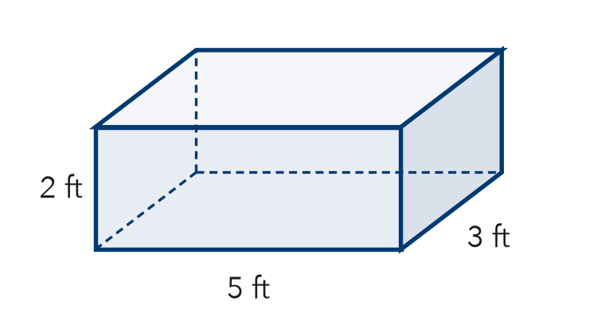
Step 1 Top: 5 × 3 =
Step 2 Front: 5 × 2 =
Step 3 End: 3 × 2 =
a. Top, front, and end faces: , ,
Step 4 Add the 3:
Step 5 Double:
b. Surface area: ft²
Step 6 ÷ 20 =
Step 7 Cans (whole cans):
c. Cans of stain needed:

3. Gift Wrap. Kai wraps a box 12 in by 10 in by 7 in. How much paper covers it?  Step 1 12 × 10 =  Step 2 12 × 7 =  Step 3 10 × 7 =  Step 4 Add the 3:  Step 5 Double:  Answer in² | 4. Two Cubes. Cube A has 5 cm edges. Cube B has 7 cm edges. Both are covered in foil.  a. SA of Cube A  Step 1 One face: × =  Step 2 6 × =  SA of Cube A: cm²  b. SA of Cube B  Step 3 One face: × =  Step 4 6 × =  SA of Cube B: cm²

ON YOUR OWN use the open space · show your work · label units
5. Moving Crate. A closed crate is 8 ft by 6 ft by 3 ft. Find its surface area.  Show your work.  Answer ft² | 6. Tessa’s Cube. A cube has 12 in edges. Tessa says its surface area is 144 in². Is Tessa right?  Show your work.  Answer in²

7. Shipping Carton. A closed shipping carton is 15 in long, 12 in wide, and 10 in tall. Find its surface area.  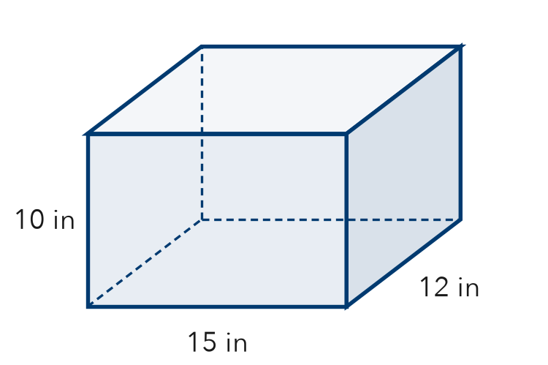  Show your work.  Answer in² | 8. Painting a Crate. A crate is 8 ft long, 5 ft wide, and 4 ft tall. One can of paint covers 40 ft².  a. Find the surface area: ft²  b. Cans to paint all six faces:  c. No paint on the bottom: new area and cans: ft², cans  Show your work.

FIND THE ERROR explain the mistake, then fix it
9. Jonah’s Work. A box is 10 cm long, 7 cm wide, and 5 cm tall. Jonah wrote: “Surface area = 10 × 7 × 5 = 350 cm².” Explain the mistake and find the surface area.
Show your work.

TEST PRACTICE choose the best answer
10. A cube with 4 cm edges has a surface area of —
A 16 cm² B 64 cm² C 96 cm² D 24 cm²

11. How many pairs of matching faces does a rectangular prism have?
A 2 B 3 C 4 D 6

CHECK YOURSELF
□ I can do this on my own □ I need a little help □ I have a question about #

