Name Date Period
Lesson 5-7 · Session 1 · Guided Steps · Form B
Surface Area of Rectangular Prisms
Learning target — I can find the surface area of a rectangular prism by adding the areas of its six faces. · 6.G.A.4
REMEMBER
• Surface area is the total area of all the faces, in square units.
• A rectangular prism has 3 pairs of matching faces: SA = 2lw + 2lh + 2wh.
• A cube has 6 matching faces: SA = 6 × (edge × edge). Open top? Leave that face out.
GUIDED PRACTICE fill in each blank — problems 1–4
1. Find the surface area of each solid.
a. cube, edges 9 cm  Step 1 One face: × =  Step 2 6 × = cm² | b. prism 8 cm × 5 cm × 3 cm  Step 1 8 × 5 =  Step 2 8 × 3 =  Step 3 5 × 3 =  Step 4 Add the 3:  Step 5 Double: cm²

c. prism 12 in × 4 in × 2 in = in² | d. cube, edges 5 m = m²

2. Toy Chest. Aaliyah stains the whole outside of this chest. One can covers 25 ft².
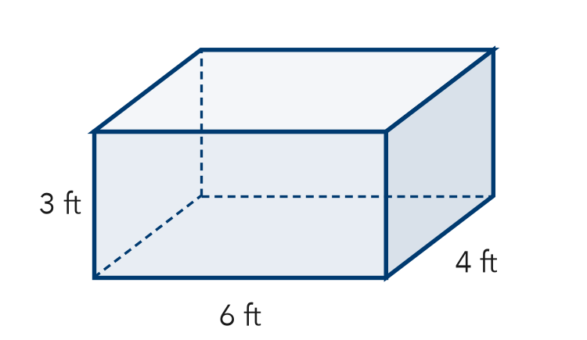
Step 1 Top: 6 × 4 =
Step 2 Front: 6 × 3 =
Step 3 End: 4 × 3 =
a. Top, front, and end faces: , ,
Step 4 Add the 3:
Step 5 Double:
b. Surface area: ft²
Step 6 ÷ 25 =
Step 7 Cans (whole cans):
c. Cans of stain needed:

3. Gift Wrap. Kai wraps a box 14 in by 9 in by 6 in. How much paper covers it?  Step 1 14 × 9 =  Step 2 14 × 6 =  Step 3 9 × 6 =  Step 4 Add the 3:  Step 5 Double:  Answer in² | 4. Two Cubes. Cube A has 6 cm edges. Cube B has 8 cm edges. Both are covered in foil.  a. SA of Cube A  Step 1 One face: × =  Step 2 6 × =  SA of Cube A: cm²  b. SA of Cube B  Step 3 One face: × =  Step 4 6 × =  SA of Cube B: cm²

ON YOUR OWN use the open space · show your work · label units
5. Moving Crate. A closed crate is 9 ft by 7 ft by 4 ft. Find its surface area.  Show your work.  Answer ft² | 6. Omar’s Cube. A cube has 11 in edges. Omar says its surface area is 121 in². Is Omar right?  Show your work.  Answer in²

7. Shipping Carton. A closed shipping carton is 16 in long, 10 in wide, and 8 in tall. Find its surface area.  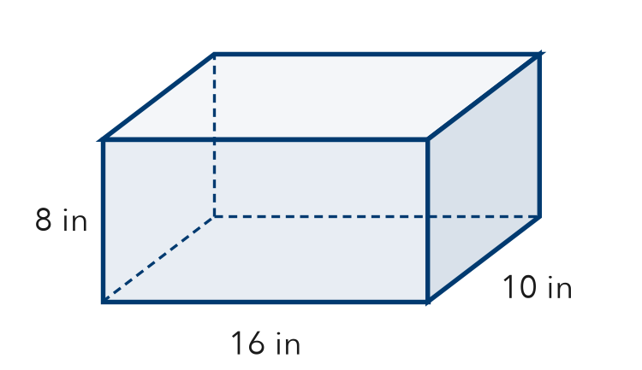  Show your work.  Answer in² | 8. Painting a Crate. A crate is 10 ft long, 6 ft wide, and 5 ft tall. One can of paint covers 50 ft².  a. Find the surface area: ft²  b. Cans to paint all six faces:  c. No paint on the bottom: new area and cans: ft², cans  Show your work.

FIND THE ERROR explain the mistake, then fix it
9. Kara’s Work. A box is 9 cm long, 6 cm wide, and 5 cm tall. Kara wrote: “Surface area = 9 × 6 × 5 = 270 cm².” Explain the mistake and find the surface area.
Show your work.

TEST PRACTICE choose the best answer
10. A prism 5 m by 4 m by 2 m has a surface area of —
A 40 m² B 38 m² C 76 m² D 80 m²

11. Surface area is measured in —
A units B square units C cubic units D degrees

CHECK YOURSELF
□ I can do this on my own □ I need a little help □ I have a question about #

