Name Date Period
Lesson 5-7 · Session 2 · Guided Steps · Form A
Surface Area of Triangular Prisms
Learning target — I can find the surface area of a triangular prism using its net. · 6.G.A.4
REMEMBER
• A triangular prism has 2 triangle ends and 3 rectangles: 5 faces.
• Triangle end: ½ × base × height. In a right triangle, the legs are base and height.
• Each rectangle: a triangle side × the prism’s length.
GUIDED PRACTICE fill in each blank — problems 1–4
1. Find each area.
a. 2 ends, base 6 ft, height 4 ft  Step 1 One end: ½ × 6 × 4 =  Step 2 Two ends: 2 × = ft² | b. rectangle 5 ft by 10 ft: ft²

c. 2 ends of 9 cm² each: cm² | d. rectangles 3, 4, 5 cm by 11 cm  Step 1 3 + 4 + 5 =  Step 2 × 11 = cm²

2. Candy Box. Both slanted sides of this candy box are 13 cm.  Step 1 One end: ½ × 24 × 5 =  Step 2 Two ends: 2 × =  a. Area of both triangle ends: cm²  Step 3 24 + 13 + 13 =  Step 4 × 20 =  b. Area of the three rectangles: cm²  Step 5 + =  c. Surface area: cm² | 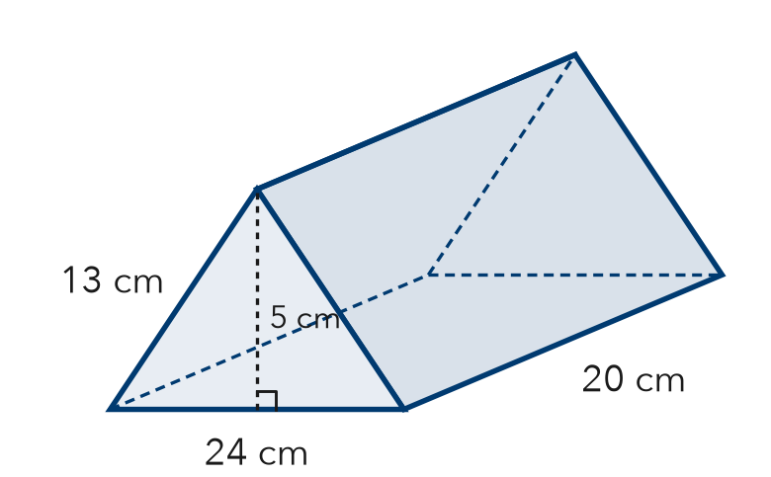

3. Ramp Wedge. A wedge is a triangular prism 14 cm wide. Its ends are right triangles with sides 20, 21, and 29 cm. Find its surface area.  Step 1 One end: ½ × × =  Step 2 Two ends:  Step 3 Sides added: + + =  Step 4 Rectangles: × =  Step 5 SA = + =  Answer cm² | 4. Cheese Wedge. A cheese wedge is a prism 6 cm thick. Its ends are right triangles with sides 5, 12, 13 cm. Find its surface area.  Step 1 One end: ½ × × =  Step 2 Two ends:  Step 3 Sides added: + + =  Step 4 Rectangles: × =  Step 5 SA = + =  Answer cm²

ON YOUR OWN use the open space · show your work · label units
5. Nolan’s Ends. A prism is 22 in long. Each end has base 14 in and height 24 in. Nolan says both ends cover 168 in². Is he right?  Show your work.  Answer in² | 6. Roof Piece. A roof piece is a prism 25 ft long. Each end: base 36 ft, height 24 ft, two 30 ft sides. Find its SA.  Show your work.  Answer ft²

7. Planter Wedge. Find the surface area of the planter.  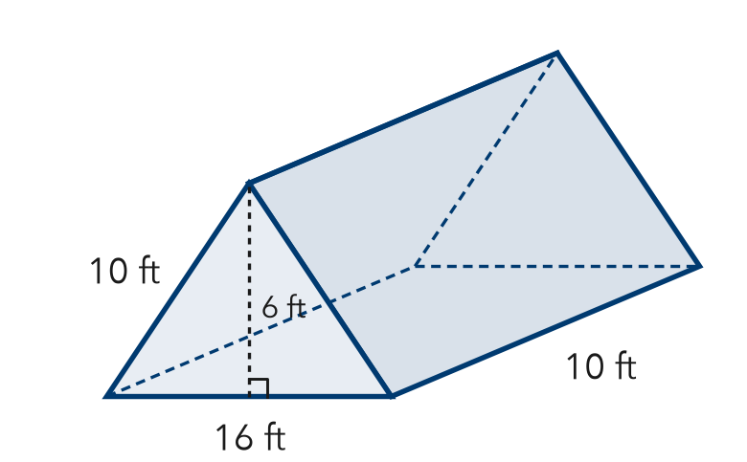  Show your work.  Answer ft² | 8. Camping Tent. A tent is a triangular prism 10 ft long. Each end: base 8 ft, height 3 ft, two 5 ft sides. The floor is 8 ft by 10 ft.  a. Area of the two ends: ft²  b. Total surface area: ft²  c. Fabric needed with no floor: ft²  Show your work.

FIND THE ERROR explain the mistake, then fix it
9. Amara’s Work. A prism is 10 cm long. Its ends are right triangles with sides 6, 8, 10 cm. Amara found the rectangles (240 cm²) and one end (24 cm²) and wrote “SA = 264 cm².” Explain and fix it.
Show your work.

TEST PRACTICE choose the best answer
10. How many rectangular faces does a triangular prism have?
A 2 B 3 C 5 D 6

11. Each rectangle in the net uses one triangle side times the —
A triangle’s height B prism’s length C triangle’s area D number of faces

CHECK YOURSELF
□ I can do this on my own □ I need a little help □ I have a question about #

